Table of Contents

UNITED STATES

SECURITIES AND EXCHANGE COMMISSION

Washington, D.C. 20549

FORM 10-Q

(Mark One)

- QUARTERLY REPORT PURSUANT TO SECTION 13 OR 15(d) OF THE SECURITIES EXCHANGE ACT OF 1934

For the quarterly period ended March 31, 2017

Or

- TRANSITION REPORT PURSUANT TO SECTION 13 OR 15(d) OF THE SECURITIES EXCHANGE ACT OF 1934

For the transition period from to

Commission file number 000-52049

SYNCHRONOSS TECHNOLOGIES, INC.

(Exact name of registrant as specified in its charter)

Delaware | 06-1594540
(State or other jurisdiction of | (I.R.S. Employer
incorporation or organization) | Identification No.)
200 Crossing Boulevard, 8th Floor
Bridgewater, New Jersey | 08807
(Address of principal executive offices) | (Zip Code)
(866) 620-3940
(Registrant’s telephone number, including area code)

(Former name, former address, and former fiscal year, if changed since last report)

Indicate by check mark whether the registrant: (1) has filed all reports required to be filed by Section 13 or 15(d) of the Securities Exchange Act of 1934 during the preceding 12 months (or for such shorter period that the registrant was required to file such reports), and (2) has been subject to such filing requirements for the past 90 days. Yes ☐ No x

Indicate by check mark whether the registrant has submitted electronically and posted on its corporate Web site, if any, every Interactive Data File required to be submitted and posted pursuant to Rule 405 of Regulation S-T during the preceding 12 months (or for such shorter period that the registrant was required to submit and post such files). Yes ☐ No x

Indicate by check mark whether the registrant is a large accelerated filer, an accelerated filer, or a non-accelerated filer. See definition of “accelerated filer and large accelerated filer” in Rule 12b-2 of the Exchange Act. (Check one):

Large accelerated filer | ☐ | Accelerated filer | x
Non-accelerated filer | ☐ (Do not check if a smaller reporting company) | Smaller Reporting Company | ☐
Emerging growth company | ☐

If an emerging growth company, indicate by check mark if the registrant has elected not to use the extended transition period for complying with any new or revised financial accounting standards provided pursuant to Section 13(a) of the Exchange Act. Yes ☐ No x

Indicate by check mark whether the registrant is a shell company (as defined in Rule 12b-2 of the Exchange Act). Yes ☐ No x

Class |  | Outstanding at June 30, 2018
Common stock, $0.0001 par value |  | 42,168,400

Table of Contents
 |  |  |  |  |  |  |  |  |  |  |  |  |  |  | SYNCHRONOSS TECHNOLOGIES, INC.
 |  |  |  |  |  |  |  |  |  |  |  |  |  |  |  | FORM 10-Q INDEX
 |  |  |  |  |  |  |  |  |  |  |  |  |  |  |  |  |  |  |  |  |  |  | PAGE NO.
 | PART I. |  |  |  |  | FINANCIAL INFORMATION |  |  |  |  |  |  |  |  |  |  |  |  |  |  |  |  | 3
 | Item 1. |  |  |  |  | Condensed Consolidated Financial Statements and Notes |  |  |  |  |  |  |  |  |  |  |  |  |  |  |  |  | 3
 |  |  |  |  |  | Condensed Consolidated Balance Sheets (unaudited) |  |  |  |  |  |  |  |  |  |  |  |  |  |  |  |  | 3
 |  |  |  |  |  | Condensed Consolidated Statements of Operations and Comprehensive Income (Loss) (unaudited) |  |  |  |  |  |  |  |  |  |  |  |  |  |  |  |  | 4
 |  |  |  |  |  | Condensed Consolidated Statements of Cash Flows (unaudited) |  |  |  |  |  |  |  |  |  |  |  |  |  |  |  |  | 6
 |  |  |  |  |  | Notes to Condensed Consolidated Financial Statements (unaudited) |  |  |  |  |  |  |  |  |  |  |  |  |  |  |  |  | 8
 | Item 2. |  |  |  |  | Management’s Discussion and Analysis of Financial Condition and Results of Operations |  |  |  |  |  |  |  |  |  |  |  |  |  |  |  |  | 49
 | Item 3. |  |  |  |  | Quantitative and Qualitative Disclosures About Market Risk |  |  |  |  |  |  |  |  |  |  |  |  |  |  |  |  |  | 57
 | Item 4. |  |  |  |  | Controls and Procedures |  |  |  |  |  |  |  |  |  |  |  |  |  |  |  |  |  | 58
 | PART II. |  |  |  |  | OTHER INFORMATION |  |  |  |  |  |  |  |  |  |  |  |  |  |  |  |  | 59
 | Item 1. |  |  |  |  | Legal Proceedings |  |  |  |  |  |  |  |  |  |  |  |  |  |  |  |  |  | 59
 | Item 1A. |  |  |  |  | Risk Factors |  |  |  |  |  |  |  |  |  |  |  |  |  |  |  |  | 59
 | Item 2. |  |  |  |  | Unregistered Sales of Equity Securities and Use of Proceeds |  |  |  |  |  |  |  |  |  |  |  |  |  |  |  |  |  | 59
 | Item 3. |  |  |  |  | Defaults Upon Senior Securities |  |  |  |  |  |  |  |  |  |  |  |  |  |  |  |  | 59
 | Item 4. |  |  |  |  | Mine Safety Disclosures |  |  |  |  |  |  |  |  |  |  |  |  |  |  |  |  |  | 59
 | Item 5. |  |  |  |  | Other Information |  |  |  |  |  |  |  |  |  |  |  |  |  |  |  |  |  | 59
 | Item 6. |  |  |  |  | Exhibits |  |  |  |  |  |  |  |  |  |  |  |  |  |  |  |  | 60
 | SIGNATURES |  |  |  |  |  |  |  |  |  |  |  |  |  |  |  |  |  |  |  |  |  |  | 61

Table of Contents

PART I. FINANCIAL INFORMATION

ITEM 1. CONDENSED CONSOLIDATED FINANCIAL STATEMENTS AND NOTES

SYNCHRONOSS TECHNOLOGIES, INC.

CONDENSED CONSOLIDATED BALANCE SHEETS (Unaudited) (In thousands)

 |  |  | March 31, 2017 |  |  | December 31, 2016
 |  |  |  |  |  | (Restated)
ASSETS
Current assets:
Cash and cash equivalents |  | $ | 221,178 |  | $ | 169,801
Restricted cash** |  |  | 19,579 |  |  | 41,632
Marketable securities |  |  | 9,963 |  |  | 12,506
Accounts receivable, net of allowances of $2,078 and $1,459 at March 31, 2017 and December 31, 2016,
respectively** |  |  | 92,494 |  |  | 107,474
Prepaid and other current assets |  |  | 58,838 |  |  | 38,277
Assets held for sale, current* |  |  | 63,154 |  |  | —
Total current assets |  |  | 465,206 |  |  | 369,690
Marketable securities |  |  | 1,680 |  |  | 2,974
Property and equipment, net |  |  | 147,120 |  |  | 158,205
Goodwill |  |  | 224,954 |  |  | 224,651
Intangible assets, net |  |  | 149,941 |  |  | 162,968
Deferred tax assets |  |  | 15,796 |  |  | 13,286
Other assets |  |  | 16,343 |  |  | 8,658
Note receivable from related party** |  |  | 73,021 |  |  | 70,269
Equity method investment |  |  | 44,398 |  |  | 43,650
Assets held for sale, non-current* |  |  | 909,682 |  |  | —
Total assets |  | $ | 2,048,141 |  | $ | 1,054,351
LIABILITIES AND STOCKHOLDERS’ EQUITY
Current liabilities:
Accounts payable |  |  | 26,707 |  |  | 17,057
Accrued expenses |  |  | 55,194 |  |  | 76,882
Deferred revenues |  |  | 88,263 |  |  | 57,430
Contingent consideration obligation |  |  | 2,831 |  |  | 2,833
Short-term debt |  |  | 6,051 |  |  | 29,000
Liabilities held for sale, current* |  |  | 55,998 |  |  | —
Total current liabilities |  |  | 235,044 |  |  | 183,202
Lease financing obligation |  |  | 12,124 |  |  | 12,450
Convertible debt, net of debt issuance costs |  |  | 226,644 |  |  | 226,291
Long term debt- term loan |  |  | 874,678 |  |  | —
Deferred tax liabilities |  |  | 16,639 |  |  | 3,508
Deferred revenues |  |  | 51,060 |  |  | 65,630
Other liabilities |  |  | 8,516 |  |  | 8,193
Liabilities held for sale, non-current* |  |  | 112,118 |  |  | —
Commitments and contingencies (Note 13)
Redeemable noncontrolling interest |  |  | 25,280 |  |  | 25,280
Stockholders’ equity:
Common stock, $0.0001 par value; 100,000 shares authorized, 50,973 and 50,388 shares issued; 45,914 |  |  | 5 |  |  | 5
and 45,292 outstanding at March 31, 2017 and December 31, 2016, respectively |  |  | 5 |  |  | 5
Treasury stock, at cost (5,059 and 5,096 shares at March 31, 2017 and December 31, 2016, respectively) |  |  | (105,584) |  | $ | (106,631)
Additional paid-in capital |  |  | 584,377 |  |  | 571,153
Accumulated other comprehensive loss |  |  | (38,489) |  |  | (42,350)
Retained earnings |  |  | 45,729 |  |  | 107,620
Total stockholders’ equity |  |  | 486,038 |  |  | 529,797
Total liabilities and stockholders’ equity |  | $ | 2,048,141 |  | $ | 1,054,351

* See Note 4 -Acquisitions and Divestitures for transactions classified as held for sale.

** See Note 6 -Investments in Affiliates and Related Transactions for related party transactions reflected in this account

See accompanying notes to condensed consolidated financial statements.

3

Table of Contents

SYNCHRONOSS TECHNOLOGIES, INC.

CONDENSED CONSOLIDATED STATEMENTS OF OPERATIONS

(Unaudited)

(In thousands, except per share data)

 | Three Months Ended March 31,
 | 2017 |  |  |  | 2016
 |  |  |  |  | (Restated)
Net revenues | $ | 86,097 |  | $ | 78,246
Costs and expenses:
Cost of revenues** |  | 46,055 |  |  | 46,151
Research and development |  | 25,489 |  |  | 25,827
Selling, general and administrative |  | 38,815 |  |  | 25,914
Net change in contingent consideration obligation |  | — |  |  | 5
Restructuring charges |  | 2,998 |  |  | 2,910
Depreciation and amortization |  | 24,087 |  |  | 22,782
Total costs and expenses |  | 137,444 |  |  | 123,589
Loss from continuing operations |  | (51,347) |  |  | (45,343)
Interest income |  | 2,857 |  |  | 630
Interest expense |  | (10,617) |  |  | (1,576)
Other income (expense), net |  | 4,186 |  |  | (381)
Equity method investment income |  | 748 |  |  | —
Loss from continuing operations, before taxes |  | (54,173) |  |  | (46,670)
Benefit for income taxes |  | 8,721 |  |  | 15,520
Net loss from continuing operations |  | (45,452) |  |  | (31,150)
Net loss from discontinued operations, net of tax* |  | (16,134) |  |  | (1,186)
Net (loss) |  | (61,586) |  |  | (32,336)
Net loss attributable to redeemable noncontrolling interests |  | (2,889) |  |  | (3,007)
Net loss attributable to Synchronoss | $ | (58,697) |  | $ | (29,329)
Basic:
Continuing operations | $ | (0.96) |  | $ | (0.65)
Discontinued operations* |  | (0.37) |  |  | (0.03)
 | $ | (1.33) |  | $ | (0.68)
Diluted:
Continuing operations | $ | (0.96) |  | $ | (0.65)
Discontinued operations* |  | (0.37) |  |  | (0.03)
 | $ | (1.33) |  | $ | (0.68)
Weighted-average common shares outstanding:
Basic |  | 44,212 |  |  | 43,423
Diluted |  | 44,212 |  |  | 43,423
- See Note 4 -Acquisitions and Divestitures for transactions classified as held for sale. **Cost of revenues excludes depreciation and amortization which is shown separately.

See accompanying notes to condensed consolidated financial statements.

4

Table of Contents

CONDENSED CONSOLIDATED STATEMENTS OF COMPREHENSIVE (LOSS) INCOME (Unaudited) (In thousands)

 |  | Three Months Ended
 |  | March 31,
 |  | 2017 |  |  | 2016
 |  |  |  |  | (Restated)
Net (loss) | $ | (61,586) |  | $ | (32,336)
Other comprehensive income (loss), net of tax:
Foreign currency translation adjustments |  | 3,660 |  |  | 9,463
Unrealized gain on available for sale securities |  | 8 |  |  | 20
Net income (loss) on intra-entity foreign currency transactions |  | 193 |  |  | (262)
Total other comprehensive income, net of tax |  | 3,861 |  |  | 9,221
Comprehensive loss |  | (57,725) |  |  | (23,115)
Comprehensive loss attributable to redeemable noncontrolling interests |  | (2,889) |  |  | (3,007)
Comprehensive loss attributable to Synchronoss | $ | (54,836) |  | $ | (20,108)

5

Table of Contents

SYNCHRONOSS TECHNOLOGIES, INC.

CONDENSED CONSOLIDATED STATEMENTS OF CASH FLOWS

(Unaudited) (In thousands)

 |  | Three Months Ended March 31,
 |  | 2017 |  |  | 2016
 |  |  |  |  | (Restated)
Operating activities:
Net loss from continuing operations | $ | (45,452) |  | $ | (31,150)
Net loss from discontinued operations* |  | (16,134) |  |  | (1,186)
Adjustments to reconcile net loss to net cash (used in) provided by operating activities:
Depreciation and amortization expense |  | 24,087 |  |  | 22,782
Discontinued operations non-cash and working capital adjustments* |  | 26,183 |  |  | 1,295
Stock-based compensation |  | 8,112 |  |  | 7,790
Contingent consideration obligation |  | (2) |  |  | 5
Amortization of debt issuance costs |  | 1,870 |  |  | 375
Accrued PIK interest |  | (2,752) |  |  | —
Earnings from equity method investments |  | (748) |  |  | —
Gain on disposals |  | (4,947) |  |  | —
Amortization of bond premium |  | 91 |  |  | 373
Deferred income taxes |  | 5,119 |  |  | (47)
Non-cash interest on leased facility |  | 269 |  |  | 229
Changes in operating assets and liabilities:
Accounts receivable, net of allowance for doubtful accounts |  | 9,320 |  |  | (22,910)
Prepaid expenses and other current assets |  | (21,055) |  |  | 20,194
Other assets |  | (4,925) |  |  | 957
Accounts payable |  | 11,082 |  |  | 8,317
Accrued expenses |  | (18,821) |  |  | (1,486)
Other liabilities |  | (39) |  |  | (7,662)
Deferred revenues |  | 16,143 |  |  | 25,482
Net cash (used in) provided by operating activities |  | (12,599) |  |  | 23,358
Investing activities:
Purchases of fixed assets |  | (4,402) |  |  | (10,003)
Purchases of intangible assets and capitalized software |  | (2,409) |  |  | (1,346)
Proceeds from the sale of Speechcycle |  | 13,500 |  |  | —
Purchases of marketable securities available-for-sale |  | (219) |  |  | (8,598)
Maturities of marketable securities available-for-sale |  | 3,975 |  |  | 12,565
Investing activities in discontinued operations* |  | (2,704) |  |  | —
Businesses acquired, net of cash |  | (815,008) |  |  | (86,482)
Net cash (used in) investing activities |  | (807,267) |  |  | (93,864)

6

Table of Contents

 |  | Three Months Ended March 31,
 |  | 2017 |  |  | 2016
 |  |  |  |  | (Restated)
Financing activities:
Share-based compensation-related proceeds, net of taxes paid on withholding shares |  | 2,406 |  |  | 1,755
Debt issuance costs related to the Credit Facility |  | (3,692) |  |  | —
Debt issuance costs related to long term debt |  | (19,887)
Proceeds from issuance of long term debt |  | 900,000 |  |  | —
Borrowings on revolving line of credit |  | — |  |  | 50,000
Repayment of revolving line of credit |  | (29,000) |  |  | —
Excess tax benefit from the exercise of stock options |  | — |  |  | —
Repurchases of common stock |  | — |  |  | (16,581)
Proceeds from sale of Treasury Shares |  | 1,047 |  |  | 955
Payments on capital obligations |  | (664) |  |  | (253)
Net cash provided by financing activities |  | 850,210 |  |  | 35,876
Effect of exchange rate changes on cash |  | (1,020) |  |  | (158)
Net increase (decrease) in cash and cash equivalents |  | 29,324 |  |  | (34,788)
Cash, restricted cash and cash equivalents at beginning of period |  | 211,433 |  |  | 147,872
Cash, restricted cash and cash equivalents at end of period | $ | 240,757 |  | $ | 113,084
Supplemental disclosures of cash flow information:
Cash paid for income taxes | $ | 1,488 |  | $ | 1,780
Cash paid for interest | $ | 1,379 |  | $ | 1,533
Supplemental disclosures of non-cash investing and financing activities:
Issuance of common stock in connection with Openwave acquisition | $ | — |  | $ | 22,000
Issuance of common stock in connection with Intralinks acquisition | $ | 4,700 |  | $ | —
Cash and cash equivalents per the Consolidated Balance Sheets | $ | 221,178 |  | $ | 86,782
Restricted cash per the Consolidated Balance Sheets | $ | 19,579 |  | $ | 26,302
Total cash, cash equivalents and restricted cash | $ | 240,757 |  | $ | 113,084

* See Note 4 - Acquisitions and Divestitures for transactions classified as discontinued operations.

See accompanying notes to condensed consolidated financial statements.

7

Table of Contents

SYNCHRONOSS TECHNOLOGIES, INC.

NOTES TO CONDENSED CONSOLIDATED FINANCIAL STATEMENTS — UNAUDITED

(Amounts in tables in thousands, except for per share data or unless otherwise noted)

1. Description of Business

General

Synchronoss Technologies, Inc. (referred to herein as “Synchronoss”, the “Company”, “we”, “our” or “us”) is a global software and services company that provides essential technologies for the mobile transformation of business. The Company’s portfolio, which is targeted at the Consumer and Enterprise markets, contains offerings such as personal cloud, secure-mobility, identity management and scalable messaging platforms, products and solutions. These essential technologies create a better way of delivering the transformative mobile experiences that service providers and enterprises need to help them stay ahead of the curve in competition, innovation, productivity, growth and operational efficiency.

Synchronoss’ products and platforms are designed to be carrier-grade, flexible and scalable, enabling multiple converged communication services to be managed across a range of distribution channels including e-commerce, m-commerce, telesales, customer stores, indirect and other retail outlets. This business model allows the Company to meet the rapidly changing converged services and connected devices offered by their customers. Synchronoss’ products, platforms and solutions enable its enterprise and service provider customers to acquire, retain and service subscribers and employees quickly, reliably and cost-effectively with white label and custom-branded solutions. Synchronoss customers can simplify the processes associated with managing the customer experience for procuring, activating, connecting, backing-up, synchronizing and sharing/collaboration with connected devices and contents from these devices and associated services. The extensibility, scalability, reliability and relevance of the Company’s platforms enable new revenue streams and retention opportunities for their customers through new subscriber acquisitions, sale of new devices, accessories and new value-added service offerings in the Cloud. By using the Company’s technologies, Synchronoss customers can optimize their cost of operations while enhancing their customer experience.

The Company currently operates in and markets their solutions and services directly through their sales organizations in North America, Europe, the Middle East and Africa (“EMEA”), and the Asia-Pacific region. Synchronoss delivers essential technologies for mobile transformation to two primary types of customers: service provider and enterprise customers in regulated verticals and use cases.

Service Providers, Retailers, OEMs, Re-sellers and Service Integrators

The Company’s products and platforms provide end-to-end seamless integration between customer-facing channels/applications, communication services, or devices and “back-office” infrastructure-related systems and processes. Synchronoss’ customers rely on these solutions and technology to automate the process of activation and content and settings management for their subscribers’ devices while delivering additional communication services. Synchronoss’ portfolio includes: cloud-based sync, backup, storage and content engagement capabilities, broadband connectivity solutions, analytics, white label messaging, identity/access management that enable communications service providers (“CSPs”), cable operators/multi-services operators (“MSOs”) and original equipment manufacturers (“OEMs”) with embedded connectivity (e.g. smartphones, laptops, tablets and mobile internet devices (“MIDs”) such as automobiles, wearables for personal health and wellness, and connected homes), multi-channel retailers, as well as other customers to accelerate and monetize value-add services for secure and broadband networks and connected devices.

2. Basis of Presentation and Consolidation

The condensed consolidated financial statements as of March 31, 2017 and for the three months ended March 31, 2017 and 2016 are unaudited, but in the opinion of management, include all adjustments (consisting only of normal recurring adjustments) necessary for a fair presentation of the Company’s financial position, results of operations and cash flows for the interim periods. They do not include all of the information and footnotes required by U.S. generally accepted accounting principles (“GAAP”) for complete financial statements and should be read in conjunction with the Company’s audited consolidated financial statements and related notes for 2017 and 2016 included in the Company’s Annual Report on Form 10-K for the year ended December 31, 2017, as they have been filed prior to this quarterly report on Form 10-Q and certain prior year amounts have been restated. Refer to Note 3 - Restatement of Previously Issued Consolidated Financial Statements and Note 14 - Subsequent Events Review for background on the restatement of previously issued financial statements and Nasdaq compliance, respectively. The results of operations for the three months ended March 31, 2017 are not necessarily indicative of the results to be expected for the year ended December 31, 2017.

8

Table of Contents

SYNCHRONOSS TECHNOLOGIES, INC.

NOTES TO CONDENSED CONSOLIDATED FINANCIAL STATEMENTS — UNAUDITED

(Amounts in tables in thousands, except for per share data or unless otherwise noted)

The condensed consolidated financial statements include the accounts of the Company, its wholly-owned subsidiaries and variable interest entities (“VIE”) in which the Company is the primary beneficiary and entities in which the Company has a controlling interest. Investments in less than majority-owned companies in which the Company does not have a controlling interest, but does have significant influence, are accounted for as equity method investments. Investments in less than majority-owned companies in which the Company does not have the ability to exert significant influence over the operating and financial policies of the investee are accounted for using the cost method. All material intercompany transactions and accounts are eliminated in consolidation.

For further information about the Company’s basis of presentation and consolidation or its significant accounting policies, refer to the consolidated financial statements and footnotes thereto included in the Company’s Annual Report on Form 10-K for the year ended December 31, 2017.

Restricted Cash

Restricted cash includes amounts to various deposits, escrows and other cash collateral that are restricted by contractual obligation. The amounts held in escrow, related to the Company’s guarantee of STIH’s Third Party Note was $6.2 million as of March 31, 2017. During the quarter ended March 31, 2017, $23.8 million was released from escrow upon assignment of certain customer contracts contributed in the sale of our BPO business. Remaining amounts were primarily attributed to cash held in transit (see Note 6 - Investments in Affiliates and Related Transactions), and operating cash held by Zentry, which cannot be used to fulfill the obligations of the Company as a whole.

Recently Issued Accounting Standards

Recent accounting pronouncements adopted

Standard | Description | Effect on the financial statements
ASU 2017-04 Simplifying | In January 2017, the Financial Accounting Standards Board (“FASB”) issued guidance which | The Company elected to early adopt this
the Test for Goodwill | eliminates Step 2 from the goodwill impairment test. Under the amendments in this Update, an | ASU for annual and interim goodwill
Impairment | entity should recognize an impairment charge for the amount by which the carrying amount | impairment testing dates after January 1,
 | exceeds the reporting unit's fair value; however, the loss recognized should not exceed the total | 2017. The adoption of this ASU had no
 | amount of goodwill allocated to that reporting unit. Accounting Standard Update (“ASU”) | impact on the Company’s consolidated
 | 2017-04 also eliminates the requirement for any reporting unit with a zero or negative carrying | financial statements.
 | amount to perform a qualitative assessment and, if it fails that qualitative test, to perform Step
 | 2 of the goodwill impairment test. ASU 2017-04 is effective for annual or any interim goodwill
 | impairment tests in fiscal years beginning after December 15, 2019. Early adoption is
 | permitted for interim or annual goodwill impairment tests performed on testing dates after
 | January 1, 2017.
Date of adoption: January 1,
2020.

9

Table of Contents

SYNCHRONOSS TECHNOLOGIES, INC.

NOTES TO CONDENSED CONSOLIDATED FINANCIAL STATEMENTS — UNAUDITED

(Amounts in tables in thousands, except for per share data or unless otherwise noted)

Standard | Description | Effect on the financial statements
ASU 2017-01 Business | In January 2017, FASB changed its definition of a business in an effort to help entities | The Company adopted this ASU on January
Combinations (Topic 805), | determine whether a set of transferred assets and activities is a business. The guidance requires | 1, 2017 on a prospective basis. The
Clarifying the Definition of | an entity to first evaluate whether substantially all of the fair value of the gross assets acquired | adoption of this ASU had no impact on the
a Business | is concentrated in a single identifiable asset or a group of similar identifiable assets. If this | Company’s condensed consolidated
 | threshold is met, the set of transferred assets and activities is not a business. If the threshold is | financial statements.
 | not met, the entity evaluates whether the set meets the requirement that a business include, at a
 | minimum, an input and a substantive process that together significantly contribute to the ability
 | to create outputs. The guidance narrows the definition of outputs by more closely aligning it
 | with how outputs are described in the new revenue guidance. The guidance is effective for
 | public business entities for annual periods beginning after 15 December 2017, and interim
 | periods within those periods. For all other entities, it is effective for annual periods beginning
 | after 15 December 2018, and interim periods within annual periods beginning after 15
 | December 2019. Early adoption is permitted.
Date of adoption: January 1,
2017.

ASU 2016-18 Statement of In November 2016, the FASB issued ASU 2016-18, which amends the guidance in ASC 230,

Cash Flows (Topic 230) including providing additional guidance related to transfers between cash and restricted cash

and how entities present, in their statement of cash flows, the cash receipts and cash payments

that directly affect the restricted cash accounts. ASU 2016-18 is effective for annual reporting

periods beginning after December 15, 2017, and interim periods within those years, with early

adoption permitted.

Date of adoption: January 1,

2017.

The Company adopted this ASU on January 1, 2017 to each period presented and applied the changes to the condensed consolidated statements of cash flows.

ASU 2016-17

Consolidation: Interest Held

through Related Parties That

Are under Common Control

Date of adoption: January 1, 2017.

In October 2016, the FASB issued ASU 2016-17, to amend the consolidation guidance on how a reporting entity that is the single decision maker of a variable interest entity should treat indirect interests in the entity held through related parties that are under common control within the reporting entity when determining whether it is the primary beneficiary of that variable interest entity. The standard is effective for fiscal years beginning after December 15, 2016, including interim periods within those fiscal years. Early adoption is permitted.

The Company adopted this ASU on January 1, 2017 on a prospective basis. The adoption of this ASU had no significant impact on the Company’s condensed consolidated financial statements.

ASU 2016-16 Intra-Entity In October 2016, the FASB issued ASU 2016-16, which requires entities to recognize at the

Transfers of Assets Other transaction date the income tax effects for intra-entity transfers of assets other than inventory.

Than Inventory The standard is effective for interim and annual reporting periods beginning after December

15, 2017, with early adoption permitted.

Date of adoption: January 1,

2017.

The Company adopted this ASU on January 1, 2017 on a modified retrospective basis through a cumulative-effect adjustment directly to retained earnings of $3.2 million as of January 1, 2017.

ASU 2016-15 Statement of In August 2016, the FASB issued ASU 2016-15 which will make eight targeted changes to

Cash Flows how cash receipts and cash payments are presented and classified in the statement of cash

flows. ASU 2016-15 is effective for fiscal years beginning after December 15, 2017. ASU 2016-15 will require adoption on a retrospective basis unless it is impracticable to apply, in which case the Company would be required to apply the amendments prospectively as of the earliest date practicable.

Date of adoption: January 1,

2017.

The Company adopted this ASU on January 1, 2017 using a retrospective transition method. The adoption of this ASU had no impact on the Company’s condensed consolidated financial statements.

10

Table of Contents

SYNCHRONOSS TECHNOLOGIES, INC.

NOTES TO CONDENSED CONSOLIDATED FINANCIAL STATEMENTS — UNAUDITED

(Amounts in tables in thousands, except for per share data or unless otherwise noted)

Standards issued not yet adopted

Standard | Description | Effect on the financial statements
ASU 2017-09 Stock | In May 2017, FASB issued guidance which clarifies when changes to the terms or conditions of | The Company is currently evaluating the
Compensation (Topic 718), | a share-based payment award must be accounted for as modifications. Entities will apply the | impact of the adoption of this ASU on its
Scope of Modification | modification accounting guidance if the value, vesting conditions or classification of the award | condensed consolidated financial
Accounting | changes. The guidance also clarifies that a modification to an award could be significant and | statements.
 | therefore require disclosure, even if modification accounting is not required. ASU 2017-09 is
 | effective for fiscal years, and interim periods within those years, beginning after December 31,
 | 2017. Early adoption is permitted as of the beginning of an annual period for which financial
 | statements have not been issued. ASU 2017-09 should be applied prospectively to an award
 | modified on or after the adoption date.
Date of adoption: January 1,
2018.

ASU 2016-13 Financial Instruments-Credit Losses (Topic 326): Measurement of Credit Losses on Financial Instruments

Date of adoption: January 1, 2020.

In June 2016, the FASB issued ASU 2016-13 which replaces the incurred loss impairment methodology in current GAAP with a methodology that reflects expected credit losses and requires consideration of a broader range of reasonable and supportable information to inform credit loss estimates. The ASU is effective for public companies in annual periods beginning after December 15, 2019, and interim periods within those years. Early adoption is permitted beginning after December 15, 2018 and interim periods within those years.

The Company is currently evaluating the impact of the adoption of this ASU on its condensed consolidated financial statements.

ASU 2016-02 Leases (Topic In February 2016, the FASB issued ASU 2016-02 which requires lessees to recognize, for all

842) leases of 12 months or more, a liability to make lease payments and a right-of-use asset

representing the right to use the underlying asset for the lease term. Additionally, the guidance requires improved disclosures to help users of financial statements better understand the nature of an entity’s leasing activities. This ASU is effective for public reporting companies for interim and annual periods beginning after December 15, 2018, with early adoption permitted, and must be adopted using a modified retrospective approach.

Date of adoption: January 1,

2019.

The Company is in the process of evaluating the effect of the new guidance on its condensed consolidated financial statements and disclosures.

In May 2014, the FASB issued a new accounting standard related to revenue recognition, ASU 2014-09, “Revenue from Contracts with Customers,” (“ASC 606” or “Topic 606”). The new standard supersedes the existing revenue recognition requirements under U.S. GAAP and requires entities to recognize revenue when they transfer control of promised goods or services to customers in an amount that reflects the consideration to which the entity expects to be entitled to in exchange for those goods or services. It also requires increased disclosures regarding the nature, amount, timing, and uncertainty of revenues and cash flows arising from contracts with customers.

On January 1, 2018, we adopted Topic 606 applying the modified retrospective method to all contracts that were not completed as of January 1, 2018. We recorded a net reduction to opening retained earnings of approximately $10.1 million as of January 1, 2018 due to the cumulative impact of adopting Topic 606.

The impact of adoption primarily relates to (1) the delayed pattern of recognition under Topic 606 for certain professional services revenue when such professional services involve the customization of features and functionality for subscription services customers and (2) the earlier pattern of recognition under Topic 606 for license revenue when the Company provides hosting services for on-premise license customers. In the case of professional services that involve the customization of features and functionality for subscription services, under historic accounting policies the professional services were considered to have standalone value, and as a result were recognized as the services were performed. Under Topic 606, such professional services are not considered to be a distinct performance obligation within the context of the subscription services contract, and as such customization services revenue is recognized over the shorter of the estimated remaining life of the subscription software (typically three years) or the remaining term of the subscription services contract. In the case of license contracts sold in association with hosting, under historic accounting policies the license revenue was recognized over the hosting term due to the lack of vendor specific objective evidence (“VSOE”) of fair value for the hosting services. Under Topic 606, VSOE is no longer required in order to allocate revenue between the license and the hosting services, and the license revenue is generally recognized upon delivery of the software based on the relative allocation of the contract price based on the established standalone selling price (“SSP”)

11

Table of Contents

SYNCHRONOSS TECHNOLOGIES, INC.

NOTES TO CONDENSED CONSOLIDATED FINANCIAL STATEMENTS — UNAUDITED

(Amounts in tables in thousands, except for per share data or unless otherwise noted)

Additional impacts of adoption include (1) in certain cases changes in the amount allocated to the various performance obligation in accordance with the relative standalone selling price method required by Topic 606 compared to the amount allocated to the various elements in accordance with the residual method or the relative selling price method, as applicable, under historic accounting policies, (2) the capitalization and subsequent amortization of certain sales commissions as costs to obtain a contract under ASC 340-40, whereas under historic accounting policies all such amounts were expensed as incurred (3) the timing and amount of revenue recognition for certain sales contracts that are considered to involve variable consideration under Topic 606, but were considered to either not be fixed or determinable or to involve contingent revenue features under historic accounting policies, (4) in certain limited cases, the accounting for discounted customer options to purchase future software or services as material rights under Topic 606, as well as (5) the income tax impact of the above items, as applicable.

In connection with the adoption of Topic 606 and the related cost accounting guidance under ASC 340, we are required to capitalize certain contract acquisition costs consisting primarily of commissions and bonuses paid when contracts are signed. As of January 1, 2018, the date we adopted Topic 606, we capitalized $0.7 million in contract acquisition costs related to contracts that were not completed.

3. Restatement of Previously Issued Consolidated Financial Statements

The Company has restated its audited consolidated financial statements for the years ended December 31, 2016 and 2015 for the matters described below. The effects of these restatement adjustments on (i) the Company’s Consolidated Balance Sheet at December 31, 2016, (ii) the Company’s Consolidated Statement of Operations for the years ended December 31, 2016 and 2015, (iii) the Company’s Consolidated Statements of Comprehensive Income for the years ended December 31, 2016 and 2015, (iv) the Company’s Consolidated Statements of Stockholders’ Equity for the years ended December 31, 2016 and 2015 and (v) the Company’s Consolidated Statement of Cash Flows for the years ended December 31, 2016 and 2015 are presented in the Company’s 2017 Form 10-K.

The effects of the restatement adjustments on the Company’s unaudited Condensed Consolidated financial statements as of March 31, 2016 and for the three month period then ended are reflected in the tables below.

The individual restatement matters that underlie the restatement adjustments are described below.

Revenue Recognition Adjustments Related to Hosting Services

The Company typically sells hosting services to its subscription services customers, as well as to certain software license customers. As part of the Company’s review of its historical accounting, it has determined that adjustments are required related to certain transactions in each of these two categories of customers that purchase hosting services.

It was observed that in certain instances, the Company has historically entered into hosting arrangements that included various components to the fee structure with certain fees accelerated during the initial years of the arrangement. Historically, the Company recognized the accelerated fees as billed and maintenance and support fees were recognized on a straight-line basis through the term of the arrangement. However, the Company has determined to revise its accounting treatment for certain hosting services to reflect revenue recognition on a straight-line basis for such fees over the appropriate period of time during which (i) the benefits of hosting services were provided to the customer or (ii) the customer benefited from the set-up fees. The revised accounting treatment for the revenue recognition is reflected in the restated consolidated financial statements, whereby there has been a deferral of a portion of the accelerated fees out of the initial period of the arrangement, and recognition of those deferred amounts in the later periods of the hosting services arrangement.

In the case of certain perpetual software license customers, the Company historically recognized the perpetual software license fee revenue on an upfront basis. The Company has determined to revise its accounting treatment of that software license fee revenue to recognize it ratably over a period of time due to the inclusion of hosting services, as part of the same multiple element arrangement. In certain of these cases, the Company had entered into a separate hosting services contract with the customer that the Company has now determined should have been combined with the software license agreement and treated as part of a larger multiple element arrangement.

In accordance with the software revenue recognition rules, since the Company cannot establish vendor specific objective evidence of fair value of the hosting services, the software license element cannot be separated from the hosting services. The

12

Table of Contents

SYNCHRONOSS TECHNOLOGIES, INC.

NOTES TO CONDENSED CONSOLIDATED FINANCIAL STATEMENTS — UNAUDITED

(Amounts in tables in thousands, except for per share data or unless otherwise noted)

revised accounting treatment for the revenue recognition is reflected in the restated consolidated financial statements, whereby the bundled arrangement fees have been recognized ratably over the economic life of the hosting services.

Revenue Recognition Adjustments Related to Establishing Persuasive Evidence of an Arrangement and Other Revenue Adjustments

The Company historically has had, and continues to have, contractual arrangements with certain customers whereby there is an established master services agreement that includes general terms and conditions. Such master services agreements contemplate the delivery by the customer of purchasing documentation for purposes of completing orders, indicating the nature, price and quantity of products and services ordered. In certain cases, the Company historically formed a view that persuasive evidence of an arrangement existed relating to such orders based upon its receipt from a customer of written confirmation of the order and commitment to pay the agreed price, such as a quote approval sent by the customer in response to a quote issued by the Company, but prior to that customer’s subsequent delivery to the Company an executed statement of work or, in some instances, a purchase order, pursuant to a master services agreement.

The Company has determined, in certain situations, to revise the timing of revenue recognition to when it received final formal contract documentation, which occurred in a future period. In those cases where the adjustment to defer revenue has been recorded prior to when cash payment was received from the customer, the balance sheet impact has been to reduce the related accounts receivable balance, whereas the balance sheet impact of these adjustments after the receipt of cash payment from the customer has been to increase accrued liabilities.

The Company also adjusted revenue recognition in connection with certain other transactions, including (i) where the payment obligation on the date of sale was found not to have been fixed and determinable; (ii) where collectability was not reasonably assured; (iii) where the software delivered to the customer was ultimately deemed not to have met acceptance criteria; or (iv) where formal acceptance was not obtained.

In certain situations, these adjustments represent issues related to the timing of revenue recognition, while in other cases, these adjustments represent amounts that had subsequently been written-off to bad debt expense (whereby now both the revenue and the related bad debt expense has been reversed).

Adjustments Related to Accounting for Acquisitions and Divestiture

The Company has identified and corrected errors related to fees received under license agreements entered into with parties of certain historical acquisitions and a divestiture. In each case, the Company had originally treated the license agreement as a separate transaction and recorded the license fees on a gross basis as revenue. The Company has determined to revise its accounting treatment of the license arrangements, to record the license fees as part of the accounting for the acquisition or divestiture, as follows:

- In certain cases, the Company entered into a license agreement as part of settling prior intellectual property infringement claims against an acquired entity and/or its selling parent company and affiliates. Historically, the Company had recognized these license fees separately as revenue. However, the Company has determined to net these license fees against the consideration paid as part of the acquisitions, resulting in a reduction of the goodwill and/or intangible assets recorded in purchase accounting.

- The Company’s consolidated joint venture Zentry LLC (“Zentry”) and the Company’s partner in that joint venture entered into a license agreement in December 2015 at the same time as the formation of the joint venture. Historically, the Company recorded the license fees as revenue separately from the Zentry formation. The Company has determined to net these license fees against the cash contributions paid as part of the joint venture formation, resulting in a reduction of the goodwill and intangible assets recorded in purchase accounting.
- The Company entered into a licensing agreement in December 2016 with Sequential Technology International, LLC (“STIN”) shortly after closing the divestiture of its activation business to Sequential Technology International Holdings, LLC (“STIH”). Historically, the Company recorded the license fees as revenue separately from the accounting for the divestiture. The Company has determined to classify these license fees as additional gain on sale of the activation exception handling business.

- The Company made adjustments to reduce the contingent consideration payable to shareholders of Razorsight Corporation (“Razorsight”), which was acquired by the Company in August 2015, and the related losses previously recorded to adjust that liability to fair value, as a result of the determination that many of the sales of Razorsight software that had originally been included in the earn-out calculation have now been adjusted as part of the restatement.

13

Table of Contents

SYNCHRONOSS TECHNOLOGIES, INC.

NOTES TO CONDENSED CONSOLIDATED FINANCIAL STATEMENTS — UNAUDITED

(Amounts in tables in thousands, except for per share data or unless otherwise noted)

- The Company made adjustments to record the fair value of the Company’s guarantee of certain of STIN’s debt as part of the divestiture of its activation exception handling business to STIH in December 2016, to record the sellers note extended in the transaction at fair value, and to adjust certain receivables and other assets sold in the transaction.
- The Company made certain adjustments to the opening balances of Openwave Messaging, Inc. (“Openwave”) and SNCR, LLC (“SNCR, LLC”); impacting deferred revenue, goodwill and intangibles. Adjustments in deferred revenue and intangibles resulted were reported post-acquisition as revenues and costs were realized.

Other Adjustments and Capitalized Software

The Company also identified and corrected certain errors in the amounts reported as capitalized software development. These adjustments were primarily around (i) the recognition of impairment or immediate expensing of certain previously capitalized software development costs and (ii) revisions of amounts capitalized and the timing of when such capitalized costs are amortized. Adjustments pertaining to capitalized software development were driven primarily due to misalignment on the unit of account being measured in tracking project progress and ultimately general release as well as the appropriateness of the capitalization of certain administrative costs.

The Company also identified and corrected certain other errors, primarily due to timing of recognition of (i) stock-based compensation arrangements, (ii) accruals and reserves, (iii) noncontrolling interests and (iv) impairment charges. Impairment charges were primarily due to long-lived asset impairments realized on SNCR, LLC assets, due to continued delays in product development and sales. Additionally, the Company identified certain prior year balance sheet classification adjustments requiring, the most significant of which, a reclassification between cash and restricted cash due to certain contractual restrictions on cash balances, and reclassifications between treasury stock and additional paid-in-capital due to share issuances from the Company’s common stock pool, rather than its treasury stock.

Income Taxes

The Company recorded adjustments to income taxes to reflect the impact of the restatement adjustments, as well as a discrete tax adjustment to record a valuation allowance at a specific foreign jurisdiction in an earlier year than originally recorded. See Note 11 - Income Taxes for discussion of the related impact to the Company’s effective tax rate.

14

Table of Contents

SYNCHRONOSS TECHNOLOGIES, INC.

NOTES TO CONDENSED CONSOLIDATED FINANCIAL STATEMENTS — UNAUDITED

(Amounts in tables in thousands, except for per share data or unless otherwise noted)

The following table presents the Condensed Consolidated Balance Sheet as previously reported, restatement adjustments and the Condensed Consolidated Balance Sheet as restated at December 31, 2016:

 |  |  |  |  |  |  |  |  |  | Adjustments
 |  |  |  |  |  |  |  | Revenue -
 |  |  |  |  |  |  |  | Evidence of
 |  |  |  |  |  |  | Arrangement |  |  |  |  |  | Capitalized
 | As Previously |  |  | Revenue |  |  |  | and Other |  | Acquisitions & |  |  | Software |  |  | Income
 | Reported ** |  |  | - Hosting |  |  |  | Revenue |  |  | Divestiture |  | and Other |  |  | Taxes |  | As Restated
ASSETS
Current assets:
Cash and cash equivalents | $ | 181,018 |  | $ | — |  | $ | — |  | $ | — |  | $ (11,217) |  | $ | — |  | $ 169,801
Restricted cash |  | — |  |  | — |  |  | — |  |  | — |  | 41,632 |  |  | — |  | 41,632
Marketable securities |  | 12,506 |  |  | — |  |  | — |  |  | — |  | — |  |  | — |  | 12,506
Accounts receivable, net |  | 137,233 |  |  | (344) |  |  | (36,509) |  |  | 7,896 |  | (802) |  |  | — |  | 107,474
Prepaid expenses and other assets |  | 33,696 |  |  | — |  |  | — |  |  | 1,408 |  | (1,166) |  |  | 4,339 |  | 38,277
Total current assets |  | 364,453 |  |  | (344) |  |  | (36,509) |  |  | 9,304 |  | 28,447 |  |  | 4,339 |  | 369,690
Restricted cash |  | 30,000 |  |  | — |  |  | — |  |  | — |  | (30,000) |  |  | — |  | —
Marketable securities |  | 2,974 |  |  | — |  |  | — |  |  | — |  | — |  |  | — |  | 2,974
Property and equipment, net |  | 155,599 |  |  | — |  |  | — |  |  | (823) |  | 3,429 |  |  | — |  | 158,205
Goodwill |  | 269,905 |  |  | — |  |  | — |  |  | (41,358) |  | — |  |  | (3,896) |  | 224,651
Intangible assets, net |  | 203,864 |  |  | — |  |  | — |  |  | (19,830) |  | (21,066) |  |  | — |  | 162,968
Deferred tax assets |  | 1,503 |  |  | — |  |  | — |  |  | — |  | — |  |  | 11,783 |  | 13,286
Other assets |  | 7,541 |  |  | — |  |  | — |  |  | (70) |  | 1,187 |  |  | — |  | 8,658
Note receivable from related party |  | 83,000 |  |  | — |  |  | — |  |  | (12,731) |  | — |  |  | — |  | 70,269
Equity method investment |  | 45,890 |  |  | — |  |  | — |  |  | (2,240) |  | — |  |  | — |  | 43,650
Total Assets |  | 1,164,729 |  |  | (344) |  |  | (36,509) |  |  | (67,748) |  | (18,003) |  |  | 12,226 |  | 1,054,351

- Certain amounts reflected in this column have been adjusted for retrospective application of discontinued operations. 15

Table of Contents

SYNCHRONOSS TECHNOLOGIES, INC.

NOTES TO CONDENSED CONSOLIDATED FINANCIAL STATEMENTS — UNAUDITED

(Amounts in tables in thousands, except for per share data or unless otherwise noted)

 |  |  |  |  |  |  |  |  |  | Adjustments
 |  |  |  |  |  |  |  | Revenue -
 |  |  |  |  |  |  |  | Evidence of
 |  |  |  |  |  |  |  | Arrangement |  |  |  |  | Capitalized
 | As Previously |  |  | Revenue |  |  |  | and Other |  | Acquisitions & |  |  |  | Software |  |  | Income
 | Reported ** |  |  | - Hosting |  |  |  | Revenue |  |  | Divestiture |  | and Other |  |  |  | Taxes |  | As Restated
Current liabilities:
Accounts payable | $ | 15,770 |  | $ | — |  | $ | — |  | $ | — |  | $ | 1,287 |  | $ | — |  | $ | 17,057
Accrued expenses |  | 69,435 |  |  | — |  |  | 5,274 |  |  | 971 |  |  | 246 |  |  | 956 |  |  | 76,882
Deferred revenues |  | 27,542 |  |  | 33,398 |  |  | (151) |  |  | (3,360) |  |  | 1 |  |  | — |  |  | 57,430
Contingent consideration obligation |  | 11,860 |  |  | — |  |  | — |  |  | (9,027) |  |  | — |  |  | — |  |  | 2,833
Short-term debt |  | 29,000 |  |  | — |  |  | — |  |  | — |  |  | — |  |  | — |  |  | 29,000
Total current liabilities |  | 153,607 |  |  | 33,398 |  |  | 5,123 |  |  | (11,416) |  |  | 1,534 |  |  | 956 |  |  | 183,202
Lease financing obligation - long term |  | 12,121 |  |  | — |  |  | — |  |  | 41 |  |  | 288 |  |  | — |  |  | 12,450
Convertible debt, net of debt issuance costs |  | 226,291 |  |  | — |  |  | — |  |  | — |  |  | — |  |  | — |  |  | 226,291
Deferred tax liability |  | 49,822 |  |  | — |  |  | — |  |  | — |  |  | — |  |  | (46,314) |  |  | 3,508
Deferred revenues |  | 12,134 |  |  | 52,965 |  |  | 531 |  |  | — |  |  | — |  |  | — |  |  | 65,630
Other liabilities |  | 3,783 |  |  | — |  |  | — |  |  | — |  |  | 1,679 |  |  | 2,731 |  |  | 8,193
Redeemable noncontrolling interests |  | 49,856 |  |  | — |  |  | — |  |  | (28,813) |  |  | 4,237 |  |  | — |  |  | 25,280
Commitments and contingencies
Common stock |  | 5 |  |  | — |  |  | — |  |  | — |  |  | — |  |  | — |  |  | 5
Treasury stock |  | (95,183) |  |  | — |  |  | — |  |  | — |  |  | (11,448) |  |  | — |  |  | (106,631)
Additional paid-in capital |  | 575,093 |  |  | — |  |  | — |  |  | (7,667) |  |  | 3,727 |  |  | — |  |  | 571,153
Accumulated other comprehensive loss |  | (43,253) |  |  | — |  |  | 658 |  |  | — |  |  | 138 |  |  | 107 |  |  | (42,350)
Retained earnings |  | 220,453 |  | (86,707) |  |  |  | (42,821) |  |  | (19,893) |  |  | (18,158) |  |  | 54,746 |  |  | 107,620
Total stockholders' equity |  | 657,115 |  | (86,707) |  |  |  | (42,163) |  |  | (27,560) |  |  | (25,741) |  |  | 54,853 |  |  | 529,797
Total liabilities & stockholders' equity | $ | 1,164,729 |  | $ | (344) |  | $ | (36,509) |  | $ | (67,748) |  | $ | (18,003) |  | $ | 12,226 |  | $ | 1,054,351

- Certain amounts reflected in this column have been adjusted for retrospective application of discontinued operations.

16

Table of Contents

SYNCHRONOSS TECHNOLOGIES, INC.

NOTES TO CONDENSED CONSOLIDATED FINANCIAL STATEMENTS — UNAUDITED

(Amounts in tables in thousands, except for per share data or unless otherwise noted)

The following table presents the Condensed Consolidated Statement of Operations as previously reported, restatement adjustments and the Condensed Consolidated Statement of Operations as restated for the three months ended March 31, 2016:

 |  |  |  |  |  |  |  |  | Adjustments
 |  |  |  |  |  |  |  | Revenue - |  |  |  |  | Capitalized
 | As Previously |  |  | Revenue - |  |  |  | Evidence of |  | Acquisitions & |  |  |  |  |  |  | Income
 |  |  |  |  |  |  | Arrangement and |  |  |  |  |  |  | Software |  |  |  |  | As Restated
 |  | Reported** |  |  | Hosting |  |  | Other Revenue |  |  | Divestiture |  | and Other |  |  |  | Taxes
Net revenues | $ | 104,219 | $ |  | 2,119 |  | $ | (18,086) | $ |  | (10,006) |  | $ | — |  | $ | — |  | $ | 78,246
Costs and expenses:
Cost of revenues* |  | 46,448 |  |  | — |  |  | — |  |  | (1) |  |  | (296) |  |  | — |  |  | 46,151
Research and development |  | 24,097 |  |  | — |  |  | — |  |  | — |  |  | 1,730 |  |  | — |  |  | 25,827
Selling, general and administrative |  | 26,923 |  |  | — |  |  | — |  |  | 84 |  |  | (1,093) |  |  | — |  |  | 25,914
Net change in contingent consideration obligation |  | 341 |  |  | — |  |  | — |  |  | (336) |  |  | — |  |  | — |  |  | 5
Restructuring charges |  | 2,910 |  |  | — |  |  | — |  |  | — |  |  | — |  |  | — |  |  | 2,910
Depreciation and amortization |  | 24,055 |  |  | — |  |  | — |  |  | (1,111) |  |  | (162) |  |  | — |  |  | 22,782
Total costs and expenses |  | 124,774 |  |  | — |  |  | — |  |  | (1,364) |  |  | 179 |  |  | — |  |  | 123,589
Loss from continuing operations |  | (20,555) |  |  | 2,119 |  |  | (18,086) |  |  | (8,642) |  |  | (179) |  |  | — |  |  | (45,343)
Interest income |  | 630 |  |  | — |  |  | — |  |  | — |  |  | — |  |  | — |  |  | 630
Interest expense |  | (1,576) |  |  | — |  |  | — |  |  | — |  |  | — |  |  | — |  |  | (1,576)
Other expense, net |  | (884) |  |  | — |  |  | 503 |  |  | — |  |  | — |  |  | — |  |  | (381)
Loss from continuing operations, before taxes |  | (22,385) |  |  | 2,119 |  |  | (17,583) |  |  | (8,642) |  |  | (179) |  |  | — |  |  | (46,670)
Benefit for income taxes |  | 361 |  |  | — |  |  | — |  |  | — |  |  | — |  |  | 15,159 |  |  | 15,520
Net loss from continuing operations |  | (22,024) |  |  | 2,119 |  |  | (17,583) |  |  | (8,642) |  |  | (179) |  |  | 15,159 |  |  | (31,150)
Net income (loss) from discontinued operations, net of
tax |  | 10,941 |  |  | — |  |  | (2,111) |  |  | — |  |  | — |  |  | (10,016) |  |  | (1,186)
Net loss |  | (11,083) |  |  | 2,119 |  |  | (19,694) |  |  | (8,642) |  |  | (179) |  |  | 5,143 |  |  | (32,336)
Net loss attributable to redeemable noncontrolling
interests |  | (3,129) |  |  | — |  |  | — |  |  | — |  |  | 122 |  |  | — |  |  | (3,007)
Net loss attributable to Synchronoss | $ | (7,954) |  | $ | 2,119 |  | $ | (19,694) |  | $ | (8,642) |  | $ | (301) |  | $ | 5,143 |  | $ | (29,329)
Basic:
Continuing operations | $ | (0.44) |  |  |  |  |  |  |  |  |  |  |  |  |  |  |  |  | $ | (0.65)
Discontinued operations |  | 0.26 |  |  |  |  |  |  |  |  |  |  |  |  |  |  |  |  |  | (0.03)
 | $ | (0.18) |  |  |  |  |  |  |  |  |  |  |  |  |  |  |  |  | $ | (0.68)
Diluted:
Continuing operations | $ | (0.44) |  |  |  |  |  |  |  |  |  |  |  |  |  |  |  |  | $ | (0.65)
Discontinued operations |  | 0.26 |  |  |  |  |  |  |  |  |  |  |  |  |  |  |  |  |  | (0.03)
 | $ | (0.18) |  |  |  |  |  |  |  |  |  |  |  |  |  |  |  |  | $ | (0.68)
Weighted-average common shares outstanding:
Basic |  | 43,423 |  |  |  |  |  |  |  |  |  |  |  |  |  |  |  |  |  | 43,423
Diluted |  | 43,423 |  |  |  |  |  |  |  |  |  |  |  |  |  |  |  |  |  | 43,423

- Cost of services excludes depreciation and amortization which is shown separately.

- Certain amounts reflected in this column have been adjusted for retrospective application of discontinued operations.

17

Table of Contents

SYNCHRONOSS TECHNOLOGIES, INC.

NOTES TO CONDENSED CONSOLIDATED FINANCIAL STATEMENTS — UNAUDITED

(Amounts in tables in thousands, except for per share data or unless otherwise noted)

The following table presents the Condensed Consolidated Statement of Comprehensive Income (Loss) as previously reported, restatement adjustments and the Condensed Consolidated Statement of Comprehensive Income (Loss) as restated for the three months ended March 31, 2016:

 |  |  |  |  |  |  |  |  | Adjustments
 |  |  |  |  |  |  |  | Revenue -
 |  |  |  |  |  |  |  | Evidence of |  | Acquisitions |  |  | Capitalized
 | As Previously |  |  |  | Revenue - |  | Arrangement |  |  |  |  |  |  |  |  | Income |  |  |  | As
 |  |  |  |  |  |  |  | and Other |  |  | & |  | Software and |  |  |  |  |  |  | As
 |  | Reported** |  |  | Hosting |  |  | Revenue |  |  | Divestiture |  |  | Other |  |  | Taxes |  |  | Restated
Net loss | $ | (11,083) |  | $ | 2,119 |  | $ | (19,694) | $ |  | (8,642) |  | $ | (179) |  | $ | 5,143 |  | $ | (32,336)
Other comprehensive income (loss), net of tax:
Foreign currency translation adjustments |  | 9,668 |  |  | — |  |  | (224) |  |  | — |  |  | 19 |  |  | — |  |  | 9,463
Unrealized gain (loss) on available for sale securities |  | 20 |  |  | — |  |  | — |  |  | — |  |  | — |  |  | — |  |  | 20
Net income (loss) on intra-entity foreign currency transactions |  | (262) |  |  | — |  |  | — |  |  | — |  |  | — |  |  | — |  |  | (262)
Total other comprehensive income (loss), net of tax |  | 9,426 |  |  | — |  |  | (224) |  |  | — |  |  | 19 |  |  | — |  |  | 9,221
Comprehensive income (loss) |  | (1,657) |  |  | 2,119 |  |  | (19,918) |  |  | (8,642) |  |  | (160) |  |  | 5,143 |  |  | (23,115)
Comprehensive income (loss) attributable to redeemable noncontrolling
interests |  | (3,129) |  |  | — |  |  | — |  |  | — |  |  | 122 |  |  | — |  |  | (3,007)
Comprehensive income (loss) attributable to Synchronoss | $ | 1,472 |  | $ | 2,119 |  | $ | (19,918) | $ |  | (8,642) |  | $ | (282) |  | $ | 5,143 |  | $ | (20,108)

** Certain amounts reflected in this column have been adjusted for retrospective application of discontinued operations.

18

Table of Contents

SYNCHRONOSS TECHNOLOGIES, INC.

NOTES TO CONDENSED CONSOLIDATED FINANCIAL STATEMENTS — UNAUDITED

(Amounts in tables in thousands, except for per share data or unless otherwise noted)

The following table presents the Condensed Consolidated Statement of Cash Flows as previously reported, adjustments, and the Condensed Consolidated Statement of Cash Flows as restated for the three months ended March 31, 2016:

 | As Previously
 |  | Reported |  |  | Adjustments |  |  | As Restated
Operating activities:
Net loss from continuing operations | $ | (22,024) |  | $ | (9,126) |  | $ | (31,150)
Net income (loss) from discontinued operations |  | 10,941 |  |  | (12,127) |  |  | (1,186)
Adjustments to reconcile net loss to net cash provided by operating activities: |  | 38,770 |  |  | (5,968) |  |  | 32,802
Changes in operating assets and liabilities: |  | 9,421 |  |  | 13,471 |  |  | 22,892
Net cash provided by operating activities |  | 37,108 |  |  | (13,750) |  |  | 23,358
Investing activities:
Net cash used in investing activities |  | (107,614) |  |  | 13,750 |  |  | (93,864)
Financing activities:
Net cash provided by financing activities |  | 35,876 |  |  | — |  |  | 35,876
Effect of exchange rate changes on cash |  | 80 |  |  | (238) |  |  | (158)
Net decrease in cash and cash equivalents |  | (34,550) |  |  | (238) |  |  | (34,788)
Cash, restricted cash and cash equivalents at beginning of period |  | 147,634 |  |  | 238 |  |  | 147,872
Cash, restricted cash and cash equivalents at end of period |  | 113,084 |  |  | — |  |  | 113,084
Cash and cash equivalents per the Condensed Consolidated Balance Sheet |  | 113,084 |  |  | (26,302) |  |  | 86,782
Restricted cash per the Condensed Consolidated Balance Sheet |  | — |  |  | 26,302 |  |  | 26,302
Total cash, cash equivalents and restricted cash | $ | 113,084 |  | $ | — |  | $ | 113,084
Supplemental disclosures of cash flow information:
Cash paid for income taxes |  | 1,780 |  |  | — |  |  | 1,780
Cash paid for interest | $ | 1,533 |  | $ | — |  | $ | 1,533

19

Table of Contents

SYNCHRONOSS TECHNOLOGIES, INC.

NOTES TO CONDENSED CONSOLIDATED FINANCIAL STATEMENTS — UNAUDITED

(Amounts in tables in thousands, except for per share data or unless otherwise noted)

4. Acquisitions and Divestitures

Acquisitions

2017 Transactions

Intralinks

On January 19, 2017, the Company purchased all outstanding shares of Intralinks Holdings, Inc. (“Intralinks”). In connection with the acquisition, the Company entered into a $900.0 million senior secured term loan (the “2017 Term Facility”), as of the date of acquisition. Intralinks is a global technology provider of Software as a service (“SaaS”) solutions for secure enterprise content collaboration within and among organizations. Intralinks’ cloud-based solutions enable organizations to securely manage, control, track, search, exchange and collaborate on sensitive information inside and outside the firewall. The total purchase price consideration consisted of the repayment of existing Intralinks indebtedness, and non-cash consideration for services rendered on unvested Intralinks equity awards that were converted into the Company equity awards on the acquisition date. The acquisition was primarily funded from the proceeds of the $900.0 million credit agreement as of the date of acquisition (See Note 7 - Debt for further discussion regarding the credit agreement).

The following is a summary of the components of the consideration transferred as part of the acquisition:
Cash consideration for outstanding Intralinks' common shares | $ | 746,071
Cash consideration for accelerated equity awards to Intralinks' employees upon change in control |  | 7,873
Cash consideration for vested unexercised Intralinks' stock options |  | 19,838
Cash consideration for existing Intralinks' debt |  | 77,800
Cash consideration for shareholders purchase price settlement |  | 2,794
Total cash consideration transferred |  | 854,376
Fair value of replacement awards |  | 4,702
Total consideration transferred | $ | 859,078
20

Table of Contents

SYNCHRONOSS TECHNOLOGIES, INC.

NOTES TO CONDENSED CONSOLIDATED FINANCIAL STATEMENTS — UNAUDITED

(Amounts in tables in thousands, except for per share data or unless otherwise noted)

The purchase price allocation as of the date of the acquisition was as follows:

 |  |  | Weighted Average |  |  | Purchase Price
 |  |  | Life in Years |  |  | Allocation
 | Cash |  |  |  | $ | 39,370
 | Accounts receivable |  |  |  |  | 46,182
 | Prepaid expenses and other assets |  |  |  |  | 9,775
 | Property and equipment, net |  | 4 |  |  | 14,075
 | Goodwill |  |  |  |  | 482,822
Intangible Assets:
 | Developed technology |  | 6 |  |  | 79,400
 | Capitalized software costs |  | 1 |  |  | 277
 | Trade name |  | 18 |  |  | 47,800
 | Customer relationships |  | 10 |  |  | 284,100
 |  |  |  |  |  | 411,577
 | Other assets, long-term |  |  |  |  | 3,865
 | Investment in unconsolidated affiliate |  |  |  |  | 5,800
Total assets acquired |  |  |  |  |  | 1,013,466
 | Accounts payable |  |  |  |  | 4,853
 | Accrued expenses |  |  |  |  | 21,421
 | Deferred revenues, short-term |  |  |  |  | 12,449
 | Deferred tax liability |  |  |  |  | 110,044
 | Deferred revenues, long-term |  |  |  |  | 1,051
 | Other liabilities, long-term |  |  |  |  | 4,570
Total liabilities |  |  |  |  |  | 154,388
Net assets acquired |  |  |  |  | $ | 859,078

The goodwill recorded in connection with this acquisition was primarily attributed to operating synergies and other benefits expected to result from the combined operations and the assembled workforce acquired. The goodwill acquired is not deductible for tax purposes.

Assets Held For Sale Classification

In the second quarter of 2017, the Company received a non-binding indication of interest from Siris to acquire the Company and the Company’s Board of Directors decided to explore a broad range of strategic alternatives to a sale of the Company, which included the sale of Intralinks. With the closing of the Intralinks Transaction on November 14, 2017, and as a result of this plan of disposal, the assets and liabilities of Intralinks have been classified as held for sale in our Consolidated Condensed Balance Sheet at March 31, 2017. The Company has also presented the operations of the business as discontinued operations in the Consolidated Condensed Statement of Operations for the three months ended March 31, 2017 to provide consistent presentation with our recently filed Form 10-K for the year ended December 31, 2017 and with our subsequent filings of all of the Company’s quarterly reports on Form 10-Q in 2017, following the filing of our annual report on Form 10-K for the year ended December 31, 2017. The Company’s election to disclose such amounts as held for sale are due to continued reporting delays of this Form 10-Q as part of the Company’s restatement process.

2016 Transactions

Openwave Messaging, Inc. (“Openwave”)

On March 1, 2016, the Company acquired all outstanding shares of Openwave for $114.5 million, net of working capital adjustments and liabilities assumed, comprised of $92.5 million paid in cash and $22.0 million paid in shares of the Company’s common stock, based upon the average market value of the common stock for the ten trading days prior to the acquisition date.

21

Table of Contents

SYNCHRONOSS TECHNOLOGIES, INC.

NOTES TO CONDENSED CONSOLIDATED FINANCIAL STATEMENTS — UNAUDITED

(Amounts in tables in thousands, except for per share data or unless otherwise noted)

Openwave’s product portfolio includes its core complete messaging platform optimized for today’s most complex messaging requirements worldwide with a particular geographic strength in Asia-Pacific. With this acquisition and combined with Synchronoss’ current global footprint, Synchronoss will have increased direct access to subscribers around the world for the Synchronoss Personal Cloud™ platform and bolster the Company’s go-to-market efforts internationally.

In connection with the acquisition of Openwave, the Company entered into $10.0 million patent settlement agreement. The Company determined that the transaction was negotiated in the overall consideration paid for the purchase of Openwave, and as result, the proceeds were reflected as a reduction in the Company’s purchase price.

The following is a summary of the components of the consideration transferred as part of the acquisition:

 |  |  |  | (Restated)
Cash consideration for outstanding common shares |  | $ |  | 102,538
Issuance of Common Stock |  |  |  | 22,000
Intellectual Property Settlement |  |  |  | (10,000)
Total consideration transferred |  |  |  | 114,538
Issuance of Common Stock |  |  |  | (22,000)
Cash Consideration Transferred |  |  | $ | 92,538
The Company determined the fair value of the net assets acquired as follows:
(Restated) |  | Purchase Price
(Restated) |  | Allocation
Cash | $ | 4,110
Prepaid expenses and other assets |  | 3,005
Property, Plant & Equipment |  | 2,882
Long term assets |  | 1,870
Intangible assets: |  |  |  |  |  | Wtd. Avg.
Trade name |  | 1,000 |  |  |  | 1 year
Technology |  | 32,100 |  |  |  | 7 years
Customer relationships |  | 29,000 |  |  |  | 10 years
Goodwill |  | 81,015
Total assets acquired |  | 154,982
Accounts payable and accrued liabilities |  | 17,622
Deferred revenues |  | 7,331
Long term liabilities |  | 15,491
Net assets acquired | $ | 114,538

The goodwill recorded in connection with this acquisition was based on operating synergies and other benefits expected to result from the combined operations and the assembled workforce acquired. The goodwill acquired is not deductible for tax purposes.

Acquisition-Related Costs

Total acquisition-related costs recognized during the three months ended March 31, 2017 and 2016 including transaction costs such as legal, accounting, valuation and other professional services, were $11.8 million and $1.3 million, respectively, and are included in selling, general and administrative expense in the Condensed Consolidated Statements of Operations.

22

Table of Contents

SYNCHRONOSS TECHNOLOGIES, INC.

NOTES TO CONDENSED CONSOLIDATED FINANCIAL STATEMENTS — UNAUDITED

(Amounts in tables in thousands, except for per share data or unless otherwise noted)

Divestitures

2017 Transactions

SpeechCycle

On February 1, 2017 the Company completed a divestiture of its SpeechCycle business, to an unrelated third party, for consideration of $13.5 million. As part of the divestiture, the Company entered into a one year transition services agreement with the acquiring company to support various indirect activities such as customer software support, technical support services, maintenance and general administrative support services.

The Company recorded a pre-tax gain of $4.9 million as a result of the divestiture which is included in other income (expense), net in the Condensed Consolidated Statement of Operations.

2016 Transactions

Sequential Technology International, LLC (“STIN”)

On December 16, 2016, Synchronoss completed a divestiture of a portion of its business process outsourcing (“BPO”) carrier activation business to a newly formed entity named STIN which had a total value of $140.8 million. As part of the sales arrangement, Synchronoss will retain a 30% investment in STIN. Sequential Technology International Holdings, LLC (“STIH”), an unrelated third party that was formerly named Omniglobe International LLC, will own the remaining 70% of STIN. STIH financed the purchase of these assets through cash of $27.3 million (including $10.0 million of license), a new term loan with Goldman Sachs Bank (“Goldman”), and a related party subordinated seller’s note receivable with a par value of $83.0 million issued by Synchronoss, which is secured by STIH’s interest in STIN. The sellers note was issued at a discount, with a transaction value of $69.8 million. The sellers note earns interest at a rate of LIBOR plus 1100 bps per annum and matures on June 16, 2022. On December 22, 2016, the Company entered into a non-exclusive perpetual license agreement with STIH, for the consideration of $10.0 million. The Company determined that the license agreement was negotiated with the sale, and in the overall consideration paid for the purchase of STIN, and as a result, the proceeds from sale of the perpetual license were reflected as additional consideration received from the sale of its BPO business, resulting in additional gain recognized on the sale.

Additionally, as part of its divestiture, the Company provided a guarantee to Goldman for $30.0 million of the $40.0 million in senior debt extended by Goldman to STIH which is referenced as the Third Party Note in Note 6 - Investments in Affiliates and Related Transactions.” The Company recognized the guarantee on the date of the transaction as a reduction in the gain on sale in the amount of $0.6 million.

The Company and STIH agreed to a put and call option in regards to the Company’s equity interest in STIN. The Company will have the right to exercise a put option at any time to sell its interest in STIN, at the fair market value determined at the date of exercise. Additionally, STIH will have the right to exercise a call option at any time to purchase the interest in STIN at the fair market value determined at the date of exercise.

The Company determined that the put and call options are embedded within the host contract and do not require bifurcation and separate accounting treatment. STIN has been determined to be a VIE of which the Company is not the primary beneficiary.

As part of the divestiture, Synchronoss entered into a three year MSA with STIN to provide for access to certain platforms, and assets necessary to perform certain tasks, as part of the exception handling process. See Note 6 - Investments in Affiliates and Related Transactions.

23

Table of Contents

SYNCHRONOSS TECHNOLOGIES, INC.

NOTES TO CONDENSED CONSOLIDATED FINANCIAL STATEMENTS — UNAUDITED

(Amounts in tables in thousands, except for per share data or unless otherwise noted)

The following is a summary of the operating results of BPO which have been reflected within income from discontinued operations, net of tax:

 | Three Months Ended
 |  | March 31, 2016
 |  | (Restated)
Net revenues | $ | 36,356
Costs and expenses:
Cost of services |  | 21,858
Selling, general and administrative |  | 719
Total costs and expenses |  | 22,577
Income from discontinued operations before taxes |  | 13,779
Provision for income taxes |  | (14,965)
Discontinued operations, net of taxes | $ | (1,186)

The financial results reflected above may not represent the BPO’s stand-alone operating results, as the results reported within income from discontinued operations, net of tax only include certain costs that are directly attributable to the BPO and exclude certain overhead costs that were previously allocated to the BPO for each period.

Mirapoint

On December 29, 2016, the Company completed the divestiture of the Company’s Mirapoint business to an unrelated third party and recorded a gain of $1.4 million on the sale, which is included in other income (expense), net in the Condensed Consolidated Statements of Operations.

Subsequent Events - Divestiture of Intralinks

On June 23, 2017, the Company received a non-binding indication of interest from Siris Capital Group, LLC (“Siris”) to acquire the Company. In light of the indication of interest, the Company’s Board of Directors decided to explore a broad range of strategic alternatives that would have the potential to unlock shareholder value. In October 2017, the Company concluded its review of strategic alternatives and determined that the best approach for the Company to achieve its goal of maximizing shareholder value was to focus on its core Telecommunication, Media and Technology (“TMT”) business, divest non-core assets and improve the Company’s balance sheet strength, cash position and potential profitability. Under the terms of certain definitive agreements, investment funds affiliated with Siris acquired all of the stock of the Company’s wholly-owned subsidiary, Intralinks for consideration of cash and an option for investment in convertible preferred equity of the Company.

Subject to the terms and conditions set forth in the Share Purchase Agreement, dated as of October 17, 2017 (the “Share Purchase Agreement”), among Synchronoss, Intralinks and Impala Private Holdings II, LLC, an affiliate of Siris (“Impala”), a related party, due to its significant interest in common stock. Impala agreed to acquire from the Company the issued and outstanding shares of common stock of Intralinks for approximately $977.3 million in cash plus a potential contingent payment of up to $25.0 million, subject to an adjustment for cash, debt and working capital (the “Intralinks Transaction”). The total amount of funds used to complete the Intralinks Transaction and related transactions and pay related fees and expenses was approximately $1.0 billion, which was funded through a combination of equity and debt financing obtained by Impala.

Under the terms of the Share Purchase Agreement, the Company also provided Siris with a Siris Put Right (“Siris Put Right”), which would allow Silver to put shares held at the time, to Synchronoss at price of $14.56 per share, or $87.3 million in the aggregate. The Company determined that the Call option on the issuance of preferred and the Siris Put Right, together, represented one mandatorily redeemable financial instrument with a fair value of $33.6 million, which reduced the gain on sale of Intralinks.

At the closing of the Intralinks Transaction on November 14, 2017, Impala acquired all of the issued and outstanding shares of Intralinks for approximately $991.0 million in cash, subject to post-closing adjustments for changes in cash, debt and working capital. If, in the future, Impala receives net cash proceeds in excess of $440.0 million from any sale of equity or assets of Intralinks, or a dividend or distribution in respect of the shares of Intralinks, then Impala is required to pay the Company up to an additional $25.0 million in cash or publicly traded securities. Immediately following the consummation of the Intralinks Transaction, the

24

Table of Contents

SYNCHRONOSS TECHNOLOGIES, INC.

NOTES TO CONDENSED CONSOLIDATED FINANCIAL STATEMENTS — UNAUDITED

(Amounts in tables in thousands, except for per share data or unless otherwise noted)

Company paid to Impala $5.0 million as partial reimbursement of the out-of-pocket fees and expenses incurred by Impala, Siris and their respective affiliates in connection with the execution of the Share Purchase Agreement and the Intralinks Transaction. Amounts reimbursed were recorded as a reduction to the gain on sale.

In accordance with the terms of the Share Purchase Agreement, dated as of October 17, 2017 (the “PIPE Purchase Agreement”), with Silver Private Holdings I, LLC, an affiliate of Siris (“Silver”), on February 15, 2018, we issued to Silver 185,000 shares of our newly issued Series A Convertible Participating Perpetual Preferred Stock (the “Series A Preferred Stock”), par value $0.0001 per share, with an initial liquidation preference of $1,000 per share, in exchange for $97.7 million in cash and the transfer from Silver to us of the 5,994,667 shares of our common stock held by Silver (the “Preferred Transaction”). In connection with the issuance of the Series A Preferred Stock, we (i) filed a Certificate of Designation with the State of Delaware setting forth the rights, preferences, privileges, qualifications, restrictions and limitations on the Series A Preferred Stock (the “Series A Certificate”) and (ii) entered into an Investor Rights Agreement with Silver setting forth certain registration, governance and preemptive rights of Silver with respect to us (the “Investor Rights Agreement”). See Note 9 - Stockholder’s Equity for further discussion.

The following is a summary of the operating results of Intralinks during the quarter ended March 31, 2017, which have been reflected within income from discontinued operations, net of tax:

Net revenues | $ | 39,259
Costs and expenses:
Cost of services |  | 8,756
Research and development |  | 5,423
Selling, general and administrative |  | 29,468
Net change in contingent consideration obligation |  | —
Restructuring charges |  | 8,026
Depreciation and amortization |  | 10,138
Total costs and expenses |  | 61,811
Loss from discontinued operations |  | (22,552)
Other income, net |  | 270
Loss from discontinued operations, before taxes |  | (22,282)
Benefit for income taxes |  | 6,148
Discontinued operations, net of taxes | $ | (16,134)

Subsequent Events - SNCR, LLC

During the fourth quarter of 2017, the Company entered into a termination agreement with Goldman to terminate the venture with Goldman, referred to as SNCR, LLC, and provide a perpetual, irrevocable license of the venture’s intellectual property for use in Goldman’s back-office. As part of the agreement, the Company was relieved of any future obligations to support Goldman’s use of the software. As a result, the Company recognized impairment charges of $1.0 million during the fourth quarter of 2017 upon the venture’s termination. The venture formally ended in the first quarter of 2018 resulting in the elimination of the associated redeemable noncontrolling interest balance of the first quarter of 2018, and an increase to Additional Paid In Capital balance of $12.8 million.

5. Fair Value Measurements of Assets and Liabilities

In accordance with accounting principles generally accepted in the United States, fair value is defined as the price that would be received to sell an asset or paid to transfer a liability in an orderly transaction between market participants at the measurement date. A three level hierarchy prioritizes the inputs used to measure fair value as follows:

- Level 1 - Observable inputs - quoted prices in active markets for identical assets and liabilities;

- Level 2 - Observable inputs other than the quoted prices in active markets for identical assets and liabilities includes quoted prices for similar instruments, quoted prices for identical or similar instruments in inactive markets, and amounts derived from valuation models where all significant inputs are observable in active markets; and

- Level 3 - Unobservable inputs - includes amounts derived from valuation models where one or more significant inputs are unobservable and require the Company to develop relevant assumptions.

25

Table of Contents

SYNCHRONOSS TECHNOLOGIES, INC.

NOTES TO CONDENSED CONSOLIDATED FINANCIAL STATEMENTS — UNAUDITED

(Amounts in tables in thousands, except for per share data or unless otherwise noted)

The following is a summary of assets, liabilities and redeemable noncontrolling interests and their related classifications under the fair value hierarchy:

 |  |  |  |  | March 31, 2017
 |  | Total |  |  | (Level 1) |  |  | (Level 2) |  |  | (Level 3)
Assets
Cash, cash equivalents and restricted cash ⁽¹⁾ | $ | 240,757 |  | $ | 240,757 |  | $ | — |  | $ | —
Marketable securities-short term ⁽²⁾ |  | 9,963 |  |  | — |  |  | 9,963 |  |  | —
Marketable securities-long term ⁽²⁾ |  | 1,680 |  |  | — |  |  | 1,680 |  |  | —
Total assets | $ | 252,400 |  | $ | 240,757 |  | $ | 11,643 |  | $ | —
Liabilities
Contingent interest derivative ⁽³⁾ | $ | 288 |  | $ | — |  | $ | — |  | $ | 288
Contingent consideration obligation |  | 2,831 |  |  | — |  |  | — |  |  | 2,831
Total liabilities | $ | 3,119 |  | $ | — |  | $ | — |  | $ | 3,119
Temporary Equity
Redeemable noncontrolling interests ⁽⁴⁾ | $ | 25,280 |  | $ | — |  | $ | — |  | $ | 25,280
Total temporary equity | $ | 25,280 |  | $ | — |  | $ | — |  | $ | 25,280
 |  |  |  |  | December 31, 2016
 |  | Total |  |  | (Level 1) |  |  | (Level 2) |  |  | (Level 3)
Assets
Assets |  |  |  |  | (Restated)
Cash, cash equivalents and restricted cash ⁽¹⁾ | $ | 211,433 |  | $ | 211,433 |  | $ | — |  | $ | —
Marketable securities-short term ⁽²⁾ |  | 12,506 |  |  | — |  |  | 12,506 |  |  | —
Marketable securities-long term ⁽²⁾ |  | 2,974 |  |  | — |  |  | 2,974 |  |  | —
Total assets | $ | 226,913 |  | $ | 211,433 |  | $ | 15,480 |  | $ | —
Liabilities
Contingent consideration obligation | $ | 2,833 |  | $ | — |  | $ | — |  | $ | 2,833
Total liabilities | $ | 2,833 |  | $ | — |  | $ | — |  | $ | 2,833
Temporary Equity
Redeemable noncontrolling interests ⁽⁴⁾ | $ | 25,280 |  | $ | — |  | $ | — |  | $ | 25,280
Total temporary equity | $ | 25,280 |  | $ | — |  | $ | — |  | $ | 25,280
- Cash equivalents primarily included money market funds.

- Marketable securities is comprised of municipal bonds and certificates of deposit.

- Contingent interest derivative related to convertible debt is included in accrued expenses, for further details see Note 7 - Debt.

- Put arrangements held by the noncontrolling interests in certain of the Company’s joint ventures. During the three months ended March 31, 2017, the carrying amount of the redeemable noncontrolling interests was greater than than the fair value and accordingly no adjustment to the carrying value was recorded.

Available-for-Sale Securities

The Company utilizes the market approach to measure fair value for its financial assets. The market approach uses prices and other relevant information generated by market transactions involving identical or comparable assets. The Company’s marketable securities investments classified as Level 2 primarily utilize broker quotes in a non-active market for valuation of these securities. No transfers between Level 1, Level 2 and Level 3 of the fair value measurement hierarchy occurred during the three months ended March 31, 2017.

Unrealized gains and losses are reported as a component of accumulated other comprehensive income (loss) in stockholders’ equity. There were no sales of marketable securities during the three months ended March 31, 2017 and 2016. The cost of securities

26

Table of Contents

SYNCHRONOSS TECHNOLOGIES, INC.

NOTES TO CONDENSED CONSOLIDATED FINANCIAL STATEMENTS — UNAUDITED

(Amounts in tables in thousands, except for per share data or unless otherwise noted)

sold is based on the specific identification method. The Company evaluates investments with unrealized losses to determine if the losses are other than temporary. The Company has determined that the gross unrealized losses at March 31, 2017 and December 31, 2016 are temporary. In making this determination, the Company considered the financial condition, credit ratings and near-term prospects of the issuers, the underlying collateral of the investments, and the magnitude of the losses as compared to the cost and the length of time the investments have been in an unrealized loss position. Additionally, while the Company classifies the securities as available for sale, the Company does not currently intend to sell such investments and it is more likely than not to recover the carrying value prior to being required to sell such investments.

At March 31, 2017 and December 31, 2016, the estimated fair value of investments classified as available-for-sale, were as follows:

 |  |  |  | March 31, 2017
 |  |  |  | Gross |  |  |  | Gross
 |  | Amortized |  | Unrealized |  |  |  | Unrealized |  |  | Fair
 |  | Cost |  | Gains |  |  |  | Losses |  |  | Value
Marketable securities:
Certificates of deposit |  | 450 |  |  | 1 |  |  | — |  |  | 451
Municipal bonds |  | 11,215 |  |  | 1 |  |  | (24) |  |  | 11,192
Total marketable securities | $ | 11,665 |  | $ | 2 |  | $ | (24) |  | $ | 11,643

As of March 31, 2017, an insignificant amount of accumulated unrealized losses related to investments that have been in a continuous unrealized loss position for 12 months or longer. The aggregate related fair value of investment with unrealized losses was approximately $8.1 million.

December 31, 2016

(Restated)

 |  |  |  |  | Gross |  |  | Gross
 |  | Amortized |  |  | Unrealized |  |  | Unrealized |  |  | Fair
 |  | Cost |  |  | Gains |  |  | Losses |  |  | Value
Marketable securities:
Certificates of deposit |  | 450 |  |  | — |  |  | — |  |  | 450
Municipal bonds |  | 15,063 |  |  | 1 |  |  | (34) |  |  | 15,030
Total marketable securities | $ | 15,513 |  | $ | 1 |  | $ | (34) |  | $ | 15,480

As of December 31, 2016, an insignificant amount of accumulated unrealized losses related to investments that have been in a continuous unrealized loss position for 12 months or longer. The aggregate related fair value of investment with unrealized losses was approximately $13.8 million.

Contractual maturities of marketable debt securities are as follows:

 |  |  | March 31, 2017
 |  |  | Amortized |  |  | Fair
 |  |  | Cost |  |  | Value
Due within one year | $ |  | 9,982 |  | $ | 9,963
Due after 1 year through 5 years |  |  | 1,683 |  |  | 1,680
Total available-for-sale securities | $ |  | 11,665 |  | $ | 11,643
 | 27

Table of Contents

SYNCHRONOSS TECHNOLOGIES, INC.

NOTES TO CONDENSED CONSOLIDATED FINANCIAL STATEMENTS — UNAUDITED

(Amounts in tables in thousands, except for per share data or unless otherwise noted)

Contingent Consideration

The Company determined the fair value of the contingent consideration related to the acquisition of Razorsight Corporation (“Razorsight”) using a real options approach which uses a risk-adjusted expected growth rate based on assessments of expected growth in revenue, adjusted by an appropriate factor. The fair value measurement is based on significant inputs not observable in the market and thus represents a Level 3 measurement. The significant unobservable inputs used in the fair value measurement of the Company’s contingent consideration obligation are the probabilities of achieving certain financial targets and contractual milestones and a risk-adjusted rate of 2.19%. Significant changes in any of those probabilities in isolation may result in a higher (lower) fair value measurement. No changes in valuation techniques occurred during the three months ended March 31, 2017.

The changes in fair value of the Company’s Level 3 contingent consideration obligation during the three months ended March 31, 2017 were as follows:

Balance at December 31, 2016 (Restated) | $ | 2,833
Fair value adjustment to contingent consideration obligation included in net income |  | (2)
Balance at March 31, 2017 | $ | 2,831

Redeemable Noncontrolling Interests

The redeemable noncontrolling interests recorded at fair value are put arrangements held by the noncontrolling interests in certain of the Company’s joint ventures. The Company recognizes changes in the redemption value immediately as they occur and adjusts the carrying value of the noncontrolling interest to the greater of the estimated redemption value, which approximates fair value, at the end of each reporting period or the initial carrying amount.

The fair value of the redeemable noncontrolling interests was estimated by applying an income approach using a discounted cash flow analysis. This fair value measurement is based on significant inputs that are not observable in the market and thus represents a Level 3 measurement. Significant changes in the underlying assumptions used to value the redeemable noncontrolling interests could significantly increase or decrease the fair value estimates recorded in the Condensed Consolidated Balance Sheets.

The changes in redeemable noncontrolling interests classified as Level 3 measurements were as follows:
Balance at December 31, 2016 (Restated) | $ | 25,280
Fair value adjustment |  | 2,889
Net loss attributable to interests in subsidiaries |  | (2,889)
Balance at March 31, 2017 | $ | 25,280

6. Investments in Affiliates and Related Transactions

Sequential Technology International, LLC (“STIN”)

The Company includes investments which are accounted for using the equity method, under the caption equity method investments on the Company’s Condensed Consolidated Balance Sheets. As of March 31, 2017, the Company’s investments in equity interests was comprised of $44.4 million related to a 30% equity interest in STIN.

STIH, which holds a 70% equity interest in STIN, also holds a senior note issued by a Third Party (“Third-Party Note” or “Seller Note”). The Third-Party Note is secured against STIH’s equity interest in STIN and is senior to the Company’s equity interest in STIN. Under the arrangement, the recognition of cash dividends received by the Company from STIN, other than required cash distributions made for tax purposes, are deferred until the Third-Party Note is paid in full. Under the terms of the PIK note with STIH, deferred distributions are added to the amounts outstanding under the PIK note.

The Company concluded that STIN is a VIE as it lacks sufficient equity to finance its activities. However, the Company is not the primary beneficiary of STIN, as the Company does not have the power to direct the activities that most significantly impact STIN’s economic performance and the obligation to absorb losses or the right to receive benefits from STIN that could potentially be significant to STIN.

28

Table of Contents

SYNCHRONOSS TECHNOLOGIES, INC.

NOTES TO CONDENSED CONSOLIDATED FINANCIAL STATEMENTS — UNAUDITED

(Amounts in tables in thousands, except for per share data or unless otherwise noted)

The Company regularly reviews its equity investments for impairments based on criteria that include the extent to which the investment’s carrying value exceeds its related market value, the duration of the market decline, the Company’s ability to hold its investment until recovery and the investment’s financial strength and specific prospects.

Impairments of investments are reflected in “Equity method income/loss” in the Condensed Consolidated Statements of Operations and were recorded as a result of either the deteriorating financial position of the investee or due to a permanent impairment resulting from sustained losses and limited prospects for recovery.

During the first three months of 2017, the Company recorded $0.7 million of equity income in the Condensed Consolidated Statement of Operations related to its investment in STIN. No impairment charges were recognized during the period.

Transactions with Affiliates of STIN

Cloud Telephony and Support Services

In connection with the divestiture of the exception handling business of the Company, Synchronoss entered into a three-year Cloud Telephony and Support services agreement to grant STIN access to certain Synchronoss software and private branch exchange (“PBX”) systems to facilitate exception handling operations required to support STIN customers. The agreement requires the Company provide the following:

- Access to use its PBX system, which acts as a digital call exchange used to process both in-bound and out-bound calls as well as any corresponding interactive voice response (“IVR”).

- Solution access and hosting, including Synchronoss Activation Gateway (“SAG”) and iNow virtual front office platforms (the “Solution” service) includes access to a number of order managers, call tracker and reporting (visibility) modules used to initiate and perform necessary tasks as part of the exception handling process. Access to the Solution provides a mechanism for the exception handling business, whether STIN or any other BPO customer, to process orders manually. The Company is obligated to host and maintain the related technology throughout the term. In the event additional programs arise, requiring the use of Synchronoss products, such incremental programs will be priced in negotiations at such time.

- Technical support service, including network infrastructure support and maintenance. The Company will provide access to use and support to ensure fully operational workstations (including personal computers), including desktop, workstation and network support to the PBX systems, including firewall and anti-virus protection

The Company did not recognize any revenue related to these services during the three months ended March 31, 2017.

Support Services Agreement

Additionally, the Company entered into a Support Services Agreement (“SSA”) to perform certain general and administrative support services, including billing and cash collections. The SSA is currently operating month-to-month and the Company expects to cease its support within the calendar year. Fees earned for services performed by the Company under the SSA were recorded as a reduction in the costs to perform within selling, general and administrative in the Condensed Consolidated Statements of Operations. Amounts earned under the arrangement were immaterial during all periods presented.

Seller Note

The Company holds a subordinated seller’s note receivable from STIH which has a carrying value of $73.0 million as of March 31, 2017, which is secured by STIH’s interest in STIN. The Company recognized $2.9 million in interest income related to this note during the first three months of 2017. The related party note receivable earns PIK interest at a rate equal to LIBOR plus 1100 basis points per annum and matures on June 16, 2022.

29

Table of Contents

SYNCHRONOSS TECHNOLOGIES, INC.

NOTES TO CONDENSED CONSOLIDATED FINANCIAL STATEMENTS — UNAUDITED

(Amounts in tables in thousands, except for per share data or unless otherwise noted)

The following is a summary of the PIK note related balances as of March 31, 2017:

 |  |  |  |  |  | Unamortized |  | Loan Accrued |  | Distribution |  | Distribution
 |  | Seller Note |  | Allowance |  | Discount |  | Interest |  | Note |  | interest |  | Total
Balance at December 31, 2016
(Restated) | $ | 83,000 | $ | — | $ | (13,146) | $ | 415 | $ | — | $ | — | $ | 70,269
Activity |  | — |  | — |  | 224 |  | 2,528 |  | — |  | — |  | 2,752
Balance at March 31, 2017 | $ | 83,000 | $ | — | $ | (12,922) | $ | 2,943 | $ | — | $ | — | $ | 73,021

Related Party Balances

The STIN affiliate balances and their classification in the Condensed Consolidated Balance Sheets as of March 31, 2017 were as follows:

 |  | Period Ended
 |  | March 31, 2017 |  |  | December 31, 2016
 |  |  |  |  | (Restated)
Restricted cash ^{(A)} | $ | 5,508 |  | $ | —
Accounts receivable ^{(B)} |  | 12,661 |  |  | 1,164
Total assets | $ | 18,169 |  | $ | 1,164

- Represents cash balances outstanding as of period end in which the Company collected accounts receivable from STIN customers on behalf of STIN. This amount has been classified in short term restricted cash on the Condensed Consolidated Balance Sheets.

- These amounts principally included revenues generated from the Cloud and Telephony Support Services agreement and pass-through of vendor expenses incurred during the transition and assignment of vendor contracts.

Subsequent Event - Seller Note

As a result of STIH’s covenant violation, in June 2017, the Company distributed approximately $6.2 million to Goldman (“Distribution Note”) under the $30 million guarantee. The remaining amounts guaranteed under the arrangement were released upon assignment of certain customer contracts. Under the terms of the PIK note with STIH, distributed amounts made by the Company to Goldman are added to the amounts outstanding under the PIK note.

7. Debt

Total debt consists of the following:

 |  |  | March 31, 2017 |  | December 31, 2016
 |  |  |  |  |  | (Restated)
Convertible Senior Notes | $ |  | 230,000 |  | $ | 230,000
Credit Agreement |  |  | 900,000 |  |  | 29,000
Total debt, principal amount |  |  | 1,130,000 |  |  | 259,000
Debt issuance costs |  |  | (22,627) |  |  | (3,709)
Total debt, carrying value | $ |  | 1,107,373 |  | $ | 255,291
Total short term debt, carrying value | $ |  | 6,051 |  | $ | 29,000
Total long-term debt, carrying value | $ |  | 1,101,322 |  | $ | 226,291
 | 30

Table of Contents

SYNCHRONOSS TECHNOLOGIES, INC.

NOTES TO CONDENSED CONSOLIDATED FINANCIAL STATEMENTS — UNAUDITED

(Amounts in tables in thousands, except for per share data or unless otherwise noted)

Convertible Senior Notes

On August 12, 2014, the Company issued $230.0 million aggregate principal amount of its 0.75% Convertible Senior Notes due in 2019 (the “2019 Notes”). The 2019 Notes mature on August 15, 2019, and bear interest at a rate of 0.75% per annum payable semi-annually in arrears on February 15 and August 15 of each year. The Company accounted for the $230.0 million face value of the debt as a liability and capitalized approximately $7.1 million of financing fees, related to the issuance which are presented net of the face value of the 2019 Notes on the Condensed Consolidated Balance Sheets.

The 2019 Notes are senior, unsecured obligations of the Company, and are convertible into shares of its common stock based on a conversion rate of 18.8072 shares per $1,000 principal amount of 2019 Notes which is equivalent to an initial conversion price of approximately $53.17 per share. The Company will satisfy any conversion of the 2019 Notes with shares of the Company’s common stock. The 2019 Notes are convertible at the note holders’ option prior to their maturity and if specified corporate transactions occur. The issue price of the 2019 Notes was equal to their face amount.

Holders of the 2019 Notes who convert their notes in connection with a qualifying fundamental change, as defined in the related indenture, may be entitled to a make-whole premium in the form of an increase in the conversion rate. Additionally, following the occurrence of a fundamental change, holders may require that the Company repurchase some or all of the 2019 Notes for cash at a repurchase price equal to 100% of the principal amount of the notes being repurchased, plus accrued and unpaid interest, if any. As of March 31, 2017, none of these conditions existed with respect to the 2019 Notes and as a result, the 2019 Notes are classified as long term.

Included in the definition of a fundamental change is whether the Company’s common stock ceases to be listed or quoted on The Nasdaq Stock Market, LLC (“Nasdaq”). In May 2018, trading of the Company’s common stock has been suspended on Nasdaq, however, it has not been delisted (see Note 14 - Subsequent Events Review).

The 2019 Notes are the Company’s direct senior unsecured obligations and rank equal in right of payment to all of the Company’s existing and future unsecured and unsubordinated indebtedness.

At March 31, 2017, the carrying amount of the liability was $226.6 million and the outstanding principal of the 2019 Notes was $230.0 million, with an effective interest rate of approximately 1.38%. The fair value of the 2019 Notes was $220.1 million at March 31, 2017. The fair value of the liability of the 2019 Notes was determined using a discounted cash flow model based on current market interest rates available to the Company. These inputs are corroborated by observable market data for similar liabilities and therefore classified within Level 2 of the fair-value hierarchy.

The Company is required to meet all SEC filing requirements and deadlines in order to be in compliance with the 2019 Notes. In the event that the Company does not meet the filing requirements, the noteholders are entitled to receive additional interest of 0.25% up to 180 days from the date of notice of the default and 0.50% thereafter up to 360 days. The Company may agree to pay additional interest to the holders by notifying holders and the trustee within 90 days from the notice of default. If the Company decides to pay that interest, but has not remedied the event within 360 days from the notice of default, it will be in default. If the Company fails to elect to pay that additional interest, it will be in default if it does not remedy the event within the 90 days period.

Interest expense for the Company’s 2019 Notes related to the contractual interest coupon and contingent interest liability is noted below.

 |  | Three Months Ended March 31,
 | 2017 |  |  |  |  | 2016
 |  |  |  |  |  | (Restated)
Contractual interest expense | $ |  | 431 |  | $ | 431
Contingent interest expense |  |  | 288 |  |  | —
 | 31

Table of Contents

SYNCHRONOSS TECHNOLOGIES, INC.

NOTES TO CONDENSED CONSOLIDATED FINANCIAL STATEMENTS — UNAUDITED

(Amounts in tables in thousands, except for per share data or unless otherwise noted)

The Convertible Senior Notes consisted of the following:

 |  |  |  |  | March 31, 2017 |  |  |  |  |  | December 31, 2016 (Restated)
 |  |  |  | Unamortized Debt |  |  |  | Net Carrying |  |  |  |  | Unamortized Debt |  |  |  | Net Carrying
 | Principal Amount |  |  |  | Issuance Costs |  |  | Value |  | Principal Amount |  |  |  | Issuance Costs |  |  | Value
Convertible Senior Notes | $ | 230,000 |  | $ | 3,356 |  | $ | 226,644 |  | $ | 230,000 |  | $ | 3,709 |  | $ | 226,291

2017 Credit Agreement

On January 19, 2017, the Company entered into a new credit agreement with the lending institutions from time to time parties thereto and Goldman Sachs as administrative agent, collateral agent, swingline lender and a letter of credit issuer (as amended from time to time, the “2017 Credit Agreement”) which was comprised of a $900.0 million term credit facility with a maturity date of January 19, 2024 (the “2017 Term Facility”) and a revolving credit facility of up to $200.0 million (the “Revolving Facility”) with a maturity date of January 19, 2022. Obligations under the 2017 Credit Agreement were guaranteed by certain of the Company’s subsidiaries and secured by substantially all of the Company’s and its subsidiaries’ assets.

The 2017 Term Facility amortized at 1% per annum in equal quarterly installments with the balance payable on the maturity date. The Revolving Facility included borrowing capacity available for letters of credit and for borrowings on same-day notice under swingline loans and borrowing thereunder could be used for working capital needs and other general corporate purposes.

The 2017 Term Facility initially bear interest at a rate equal to, at the Company’s option, the adjusted LIBOR rate for an applicable interest period or an alternate base rate, in each case, plus an applicable margin of 2.75% or 1.75%, respectively. The Revolving Facility initially bear an interest at a rate equal to, at the Company’s option, the adjusted LIBOR rate or an alternate base rate, in each case, plus an applicable margin of 2.50% or 1.50%, respectively, subject to step-downs based on the Company’s ratio of first lien secured debt to adjusted EBITDA, as defined in the 2017 Credit Agreement. The Company paid a commitment fee in the range of 0.25% to 0.375% on the unused balance of the Revolving Facility. Interest was payable quarterly under the 2017 Credit Agreement.

Subject to certain customary exceptions, the 2017 Term Facility was subject to mandatory prepayments in amounts equal to: (1) 100% of the net cash proceeds from any non-ordinary course sale or other disposition of assets (including as a result of casualty or condemnation) by Synchronoss or its subsidiaries subject to customary reinvestment provisions and certain other exceptions; (2) 100% of the net cash proceeds from incurrences of debt (other than permitted debt); and (3) a customary annual excess cash flow sweep at levels based on the Company’s applicable ratio of first lien secured debt to adjusted EBITDA, as defined in the 2017 Credit Agreement.

As of March 31, 2017, the Company had $4.0 million in outstanding letters of credit issued under the Revolving Facility.

The 2017 Term Facility consisted of the following:

 |  |  |  |  | March 31, 2017
 |  |  |  | Unamortized Debt |  |  |  | Net Carrying
 | Principal Amount |  |  |  | Issuance Costs |  |  | Value
Short term portion of the 2017 Term Facility | $ | 9,000 |  | $ | 2,949 |  | $ | 6,051
Long term portion of the 2017 Term Facility |  | 891,000 |  |  | 16,322 |  |  | 874,678
Total 2017 Term Facility | $ | 900,000 |  | $ | 19,271 |  | $ | 880,729

The 2017 Credit Agreement contained a number of customary affirmative and negative covenants and events of default, which, among other things, restricted the Synchronoss’ and its subsidiaries’ ability to incur debt, allow liens on assets, make investments, pay dividends or prepay certain other debt. The 2017 Credit Agreement also required Synchronoss to comply with certain financial maintenance covenants, including a total gross leverage ratio and an interest charge coverage ratio.

Certain of the lenders under the 2017 Credit Agreement, or their affiliates, provided, and may in the future from time to time provide, certain commercial and investment banking, financial advisory and other services in the ordinary course of business for the registrant and its affiliates, for which they have in the past and may in the future receive customary fees and commissions.

32

Table of Contents

SYNCHRONOSS TECHNOLOGIES, INC.

NOTES TO CONDENSED CONSOLIDATED FINANCIAL STATEMENTS — UNAUDITED

(Amounts in tables in thousands, except for per share data or unless otherwise noted)

Amended Credit Facility

On July 7, 2016, the Company entered into an Amended Credit Facility with Wells Fargo Bank, National Association, as administrative agent and several lenders party thereto (the “Amended Credit Facility”). The Amended Credit Facility, was permitted to be used for general corporate purposes, was a $250.0 million unsecured revolving line of credit that was set to mature on July 7, 2021, subject to terms and conditions set forth therein. The Company paid a commitment fee in the range of 15 to 30 basis points on the unused balance of the revolving credit facility under the Amended Credit Facility. Synchronoss had the right to request an increase in the aggregate principal amount of the Amended Credit Facility up to $350.0 million. Interest on the borrowings ranged from 1.94% to 2.03%.

On January 19, 2017, the Company repaid all outstanding obligations under the Amended Credit Facility with Wells Fargo Bank and the several lenders party thereto. The aggregate payoff amount was $29.0 million and included all accrued interest and associated prepayment penalties. The Company paid a commitment fee in the range of 15 to 30 basis points on the unused balance of the revolving credit facility under the Amended Credit Facility.

Interest expense and commitment fees under the Credit Facility and the Amended Credit Facility were as follows:

 | Three Months Ended March 31,
 | 2017 |  |  |  | 2016
 |  |  |  |  | (Restated)
Commitment fees | $ | 172 |  | $ | 74
Interest expense |  | 7,372 |  |  | 131

2013 Credit Facility

In September 2013, the Company entered into a Credit Facility (the “Credit Facility”) with JP Morgan Chase Bank, N.A., as the administrative agent, Wells Fargo Bank, National Association, as the syndication agent and Capital One, National Association and KeyBank National Association, as co-documentation agents. The Credit Facility, which was used for general corporate purposes, was a $100.0 million unsecured revolving line of credit that was set to mature on September 27, 2018. The Company paid a commitment fee in the range of 25 to 35 basis points on the unused balance of the revolving credit facility under this credit agreement. Synchronoss had the right to request an increase in the aggregate principal amount of the Credit Facility up to $150.0 million. Interest on the borrowing was based upon LIBOR plus a 2.25 basis point margin. All outstanding balances under the Credit Facility were repaid on July 7, 2016 and the 2013 Credit Facility was terminated and replaced with the Amended Credit Facility.

Subsequent Event - 2017 Credit Agreement

As a result of the Company’s restatement, it was unable to comply with covenants requiring the timely delivery of audited financial statements and interim financial information. The Company obtained waivers to extend the dates by which the Company was required to deliver such financial information to June 30, 2017.

Waiver Agreement to 2017 Credit Agreement

On June 30, 2017, the Company, the Lenders and the Administrative Agent entered into a Limited Waiver to Credit Agreement (the “Waiver Agreement”) pursuant to which the Lenders agreed, subject to the limitations contained in the Waiver Agreement, to temporarily waive (the “Limited Waiver”) the anticipated event of default (the “Anticipated Event of Default”) resulting from the Company’s failure to deliver its first quarter 2017 financial statements, together with related items required under the 2017 Credit Agreement on or prior to June 30, 2017. In the absence of the Limited Waiver, after the occurrence of the Anticipated Event of Default the Lenders would be permitted to exercise their rights and remedies available to them under the 2017 Credit Facility with respect to an event of default. The Limited Waiver was designed to give the Company and the Lenders additional time to negotiate in good faith and document certain amendments to the 2017 Credit Facility.

As consideration for the Limited Waiver, the Company agreed to pay a consent fee to each Lender who consented to the Waiver Agreement in an amount equal to 0.15% of the aggregate principal amount of such consenting Lender’s revolving credit commitments and term loans outstanding under the 2017 Credit Agreement, which amount was credited against any consent fee

33

Table of Contents

SYNCHRONOSS TECHNOLOGIES, INC.

NOTES TO CONDENSED CONSOLIDATED FINANCIAL STATEMENTS — UNAUDITED

(Amounts in tables in thousands, except for per share data or unless otherwise noted)

that was required to be paid in connection with any subsequent waiver of the Anticipated Event of Default or related amendment of the 2017 Credit Agreement. In addition, the Company paid the reasonable fees and expenses of counsel and other costs and expenses requested by the Administrative Agent on behalf of the Lenders and certain other fees as set forth in the Waiver Agreement.

First Amendment to 2017 Credit Agreement

On July 19, 2017, the Company entered into a first amendment and limited waiver to the 2017 Credit Agreement (the “First Amendment”). Pursuant to the First Amendment, the lenders and administrative agent agreed to extend the time period for delivery by the Company of its quarterly financial statements for the quarters ended March 31, 2017 and June 30, 2017 (the “2017 Quarterly Financial Statements”) and to waive the default and event of default arising from the Company’s failure to deliver the 2017 Quarterly Financial Statements within the timeframe originally required by the 2017 Credit Agreement (or, at the Company’s election, November 16, 2017, if prior to October 17, 2017 the Company pays a fee to the Lenders equal to 25 basis points on the aggregate principal amount of revolving commitments and term loans outstanding).

The First Amendment effected various other changes to the terms of the Credit Agreement, including reducing revolving credit commitments from $200.0 million to $100.0 million (with a sub-limit on usage of $50.0 million until the earliest date by which the Company has delivered the 2017 Quarterly Financial Statements, the restated financial statements for the fiscal years ended December 31, 2016 and 2015 (and the respective quarterly periods) and certain information with respect to disclosing and remedying any material weaknesses in the Company’s internal control structure related to financial reporting).

Under the First Amendment, the Company was required to maintain a first lien secured net leverage ratio of no more than (x) 5.50 to 1 for any period ending from September 30, 2017 through March 31, 2019; (y) 5.00 to 1 for any period ending June 30, 2019 through December 31, 2019; and (z) 4.25 to 1 for any period ending March 31, 2020 and thereafter. The Company was also required to maintain a minimum interest coverage ratio of no less than 2.00 to 1.

Until the earlier of (A) the later of (i) December 15, 2017 and (ii) in the event that, prior to December 15, 2017, the Company has publicly announced a strategic transaction, or merger, business combination, acquisition or divestiture that would result in a change of control or a requirement to prepay the loans and terminate commitments under the Amended Credit Agreement, the date on which such transaction is consummated or abandoned (the “Initial Period End Date”) and (B) June 15, 2018, term loans under the Amended Credit Agreement bear interest at a rate equal to, at the Company’s option, the adjusted LIBOR rate for an applicable interest period or an alternate base rate (subject to a floor of 1.00% and 2.00%, respectively), in each case, plus an applicable margin of 4.50% or 3.50%, respectively. Thereafter, the applicable margins increase to 5.75% and 4.75%, respectively, if the Company’s first lien secured net leverage ratio is less than or equal to 5.00 to 1, and to 6.75% and 5.75%, respectively, if the Company’s first lien secured net leverage ratio is greater than 5.00 to 1. The foregoing applicable margins are subject to a retroactive increase of 0.25% each if the Restated Financial Statements show an amount of net revenue for any fiscal year ended December 31, 2015, December 31, 2016 and, if applicable, December 31, 2014 that varies by greater than 15% of the net revenue set forth on Consolidated Balance Sheets and related Consolidated Statements of Operations of the Company for such fiscal year that had originally been filed with the Securities and Exchange Commission.

Until the Initial Period End Date, revolving loans under the Amended Credit Agreement bear interest at a rate equal to, at Company’s option, the adjusted LIBOR rate or an alternate base rate (subject to a floor of 1.00% and 2.00%, respectively), in each case, plus an applicable margin of 4.50% or 3.50%, respectively. Thereafter, the applicable margins will be subject to step-downs based on the Company’s first lien secured net leverage ratio.

Until the Initial Period End Date, term loans under the Amended Credit Agreement are subject to a prepayment premium of 1.00% solely if prepaid with proceeds of a repricing transaction. Thereafter, the term loans will be subject to (x) a 2.00% prepayment premium for any voluntary prepayments (including upon a change of control) made through the one-year anniversary of the Initial Period End Date and (y) a 1.00% prepayment premium for any voluntary prepayments (including upon a change of control) made after the one-year anniversary of the Initial Period End Date and prior to the second anniversary thereof.

The Amendment also effected various other changes to the baskets and exceptions under the negative covenants of the Credit Agreement.

The Company’s effective interest rate on the term loans was approximately 4.08% prior to the First Amendment and ranged from 5.74% to 5.76% from July 19, 2017 through November 2017. During 2017, the Company paid approximately $16.8 million in fees related to obtaining waivers, amendments, and consents in relation to the 2017 Credit Agreement as a result of the delay

34

Table of Contents

SYNCHRONOSS TECHNOLOGIES, INC.

NOTES TO CONDENSED CONSOLIDATED FINANCIAL STATEMENTS — UNAUDITED

(Amounts in tables in thousands, except for per share data or unless otherwise noted)

in the delivery of the 2017 Quarterly Financial Statements. These costs were recognized within the Interest expense line of the Consolidated Statements of Operations until the debt was repaid in the fourth quarter of 2017. The remaining balance was recognized within the Extinguishment of debt line item of the Consolidated Statements of Operations.

Repayment of 2017 Credit Agreement

In connection with the consummation of the Intralinks divestiture (See Note 4 - Acquisitions and Divestitures), the Company utilized a portion of the proceeds from the Intralinks divestiture to repay all outstanding obligations under the 2017 Credit Agreement. In connection therewith, the Company delivered all notices and took all other actions to facilitate and cause the termination of the 2017 Credit Agreement, the repayment in full of all obligations then outstanding thereunder and the release of any security interests in connection therewith, effective as of November 14, 2017. The aggregate payoff amount was approximately $897.5 million and included all accrued interest, fees and prepayment penalties associated therewith. The Company incurred approximately $29.4 million of a loss on the extinguishment of the 2017 Credit Agreement for the year ended December 31, 2017.

Subsequent Event - Convertible Senior Notes

The Company received a notice of default from holders of more than 25% of the outstanding principal amount of the 2019 Notes on October 13, 2017. Based on the terms of the 2019 Notes, the Company will be obligated to begin paying additional interest starting January 11, 2018 (the 90th day following the Company’s receipt of the notice of default). The Company is required to record a derivative related to this contingent interest as a liability and expense in its financial statements.

Interest Expense

The following table summarizes the Company’s interest expense:

Three Months Ended

March 31,

 |  |  |  |  |  |  | 2017 |  |  | 2016
 |  |  |  |  |  |  |  |  |  | (Restated)
Credit Facility
 | Amortization of debt issuance costs |  |  |  |  | $ | 748 |  | $ | 22
 | Commitment fee |  |  |  |  |  | 25 |  |  | 74
 | Interest on borrowings |  |  |  |  |  | 24 |  |  | 131
2017 Term Facility
 | Amortization of debt issuance costs |  |  |  |  |  | 616 |  |  | —
 | Interest on borrowings |  |  |  |  |  | 7,348 |  |  | —
Revolving Facility
 | Amortization of debt issuance costs |  |  |  |  |  | 154 |  |  | —
 | Commitment fee |  |  |  |  |  | 147 |  |  | —
Convertible Senior Notes
 | Amortization of debt issuance costs |  |  |  |  |  | 353 |  |  | 353
 | Interest on borrowings |  |  |  |  |  | 431 |  |  | 431
 | Additional interest on default |  |  |  |  |  | 288 |  |  | —
Capital leases |  |  |  |  |  |  | 243 |  |  | 229
Other |  |  |  |  |  |  | 240 |  |  | 336
Total |  |  |  |  |  | $ | 10,617 |  | $ | 1,576

8. Accumulated Other Comprehensive Income/(Loss)

The changes in accumulated other comprehensive (loss) during the three months ended March 31, 2017, were as follows:

 |  |  |  | Net income (Loss)
 |  |  |  |  | on
 |  |  |  |  | Intra-Entity |  | Unrealized Gains
 | Foreign Currency |  |  |  | Foreign |  |  | (Losses) on
 |  | Translation |  |  | Currency |  | Available-for-Sale
 |  | Adjustment |  |  | Transactions |  |  | Securities |  |  | Total
Balance at December 31, 2016 (Restated) | $ | (37,311) |  | $ | (5,017) |  | $ | (22) |  | $ | (42,350)
Other comprehensive income |  | 3,660 |  |  | 302 |  |  | 11 |  |  | 3,973
Tax effect |  | — |  |  | (109) |  |  | (3) |  |  | (112)
Total comprehensive income |  | 3,660 |  |  | 193 |  |  | 8 |  |  | 3,861
Balance at March 31, 2017 | $ | (33,651) |  | $ | (4,824) |  | $ | (14) |  | $ | (38,489)

9. Stockholders’ Equity

There were no significant changes to the Company’s authorized capital stock and preferred stock during the three months ended March 31, 2017.

Common Stock

Each holder of common stock is entitled to vote on all matters and is entitled to one vote for each share held. Dividends on common stock will be paid when, and if, declared by the Company’s Board of Directors. No dividends have ever been declared or paid by the Company.

Preferred Stock

There were no shares of preferred stock outstanding as of March 31, 2017 or December 31, 2016. The Board of Directors is authorized to issue preferred shares and has the discretion to determine the rights, preferences, privileges and restrictions, including voting rights, dividend rights, conversion rights, redemption privileges and liquidation preferences of preferred stock. Please see the subsequent event below regarding shares of preferred stock in 2018.

Registration Rights

There were no significant changes to the Company’s registration rights during the three months ended March 31, 2017.

Stock Plans

There were no significant changes to the Company’s Stock Plans during the three months ended March 31, 2017, at which point there were 2.2 million shares available for grant or award under the Company’s 2015 Equity Incentive Plan (the “2015 Plan”).

35

Table of Contents

SYNCHRONOSS TECHNOLOGIES, INC.

NOTES TO CONDENSED CONSOLIDATED FINANCIAL STATEMENTS — UNAUDITED

(Amounts in tables in thousands, except for per share data or unless otherwise noted)

Stock-Based Compensation

The following table summarizes stock-based compensation expense related to all of the Company’s stock awards included in operating expense categories, as follows:

Three Months Ended

March 31,

 | 2017 |  |  |  | 2016
 |  |  |  |  | (Restated)
Cost of revenues | $ | 1,737 |  | $ | 1,554
Research and development |  | 2,028 |  |  | 1,779
Selling, general and administrative |  | 4,347 |  |  | 4,457
Total stock-based compensation expense | $ | 8,112 |  | $ | 7,790

The following table summarizes information about stock-based compensation:

Three Months Ended

March 31,

 | 2017 |  |  |  | 2016
 |  |  |  |  | (Restated)
Stock options | $ | 1,453 |  | $ | 1,759
Restricted stock awards |  | 6,395 |  |  | 5,777
Employee Stock Purchase Plan |  | 264 |  |  | 254
Total stock-based compensation before taxes | $ | 8,112 |  | $ | 7,790
Tax benefit | $ | 1,207 |  | $ | 2,708

The total stock-based compensation cost related to unvested equity awards as of March 31, 2017 was approximately $78 million. The expense is expected to be recognized over a weighted-average period of approximately 2.4 years.

As part of the work force reduction driven by corporate restructuring initiated in 2016, the Company terminated certain employees in 2017 and accelerated the vesting of certain unvested restricted stock awards and stock options for these employees. The Company accounted for the acceleration of these awards as a result of the restructuring termination as a Type III modification under ASC Topic 718 and the related expense recorded was insignificant for the three months ended March 31, 2017.

Replacement Awards

On January 19, 2017, certain equity awards granted under the Intralinks 2010 Equity Incentive Plan and the Intralinks 2007 Stock Option and Grant Plan (together, the “Intralinks Plans”) were assumed by the Company’s 2015 Plan. The assumed awards are subject to the vesting and service conditions of the 2015 Plan. Subsequently, these were accelerated as part of the Intralinks Transaction. Please see Note 4 - Acquisitions and Divestitures for more information on the transaction.

Among the equity awards assumed were restricted stock units subject to market-based performance targets in order for them to vest. Vesting is subject to continued service requirements through the vesting date. The grant date fair value for such unvested restricted stock units was estimated using a Monte Carlo simulation that incorporates option-pricing inputs covering the period from the grant date through the end of the performance period. Stock-based compensation expense for such unvested restricted stock units is recognized on a straight-line basis over the vesting period, regardless of whether the market condition is satisfied. All of these awards were canceled in the second and third quarter of 2017 pursuant to termination of related employees.

Stock Options

There were no significant changes to the Company’s Stock Option Plans during the three months ended March 31, 2017.

36

Table of Contents

SYNCHRONOSS TECHNOLOGIES, INC.

NOTES TO CONDENSED CONSOLIDATED FINANCIAL STATEMENTS — UNAUDITED

(Amounts in tables in thousands, except for per share data or unless otherwise noted)

The Company uses the Black-Scholes option pricing model for determining the estimated fair value for stock options. The weighted-average assumptions used in the Black-Scholes option pricing model are as follows:

Three Months Ended

March 31,

 | 2017 |  |  |  | 2016
 |  |  |  |  | (Restated)
Expected stock price volatility |  | 42.8% |  |  | 45.7%
Risk-free interest rate |  | 1.7% |  |  | 1.1%
Expected life of options (in years) |  | 4.00 |  |  | 4.00
Expected dividend yield |  | 0.0% |  |  | 0.0%
Weighted-average fair value (grant date) of the options | $ | 9.28 |  | $ | 9.81

The following table summarizes information about stock options outstanding:

 |  |  |  |  |  |  | Weighted-
 |  |  |  |  |  |  | Average
 |  |  |  |  | Weighted- |  | Remaining |  |  | Aggregate
 |  | Number of |  |  | Average |  | Contractual |  |  | Intrinsic
Options |  | Options |  |  | Exercise Price |  | Term (Years) |  |  | Value
Outstanding at December 31, 2016 (Restated) |  | 2,306 |  | $ | 32.43
Options Granted |  | 596 |  |  | 26.48
Options Exercised |  | (101) |  |  | 23.76
Options Cancelled |  | (116) |  |  | 34.81
Outstanding at March 31, 2017 |  | 2,685 |  | $ | 31.33 |  | 3.67 |  | $ | 417
Vested and expected to vest at March 31, 2017 |  | 2,586 |  | $ | 31.28 |  | 3.64 |  | $ | 417
Vested and exercisable at March 31, 2017 |  | 1,119 |  | $ | 31.50 |  | 3.04 |  | $ | 382

The below table summarizes additional information related to the Company’s awards:

Three Months Ended

March 31,

 |  | 2017 |  |  | 2016
 |  |  |  |  | (Restated)
Total intrinsic value for stock options exercised | $ | 997 |  | $ | 1,859

Awards of Restricted Stock and Performance Stock

There were no significant changes to the Company’s restricted stock award (“Restricted Stock”) and performance stock plan during the three months ended March 31, 2017.

A summary of the Company’s non-vested restricted stock at March 31, 2017, and changes during the three months ended March 31, 2017, is presented below:

 |  |  |  |  | Weighted-
 |  |  |  |  | Average
 |  | Number of |  |  | Grant Date
Non-Vested Restricted Stock |  | Awards |  |  | Fair Value
Non-vested at December 31, 2016 (Restated) |  | 1,645 | $ |  | 36.27
Granted |  | 1,363 |  |  | 26.97
Vested |  | (389) |  |  | 32.73
Forfeited |  | (69) |  |  | 33.48
Non-vested at March 31, 2017 |  | 2,550 | $ |  | 31.02

37

Table of Contents

SYNCHRONOSS TECHNOLOGIES, INC.

NOTES TO CONDENSED CONSOLIDATED FINANCIAL STATEMENTS — UNAUDITED

(Amounts in tables in thousands, except for per share data or unless otherwise noted)

Restricted stock awards are granted subject to other service conditions or service and performance conditions (“Performance-Based Awards”). Restricted stock and performance-based awards are measured at the closing stock price at the date of grant and are recognized straight line over the requisite service period. During the first quarter of 2017, the Company issued 43,413 shares of restricted stock related to the 2016 performance share objectives. Of the 2,550,481 non-vested restricted awards and units outstanding under the 2015 Plan as of March 31, 2017, 440,926 awards represents the forecasted number of awards whereby vesting is contingent on meeting certain performance conditions based on Revenue and EBITDA for the Company with an average grant date price of $31.79.

Employee Stock Purchase Plan

On February 1, 2012, the Company established a ten-year Employee Stock Purchase Plan (“ESPP” or “the Plan”) for certain eligible employees. The Plan is administered by the Company’s Board of Directors. The total number of shares available for purchase under the Plan is 500 thousand shares of the Company’s common stock. Employees participate over a six month period through payroll withholdings and may purchase, at the end of the six month period, the Company’s common stock at the lower of 85% of the fair market value on the first day of the offering period or the fair market value on the purchase date. No participant will be granted a right to purchase common stock under the Plan if such participant would own more than 5% of the total combined voting power of the Company. In addition, no participant may purchase more than a thousand shares of common stock within any purchase period or with a value greater than $25 thousand in any calendar year. The Plan was indefinitely suspended on July 27, 2017.

Share Repurchase Program

On February 4, 2016, the Company announced that our Board of Directors approved a share repurchase program under which we may repurchase up to $100.0 million of our outstanding common stock for 12 to 18 months following the announcement. In 2016, the Company repurchased approximately 1.3 million shares of the Company’s common stock under this program for an aggregate repurchase price of $40.0 million. There were no repurchases during the three months ended March 31, 2017.

Subsequent Event - Share Purchase Agreement

As of October 16, 2017, investment funds affiliated with Siris owned 5,994,667 shares (the “Existing Siris Shares”) of Synchronoss’ common stock, par value $0.0001 per share (the “Common Stock”) as of such date.

On October 17, 2017, the Company announced the entry into definitive agreements for the sale of Intralinks and the right to purchase a newly created series of preferred stock of Synchronoss to affiliates of Siris.

Subject to the terms and conditions set forth in the Share Purchase Agreement, dated as of October 17, 2017 (the “Share Purchase Agreement”), among Synchronoss, Intralinks and Impala, Impala agreed to complete the Intralinks Transaction. Please see Note 4 - Acquisitions and Divestitures for more information on the transaction.

At the closing of the Intralinks Transaction on November 14, 2017, Impala acquired all of the issued and outstanding shares of Intralinks for approximately $991.0 million in cash, subject to post-closing adjustments for changes in cash, debt and working capital. If, in the future, Impala receives net cash proceeds in excess of $440.0 million from any sale of equity or assets of Intralinks, or a dividend or distribution in respect of the shares of Intralinks, then Impala is required to pay the Company up to an additional $25.0 million in cash or publicly traded securities. Immediately following the consummation of the Intralinks Transaction, the Company paid to Impala $5.0 million as partial reimbursement of the out-of-pocket fees and expenses incurred by Impala, Siris and their respective affiliates in connection with the execution of the Share Purchase Agreement and the Intralinks Transaction.

As of November 14, 2017, investment funds affiliated with Siris owned 5,994,667 shares of the Company’s common stock as of such date.

In addition, subject to the terms and conditions set forth in the PIPE Purchase Agreement, between Synchronoss and Silver, Synchronoss agreed to issue an option to sell to Silver 185,000 shares of Series A Preferred Stock in the Preferred Transaction. Prior to or contemporaneously with the consummation of the Preferred Transaction, Synchronoss agreed to file the Series A Certificate and enter into the Investor Rights Agreement with Silver setting forth certain registration, governance and preemptive rights of Silver with respect to Synchronoss discussed below.

38

Table of Contents

SYNCHRONOSS TECHNOLOGIES, INC.

NOTES TO CONDENSED CONSOLIDATED FINANCIAL STATEMENTS — UNAUDITED

(Amounts in tables in thousands, except for per share data or unless otherwise noted)

Subsequent Event - Stock Plans

During 2017, the Company’s Board of Directors approved the issuance of market-based restricted stock to certain executives which are eligible to vest if the volume-weighted average closing price over 20 consecutive trading days equals or exceeds certain stock prices during the specific performance period from July 2017 to July 2019. The Company utilized the Monte Carlo simulation to estimate the fair value of the restricted stock on its grant date.

In connection with the appointment a new Chief Executive Officer in November 2017, the Company entered into an employment agreement which provided for the grant of restricted stock awards, stock options and performance stock awards. These awards were approved by the Compensation Committee of Synchronoss’ Board of Directors and granted as an inducement equity award outside the 2015 Plan in accordance with the Nasdaq Listing Rule 5635(c)(4) (the “Inducement Rule”).

Subsequent Event - Shares of Preferred Stock

In accordance with the terms of the PIPE Purchase Agreement, with Silver, on February 15, 2018, the Company exercised its option to complete the Preferred Transaction. In connection with the issuance of the Series A Preferred Stock, the Company (i) filed the Series A Certificate and (ii) entered into the Investor Rights Agreement. Pursuant to the PIPE Purchase Agreement, at the closing, the Company paid to Siris $5.0 million as a reimbursement of Silver’s reasonable costs and expenses incurred in connection with the Preferred Transaction.

Certificate of Designation of the Series A Preferred Stock

The rights, preferences, privileges, qualifications, restrictions and limitations of the shares of Series A Preferred Stock are set forth in the Series A Certificate. Under the Series A Certificate, the holders of the Series A Preferred Stock are entitled to receive, on each share of Series A Preferred Stock on a quarterly basis, an amount equal to the dividend rate of 14.5% divided by four and multiplied by the then-applicable Liquidation Preference (as defined in the Series A Certificate) per share of Series A Preferred Stock (collectively, the “Preferred Dividends”). The Preferred Dividends are due on January 1, April 1, July 1 and October 1 of each year (each, a “Series A Dividend Payment Date”). The Company may choose to pay the Preferred Dividends in cash or in additional shares of Series A Preferred Stock. In the event the Company does not declare and pay a dividend in-kind or in cash on any Series A Dividend Payment Date, the unpaid amount of the Preferred Dividend will be added to the Liquidation Preference. In addition, the Series A Preferred Stock participates in dividends declared and paid on shares of the Company’s common stock.

Each share of Series A Preferred Stock is convertible, at the option of the holder, into the number of shares of common stock equal to the “Conversion Price” (as that term is defined in the Series A Certificate) multiplied by the then applicable “Conversion Rate” (as that term is defined in the Series A Certificate). Each share of Series A Preferred Stock is initially convertible into 55.5556 shares of common stock, representing an initial “conversion price” of approximately $18.00 per share of common stock. The Conversion Rate is subject to equitable proportionate adjustment in the event of stock splits, recapitalizations and other events set forth in the Series A Certificate.

On and after the fifth anniversary of February 15, 2018, holders of shares of Series A Preferred Stock have the right to cause the Company to redeem each share of Series A Preferred Stock for cash in an amount equal to the sum of the current liquidation preference and any accrued dividends. Each share of Series A Preferred Stock is also redeemable at the option of the holder upon the occurrence of a “Fundamental Change” (as that term is defined in the Series A Certificate) at a specified premium. In addition, the Company is also permitted to redeem all outstanding shares of the Series A Preferred Stock at any time

- within the first 30 months of the date of issuance for the sum of the then-applicable Liquidation Preference, accrued but unpaid dividends and a make whole amount and (ii) following the 30-month anniversary of the date of issuance for the sum of the then-applicable Liquidation Preference and the accrued but unpaid dividends.

The holders of a majority of the Series A Preferred Stock, voting separately as a class, are entitled at each of the Company’s annual meetings of stockholders or at any special meeting called for the purpose of electing directors (or by written consent signed by the holders of a majority of the then-outstanding shares of Series A Preferred Stock in lieu of such a meeting): (i) to nominate and elect two members of the Company’s Board of Directors for so long as the Preferred Percentage (as defined in the Series A Certificate) is equal to or greater than 10%; and (ii) to nominate and elect one member of the Company’s Board of Directors for so long as the Preferred Percentage is equal to or greater than 5% but less than 10%.

39

Table of Contents

SYNCHRONOSS TECHNOLOGIES, INC.

NOTES TO CONDENSED CONSOLIDATED FINANCIAL STATEMENTS — UNAUDITED

(Amounts in tables in thousands, except for per share data or unless otherwise noted)

For so long as the holders of shares of Series A Preferred Stock have the right to nominate at least one director, the Company is required to obtain the prior approval of Silver prior to taking certain actions, including: (i) certain dividends, repayments and redemptions; (ii) any amendment to the Company’s certificate of incorporation that adversely effects the rights, preferences, privileges or voting powers of the Series A Preferred Stock; (iii) issuances of stock ranking senior or equivalent to shares of Series A Preferred Stock (including additional shares of Series A Preferred Stock) in the priority of payment of dividends or in the distribution of assets upon any liquidation, dissolution or winding up of us; (iv) changes in the size of the Company’s Board of Directors;

- any amendment, alteration, modification or repeal of the charter of the Company’s Nominating and Corporate Governance Committee of the Board of Directors and related documents; and (vi) any change in the Company’s principal business or the entry into any line of business outside of the Company’s existing lines of businesses. In addition, in the event that the Company is in EBITDA Non-Compliance (as defined in the Series A Certificate) or the undertaking of certain actions would result in the Company exceeding a specified pro forma leverage ratio, then the prior approval of Silver would be required to incur indebtedness (or alter any debt document) in excess of $10.0 million, enter or consummate any transaction where the fair market value exceeds $5.0 million individually or $10.0 million in the aggregate in a fiscal year or authorize or commit to capital expenditures in excess of $25.0 million in a fiscal year.

Each holder of Series A Preferred Stock has one vote per share on any matter on which holders of Series A Preferred Stock are entitled to vote separately as a class, whether at a meeting or by written consent. The holders of Series A Preferred Stock are permitted to take any action or consent to any action with respect to such rights without a meeting by delivering a consent in writing or electronic transmission of the holders of the Series A Preferred Stock entitled to cast not less than the minimum number of votes that would be necessary to authorize, take or consent to such action at a meeting of stockholders. In addition to any vote (or action taken by written consent) of the holders of the shares of Series A Preferred Stock as a separate class provided for in the Series A Certificate or by the General Corporation Law of the State of Delaware, the holders of shares of the Series A Preferred Stock are entitled to vote with the holders of shares of common stock (and any other class or series that may similarly be entitled to vote on an as-converted basis with the holders of common stock) on all matters submitted to a vote or to the consent of the stockholders of the Company (including the election of directors) as one class.

Under the Series A Certificate, if Silver and certain of its affiliates have elected to effect a conversion of some or all of their shares of Series A Preferred Stock and if the sum, without duplication, of (i) the aggregate number of shares of the Company’s common stock issued to such holders upon such conversion and any shares of the Company’s common stock previously issued to such holders upon conversion of Series A Preferred Stock and then held by such holders, plus (ii) the number of shares of the Company’s common stock underlying shares of Series A Preferred Stock that would be held at such time by such holders (after giving effect to such conversion), would exceed the 19.9% of the issued and outstanding shares of the Company’s voting stock on an as converted basis (the “Conversion Cap”), then such holders would only be entitled to convert such number of shares as would result in the sum of clauses (i) and (ii) (after giving effect to such conversion) being equal to the Conversion Cap (after giving effect to any such limitation on conversion). Any shares of Series A Preferred Stock which a holder has elected to convert but which, by reason of the previous sentence, are not so converted, will be treated as if the holder had not made such election to convert and such shares of Series A Preferred Stock will remain outstanding. Also, under the Series A Certificate, if the sum, without duplication, of (i) the aggregate voting power of the shares previously issued to Silver and certain of its affiliates held by such holders at the record date, plus (ii) the aggregate voting power of the shares of Series A Preferred Stock held by such holders as of such record date, would exceed 19.99% of the total voting power of the Company’s outstanding voting stock at such record date, then, with respect to such shares, Silver and certain of its affiliates are only entitled to cast a number of votes equal to 19.99% of such total voting power. The limitation on conversion and voting ceases to apply upon receipt of the requisite approval of holders of the Company’s common stock under the applicable listing standards.

40

Table of Contents

SYNCHRONOSS TECHNOLOGIES, INC.

NOTES TO CONDENSED CONSOLIDATED FINANCIAL STATEMENTS — UNAUDITED

(Amounts in tables in thousands, except for per share data or unless otherwise noted)

Form of Investor Rights Agreement

Concurrently with the closing of the Preferred Transaction, Synchronoss and Silver entered into an Investor Rights Agreement. Under the terms of the Investor Rights Agreement, Silver and Synchronoss have agreed that, effective as of the closing of the Preferred Transaction, the Board of Directors of Synchronoss will consist of ten members. From and after the closing of the Preferred Transaction, so long as the holders of Series A Preferred Stock have the right to nominate a member to the Board of Directors pursuant to the Series A Certificate, the Board of Directors of Synchronoss will consist of (i) two directors nominated and elected by the holders of shares of Series A Preferred Stock; (ii) four directors who meet the independence criteria set forth in the applicable listing standards (each of whom will be initially agreed upon by Synchronoss and Silver); and (iii) four other directors, two of whom shall satisfy the independence criteria of the applicable listing standards and, as of the closing of the Preferred Transaction, one of whom shall be the individual then serving as chief executive officer of Synchronoss and one of whom shall be the current chairman of the Board of Directors of Synchronoss as of the date of execution of the Investors Rights Agreement. Following the closing of the Preferred Transaction, so long as the holders of Series A Preferred Stock have the right to nominate at least one director to the Board of Directors of Synchronoss pursuant to the Series A Certificate, Silver will have the right to designate two members of the Nominating and Corporate Governance Committee of the Board of Directors.

Pursuant to the terms of the Investor Rights Agreement, neither Silver nor its affiliates may transfer any shares of Series A Preferred Stock subject to certain exceptions (including transfers to affiliates that agree to be bound by the terms of the Investor Rights Agreement).

For so long as Silver has the right to appoint a director to the Board of Directors of Synchronoss, without the prior approval by a majority of directors voting who are not appointed by the holders of shares of Series A Preferred Stock, neither Silver nor its affiliates will directly or indirectly purchase or acquire any debt or equity securities of Synchronoss (including equity-linked derivative securities) if such purchase or acquisition would result in Silver’s Standstill Percentage (as defined in the Investor Rights Agreement) being in excess of 30%. However, the foregoing standstill restrictions would not prohibit the purchase of shares pursuant to the PIPE Purchase Agreement or the receipt of shares of Series A Preferred Stock issued as Preferred Dividends pursuant to the Series A Certificate, shares of Common Stock received upon conversion of shares of Series A Preferred Stock or receipt of any shares of Series A Preferred Stock, Common Stock or other securities of the Company otherwise paid as dividends or as an increase of the Liquidation Preference (as defined in the Series A Certificate) or distributions thereon. Silver will also have preemptive rights with respect to issuances of securities of Synchronoss in order to maintain its ownership percentage.

Under the terms of the Investor Rights Agreement, Silver will be entitled to (i) three demand registrations, with no more than two demand registrations in any single calendar year and provided that each demand registration must include at least 10% of the shares of Common Stock held by Silver, including shares of Common Stock issuable upon conversion of shares of Series A Preferred Stock and (ii) unlimited piggyback registration rights with respect to primary issuances and all other issuances.

Subsequent Events - Common Stock

On November 15, 2017, the Company received a letter from the Staff of the Nasdaq notifying the Company that since it remains delinquent in filing its Quarterly Reports on Form 10-Q for the quarterly periods ended March 31, 2017, June 30, 2017 and September 30, 2017, it has not regained compliance with the Rule, which requires timely filing of periodic reports with the Securities and Exchange Commission (the “SEC”). Previously, Nasdaq granted the Company an extension until November 13, 2017 to file all delinquent periodic reports. As described in the letter, as a result of the continued delinquency, the Company’s common stock is subject to delisting unless the Company timely requests a hearing before a Nasdaq Hearings Panel (the “Panel”).

On December 6, 2017, the Company received a letter from the Hearings Department of the Nasdaq granting the Company’s request to extend the stay of suspension pending a hearing before the Panel, in late January 2018, and issuance of a final Panel decision.

On February 6, 2018, the Company received a notification letter from a Hearings Advisor from the Nasdaq Office of General Counsel informing the Company that the Nasdaq Hearings Panel (the “Panel”) granted the Company’s request for an extension until May 10, 2018 to become current with its filings with the SEC. Additionally, the extension was subject to the Company providing the Panel with periodic updates regarding its ongoing restatement of its financial statements and providing the Panel with an update issued to investors on or before March 31, 2018. The Panel granted the Company the maximum possible extension until the expiration of the Panel’s discretion to allow continued listing while the Company remained out of compliance with

41

Table of Contents

SYNCHRONOSS TECHNOLOGIES, INC.

NOTES TO CONDENSED CONSOLIDATED FINANCIAL STATEMENTS — UNAUDITED

(Amounts in tables in thousands, except for per share data or unless otherwise noted)

Nasdaq’s continued listing requirements. To comply with the Nasdaq extension requirements, the Company issued an update to investors on March 28, 2018.

On May 4, 2018, the Company informed the Panel of its determination that it would be unable to satisfy the May 10, 2018 deadline. On May 11, 2018, the Company received a notification letter from the Panel indicating that trading in the Company’s common stock was suspended effective at the open of business on May 14, 2018. The Panel also determined to delist the Company’s shares from Nasdaq after applicable appeal periods have lapsed. The Company has appealed the decision to the Nasdaq Listing and Hearing Review Council. During the appeal process, the Company’s stock remains listed however trading in the Company’s common stock on Nasdaq remains suspended. While the Company’s common stock is suspended from trading on Nasdaq, the Company’s shares are currently quoted on the OTC Markets under the trading symbol SNCR.

10. Restructuring

In March 2016 and December 2016, the Company initiated a work-force reduction as part of a corporate restructuring, with reductions occurring across all levels and departments within the Company, primarily in an effort to reduce costs subsequent to an acquisition or divestiture. These measures were intended to reduce costs and to align the Company’s resources with its key

42

Table of Contents

SYNCHRONOSS TECHNOLOGIES, INC.

NOTES TO CONDENSED CONSOLIDATED FINANCIAL STATEMENTS — UNAUDITED

(Amounts in tables in thousands, except for per share data or unless otherwise noted)

strategic priorities. The Company authorized additional work force reduction initiatives throughout 2017. As of March 31, 2017, there were $2.6 million of accrued restructuring charges on the Condensed Consolidated Balance Sheets.

A summary of the Company’s restructuring accrual at March 31, 2017 and changes during the three months ended March 31, 2017, are presented below:

 |  | Balance at
 |  | December 31, |  |  |  |  |  |  |  |  | Other |  | Balance at March
 |  | 2016 (Restated) |  |  | Charges |  |  | Payments |  |  | Adjustments¹ |  |  | 31, 2017
Employment termination costs | $ | 1,181 |  | $ | 2,998 |  | $ | (1,650) |  | $ | 4 |  | $ | 2,533
Facilities consolidation |  | 40 |  |  | — |  |  | (4) |  |  | — |  |  | 36
Total | $ | 1,221 |  | $ | 2,998 |  | $ | (1,654) |  | $ | 4 |  | $ | 2,569

- Includes non-cash adjustments.

11. Income Taxes

The Company recognized approximately $8.7 million and $15.5 million in related income tax benefit during the three months ended March 31, 2017 and 2016, respectively. The effective tax rate was approximately 16.1% for the three months ended March 31, 2017 which was lower than our U.S. federal statutory rate primarily due to the impact of losses in foreign jurisdictions which have lower tax rates than the U.S. Our effective tax rate was approximately 33.3% for the three months ended March 31, 2016, which was slightly lower than our U.S. federal statutory rate primarily due to the impact of losses in foreign jurisdictions which have lower tax rates than the U.S. We review the expected annual effective income tax rate and make changes on a quarterly basis as necessary based on certain factors such as changes in forecasted annual operating income, changes to the actual and forecasted permanent book-to-tax differences, and changes resulting from the impact of tax law changes.

43

Table of Contents

SYNCHRONOSS TECHNOLOGIES, INC.

NOTES TO CONDENSED CONSOLIDATED FINANCIAL STATEMENTS — UNAUDITED

(Amounts in tables in thousands, except for per share data or unless otherwise noted)

12. Earnings per Common Share

The following table provides a reconciliation of the numerator and denominator used in computing basic and diluted net income attributable to common stockholders per common share from continued and discontinued operations.

Three Months Ended

March 31,

 |  | 2017 |  |  | 2016
 |  |  |  |  | (Restated)
Numerator - Basic:
Net loss from continuing operations | $ | (45,452) |  | $ | (31,150)
Net loss attributable to redeemable noncontrolling interests |  | (2,889) |  |  | (3,007)
Net loss from continuing operations attributable to Synchronoss |  | (42,563) |  |  | (28,143)
Income from discontinued operations, net of taxes |  | (16,134) |  |  | (1,186)
Net loss attributable to Synchronoss | $ | (58,697) |  | $ | (29,329)
Numerator - Diluted:
Net loss from continuing operations attributable to Synchronoss | $ | (42,563) |  | $ | (28,143)
Income effect for interest on convertible debt, net of tax |  | — |  |  | —
Net loss from continuing operations adjusted for the convertible debt |  | (42,563) |  |  | (28,143)
Income from discontinued operations, net of taxes |  | (16,134) |  |  | (1,186)
Net loss attributable to Synchronoss | $ | (58,697) |  | $ | (29,329)
Denominator:
Weighted average common shares outstanding — basic |  | 44,212 |  |  | 43,423
Dilutive effect of:
Shares from assumed conversion of convertible debt ¹ |  | — |  |  | —
Options and unvested restricted shares |  | — |  |  | —
Weighted average common shares outstanding — diluted |  | 44,212 |  |  | 43,423
Basic EPS
Continuing operations | $ | (0.96) |  | $ | (0.65)
Discontinued operations |  | (0.37) |  |  | (0.03)
 | $ | (1.33) |  | $ | (0.68)
Diluted EPS
Continuing operations | $ | (0.96) |  | $ | (0.65)
Discontinued operations |  | (0.37) |  |  | (0.03)
 | $ | (1.33) |  | $ | (0.68)
Anti-dilutive stock options excluded: |  | 1,698 |  |  | 1,917
Non-vested shares of restricted stock awards and restricted stock units excluded |  | 2,550 |  |  | 1,607

- The calculation for each period does not include the effect of assumed conversion of convertible debt of 4,325,646 shares, which is based on 18.8072 shares per $1,000 principal amount of the 2019 Notes, because the effect would have been anti-dilutive.

44

Table of Contents

SYNCHRONOSS TECHNOLOGIES, INC.

NOTES TO CONDENSED CONSOLIDATED FINANCIAL STATEMENTS — UNAUDITED

(Amounts in tables in thousands, except for per share data or unless otherwise noted)

13. Commitments, Contingencies and Other

In the ordinary course of business, the Company is regularly subject to various claims, suits, regulatory inquiries and investigations. The Company records a liability for specific legal matters when it determines that the likelihood of an unfavorable outcome is probable and the loss can be reasonably estimated. Management has also identified certain other legal matters where they believe an unfavorable outcome is not probable and, therefore, no reserve is established. Although management currently believes that resolving claims against the Company, including claims where an unfavorable outcome is reasonably possible, will not have a material impact on the Company’s business, financial position, results of operations, or cash flows, these matters are subject to inherent uncertainties and management’s view of these matters may change in the future. The Company also evaluates other contingent matters, including income and non-income tax contingencies, to assess the likelihood of an unfavorable outcome and estimated extent of potential loss. It is possible that an unfavorable outcome of one or more of these lawsuits or other contingencies could have a material impact on the liquidity, results of operations, or financial condition of the Company.

Guarantee

As part of its divestiture of its activation exception handling business in 2016, the Company provided a guarantee to Goldman for $30 million of the $40 million in senior debt extended by Goldman to STIH which is referenced as the Third Party Note in Note 6 - Investments in Affiliates and Related Transactions. At March 31, 2017, STIH missed its minimum earnings before interest, tax, depreciation and amortization (“EBITDA”) target under the Goldman loan. As of March 31, 2017, the Company had $6.2 million in obligations to guarantee the debt outstanding to Goldman.

Legal Matters

On October 7, 2014, the Company filed an amended complaint in the United States District Court for the District of New Jersey (Civ Act. No. 3:14-cv-06220) against F-Secure Corporation and F-Secure, Inc. (collectively, “F-Secure”), claiming that F-Secure has infringed, and continues to infringe, several of the Company’s patents. In February 2015, the Company entered into a patent license and settlement agreement with F-Secure Corporation and F-Secure, Inc. whereby the Company granted each of these companies (but not their subsidiaries or affiliates) a limited license to our patents. As a result of entering into the patent license and settlement agreement, the parties filed a joint stipulation to dismiss the above complaint.

Subsequent Event - Legal Matters

On May 1, 2017, May 2, 2017, June 8, 2017 and June 14, 2017, four putative class actions were filed against the Company and certain of its officers and directors in the United States District Court for the District of New Jersey (the “Securities Law Action”). After these cases were consolidated, the court appointed as lead plaintiff Employees’ Retirement System of the State of Hawaii, which filed, on November 20, 2017, a consolidated amended complaint purportedly on behalf of purchasers of our common stock between February 3, 2016 and June 13, 2017. The consolidated amended complaint asserts claims under Sections 10(b) and 20(a) of the Securities Exchange Act of 1934, and it alleges, among other things, that the defendants made false and misleading statements of material information concerning the Company’s financial results, business operations, and prospects. The plaintiff seeks unspecified damages, fees, interest, and costs. On February 2, 2018, the defendants filed a motion to dismiss the consolidated amended complaint in its entirety, with prejudice, which remains pending. We believe that the asserted claims lack merit, and we intend to defend against all of the claims vigorously. Due to the inherent uncertainties of litigation, we cannot predict the outcome of the actions at this time, and we can give no assurance that the asserted claims will not have a material adverse effect on our financial position or results of operations.

On September 15, 2017, October 24, 2017, October 27, 2017 and October 30, 2017, Synchronoss shareholders filed derivative lawsuits against certain of the Company’s officers and directors and the Company (as nominal defendant) in the United States District Court for the District of New Jersey (the “Derivative Suits”). These lawsuits purport to allege claims related to breaches of fiduciary duties and unjust enrichment. The allegations in the Derivative Suits relate to substantially the same facts as those underlying the Securities Law Action described above. The plaintiffs seek unspecified damages and for the Company to take steps to improve its corporate governance and internal procedures. The plaintiffs in the Derivative Suits in which service of the complaints was effectuated have agreed to stay proceedings pending the court’s decision on the defendants’ motion to dismiss in the Securities Laws Action. The Company believes that the asserted claims lack merit, and we intend to defend against all of the claims vigorously. Due to the inherent uncertainties of litigation, the Company cannot predict the outcome of the Derivative Suits at this time, and the Company can give no assurance that the asserted claims will not have a material adverse effect on the Company’s financial position or results of operations.

45

Table of Contents

SYNCHRONOSS TECHNOLOGIES, INC.

NOTES TO CONDENSED CONSOLIDATED FINANCIAL STATEMENTS — UNAUDITED

(Amounts in tables in thousands, except for per share data or unless otherwise noted)

Our 2011 acquisition agreement with Miyowa SA (“Miyowa”) provided that former shareholders of Miyowa would be eligible for earn-out payments to the extent specified business milestones were achieved following the acquisition. In December 2013, Eurowebfund and Bakamar, two former shareholders of Miyowa filed a complaint against the Company in the Commercial Court of Paris, France claiming that they are entitled to certain earn-out payments under the acquisition agreement. The Company was served with a copy of this complaint in January 2014. On December 3, 2015, the Court dismissed all claims in the complaint against the Company. On December 19, 2015, the former shareholders of Miyowa filed an appeal with the Court of Appeal of Paris, France, appealing the Court’s decision. On January 11, 2018, the Court of Appeal of Paris, France, dismissed the appeal. The plaintiffs have informed us that they will not be appealing this decision.

On July 11, 2017, Shareholder Representative Services LLC, on behalf of the persons entitled to receive merger consideration (the “Sellers”) in connection with our acquisition of Razorsight, commenced arbitration against us with respect to a dispute over the amount due to the Sellers as additional consideration. Under the Razorsight purchase agreement, the Sellers are entitled to a percentage of any revenue recognized by us generated from the sale or licensing of Razorsight products in 2016 after a specific revenue threshold is obtained. The parties disagreed over the determination of the amount of revenue we recognized in 2016. The parties entered into an agreement resolving the arbitration in May 2018.

Except as set forth above, the Company is not currently subject to any legal proceedings that could have a material adverse effect on its operations; however, it may from time to time become a party to various legal proceedings arising in the ordinary course of its business. The Company is currently the plaintiff in several patent infringement cases. The defendants in several of these cases have filed counterclaims. Although the Company cannot predict the outcome of the cases at this time due to the inherent uncertainties of litigation, the Company continues to pursue its claims and believes that the counterclaims are without merit, and the Company intends to defend all of such counterclaims.

Subsequent Event - Guarantee

As a result, of STIH’s covenant violation, in June 2017, the Company distributed approximately $6.2 million to Goldman as previously defined, the Distribution Note. The remaining amounts guaranteed under the arrangement were released upon assignment of certain customer contracts. Under the terms of the PIK note with STIH, distributed amounts made by the Company to Goldman are added to the amounts outstanding under the PIK note. As of June 30, 2017, the Company has no further obligations to guarantee the debt outstanding to Goldman.

14. Subsequent Events Review

For further information about the Company’s significant events subsequent to the period ended March 31, 2017, refer to the consolidated financial statements and footnotes thereto included in the Company’s Annual Report on Form 10-K for the year ended December 31, 2017.

Acquisitions and Divestitures

See Note 4 - Acquisitions and Divestitures sub-section, “Subsequent Events - Divestiture of Intralinks”, for a description of subsequent events regarding the Intralinks divestiture during 2017.

Debt

See Note 7 - Debt for a description of the first amendment to the 2017 Credit Agreement, which became effective July 19, 2017 and the repayment of all outstanding obligations under the 2017 Credit Agreement on November 14, 2017.

Nasdaq Compliance and Common Stock

On May 16, 2017, the Company received notice (the “Notice”) from the Listing Qualifications Department of The Nasdaq Stock Market (“Nasdaq”) indicating that the Company was not in compliance with Nasdaq Listing Rule 5250(c)(1) because the Company had not yet filed its Quarterly Report on Form 10-Q for the period ended March 31, 2017 (the “Form 10-Q”). The Notice indicated that the Company had until July 17, 2017 to submit a plan to regain compliance with Nasdaq’s continued listing requirements. On July 17, 2017, the Company timely submitted its plan to Nasdaq detailing how the Company plans to regain compliance with Nasdaq’s continued listing requirements (the “Compliance Plan”). Nasdaq accepted the Compliance Plan and

46

Table of Contents

SYNCHRONOSS TECHNOLOGIES, INC.

NOTES TO CONDENSED CONSOLIDATED FINANCIAL STATEMENTS — UNAUDITED

(Amounts in tables in thousands, except for per share data or unless otherwise noted)

granted the Company an extension of up to 180 calendar days from the Form 10-Q’s due date, or until November 6, 2017, to regain compliance.

On July 26, 2017, the Nasdaq granted the Company an exception from its continued listing requirements until November 13, 2017 to file all delinquent periodic reports, including its delinquent Quarterly Report on Form 10-Q for the period ended March 31, 2017. In connection with its delinquency in filing its Quarterly Report on Form 10-Q for the period ended June 30, 2017, Nasdaq has requested an update to the Company’s original plan to regain compliance with Nasdaq’s continued listing requirements.

On August 16, 2017, the Company received notice from the Nasdaq indicating that the Company was not in compliance with the Rule because the Company has not yet filed its Quarterly Report on Form 10-Q for the period ended June 30, 2017.

On November 15, 2017, the Company received a letter from the Staff of the Nasdaq notifying the Company that since it remains delinquent in filing its Quarterly Reports on Form 10-Q for the quarterly periods ended March 31, 2017, June 30, 2017 and September 30, 2017, it has not regained compliance with the Rule, which requires timely filing of periodic reports with the Securities and Exchange Commission (the “SEC”). Previously, Nasdaq granted the Company an extension until November 13, 2017 to file all delinquent periodic reports. As described in the letter, as a result of the continued delinquency, the Company’s common stock is subject to delisting unless the Company timely requests a hearing before a Nasdaq Hearings Panel (the “Panel”).

On December 6, 2017, the Company received a letter from the Hearings Department of the Nasdaq granting the Company’s request to extend the stay of suspension pending a hearing before the Panel, in late January 2018, and issuance of a final Panel decision.

On February 6, 2018, the Company received a notification letter from a Hearings Advisor from the Nasdaq Office of General Counsel informing the Company that the Panel granted the Company’s request for an extension until May 10, 2018 to become current with its filings with the SEC. Additionally, the extension was subject to the Company providing the Panel with periodic updates regarding its ongoing restatement of its financial statements and providing the Panel with an update issued to investors on or before March 31, 2018. The Panel granted the Company the maximum possible extension until the expiration of the Panel’s discretion to allow continued listing while the Company remained out of compliance with Nasdaq’s continued listing requirements. To comply with the Nasdaq extension requirements, the Company issued an update to investors on March 28, 2018.

On May 4, 2018, the Company informed the Panel of its determination that it would be unable to satisfy the May 10, 2018 deadline. On May 11, 2018, the Company received a notification letter from the Panel indicating that trading in the Company’s common stock was suspended effective at the open of business on May 14, 2018. The Panel also determined to delist the Company’s shares from Nasdaq after applicable appeal periods have lapsed. The Company has appealed the decision to the Nasdaq Listing and Hearing Review Council. During the appeal process, the Company’s stock remains listed however trading in the Company’s common stock on Nasdaq remains suspended. While the Company’s common stock is suspended from trading on Nasdaq, the Company’s shares are currently quoted on the OTC Markets under the trading symbol SNCR.

Guarantee

See Note 13 - Commitments and Contingencies and Other and Note 6 - Investments in Affiliates and Related Transactions for a description of the missed STIH minimum EBITDA target under the Goldman loan and the resulting STIH covenant violation.

Share Purchase Agreement

See Note 9 - Stockholder’s Equity sub-section “Subsequent Event - Share Purchase Agreement” for a description of subsequent events regarding the Share Purchase Agreement that resulted in the Intralinks divestiture during 2017.

Shares of Preferred Stock

See Note 9 - Stockholder’s Equity sub-section “Subsequent Events - Shares of Preferred Stock” for a description of the terms of the PIPE Purchase Agreement with Silver on February 15, 2018, in which the Company issued Series A Preferred Stock.

47

Table of Contents

SYNCHRONOSS TECHNOLOGIES, INC.

NOTES TO CONDENSED CONSOLIDATED FINANCIAL STATEMENTS — UNAUDITED

(Amounts in tables in thousands, except for per share data or unless otherwise noted)

Acquisition of honeybee

In May 2018, the Company completed the acquisition of the honeybee software business, a provider of digital solutions targeted at optimizing the customer experience from Dixons Carphone plc. honeybee offers a digital transformation platform that makes it easier for companies to design and launch omni-channel customer journeys. The Company paid cash consideration of approximately $10.7 million. Customers of the honeybee platform, such as mobile operators and other communication service providers, can rapidly create and adapt digital sales processes for contact centers, retail stores, and online channels. This reduces complexity for the end-user as well as internal employees, while delivering a single customer experience at all touch-points and improved business outcomes such as reduced cost and increased revenue.

2019 Notes Notice

On June 13, 2018, The Bank of New York Mellon, in its capacity as trustee (the “Trustee”) under the indenture dated as of August 12, 2014 (the “Indenture”) governing the Company’s 0.75% Convertible Senior Notes due in 2019 (the “2019 Notes”), filed a verified complaint with the Court of Chancery of the State of Delaware, captioned The Bank of New York Mellon, as Indenture Trustee v. Synchronoss Technologies, Inc. (the “BNY Action”). The BNY Action complaint alleges that as a result of our common stock ceasing to be listed or quoted on Nasdaq and that an Event of Default under the Indenture has occurred as a result of our failure to provide a notice of such Fundamental Change, which, if true, following notice from holders of more than 25% of the outstanding principal under the Notes would trigger the acceleration of the principal and interest outstanding under the 2019 Notes. The complaint seeks a declaratory judgment that (i) a Fundamental Change occurred, (ii) the Company improperly failed to issue a Fundamental Change Company Notice (as defined in the Indenture), (iii) an Event of Default has occurred (as defined in the Indenture), (iv) the Notes have been accelerated, (v) outstanding principal and outstanding unpaid interest on the Notes became immediately due and payable as of June 11, 2018 and (vi) post-judgment interest shall accrue at the statutory rate from the date of declaratory judgment. The Company does not believe that a Fundamental Change has occurred under the Indenture. Therefore, the Company does not believe that any Event of Default, as defined in the Indenture, has occurred or is continuing and does not believe that the Trustee or any holders have a right to declare obligations under the Indenture due and payable. As such, the Company believes that the asserted claims lack merit, and the Company intends to defend against all of the claims vigorously. Due to the inherent uncertainties of litigation, the Company cannot predict the outcome of the BNY Action at this time, and the Company can give no assurance that the asserted claims will not have a material adverse effect on the Company’s financial position or results of operations.

48

Table of Contents

ITEM 2. MANAGEMENT’S DISCUSSION AND ANALYSIS OF FINANCIAL CONDITION AND RESULTS OF OPERATIONS

Management’s Discussion and Analysis of Financial Condition and Results of Operations (“MD&A”) is intended to provide a reader of our financial statements with a narrative from the perspective of our management on our financial condition, results of operations, liquidity and certain other factors that may affect our future results. The discussions give effect to the restatement adjustments made to the previously reported Consolidated Financial Statements for the years ended December 31, 2016 and December 31, 2015. For additional information and a detailed discussion of the restatement, see “Note 3 - Restatement of Previously Issued Consolidated Financial Statements” of the Notes to Condensed Consolidated Financial Statements in Item 1 of this Form 10-Q. The following discussion and analysis should be read in conjunction with our Condensed Consolidated Financial Statements and the related notes included in Item 1 “Financial Information” of this Form 10-Q.

The words “Synchronoss,” “we,” “our,” “ours,” “us,” and the “Company” refer to Synchronoss Technologies, Inc. and its consolidated subsidiaries. This quarterly report contains “forward-looking statements” within the meaning of the Private Securities Litigation Reform Act of 1995. These forward-looking statements are subject to risks and uncertainties and are based on the beliefs and assumptions of our management based on information currently available to our management. Use of words such as “believes,” “expects,” “anticipates,” “intends,” “plans,” “hopes,” “should,” “continues,” “seeks,” “likely” or similar expressions, indicate a forward-looking statement. Forward-looking statements are not guarantees of future performance and involve risks, uncertainties and assumptions. Actual results may differ materially from the forward-looking statements we make. We caution investors not to place substantial reliance on the forward-looking statements included in this quarterly report. These statements speak only as of the date of this quarterly report, and we undertake no obligation to update or revise the statements in light of future developments. All numbers are expressed in thousands unless otherwise stated.

Restatement of Previously Issued Consolidated Financial Statements

Management’s Discussion and Analysis of Financial Condition and Results of Operations have been updated to reflect the effects of the restatement described in Note 3 - Restatement of Previously Issued Consolidated Financial Statements of the Notes to Condensed Consolidated Financial Statements in Item 1 of this Form 10-Q.

Overview

Synchronoss Technologies, Inc. (“Synchronoss” or the “Company”) is a global software and services company that provides essential technologies for the mobile transformation of business. The Company’s portfolio, which is targeted at the Consumer and Enterprise markets, contains offerings such as personal cloud, secure-mobility, identity management and scalable messaging platforms, products and solutions. These essential technologies create a better way of delivering the transformative mobile experiences that service providers and enterprises need to help them stay ahead of the curve in competition, innovation, productivity, growth and operational efficiency.

Synchronoss’ products and platforms are designed to be carrier-grade, flexible and scalable, enabling multiple converged communication services to be managed across a range of distribution channels including e-commerce, m-commerce, telesales, customer stores, indirect and other retail outlets. This business model allows the Company to meet the rapidly changing converged services and connected devices offered by their customers. Synchronoss’ products, platforms and solutions enable its enterprise and service provider customers to acquire, retain and service subscribers and employees quickly, reliably and cost-effectively with white label and custom-branded solutions. Synchronoss customers can simplify the processes associated with managing the customer experience for procuring, activating, connecting, backing-up, synchronizing and sharing/collaboration with connected devices and contents from these devices and associated services. The extensibility, scalability, reliability and relevance of the Company’s platforms enable new revenue streams and retention opportunities for their customers through new subscriber acquisitions, sale of new devices, accessories and new value-added service offerings in the Cloud. By using the Company’s technologies, Synchronoss customers can optimize their cost of operations while enhancing their customer experience.

The Company currently operates in and markets their solutions and services directly through their sales organizations in North America, Europe, the Middle East and Africa (“EMEA”), and the Asia-Pacific region. Synchronoss delivers essential technologies for mobile transformation to two primary types of customers: service provider and enterprise customers in regulated verticals and use cases.

The analysis performed by management throughout this section is depicted on a continuing operations basis. Variances due to discontinued operations are excluded from the discussion. The Company has shown the operations of Intralinks and our BPO business, as discussed in further detail below, within discontinued operations.

49

Table of Contents

Revenues

We generate a majority of our revenues on a per transaction or subscription basis, which is derived from contracts that extend up to 60 months from execution which provide various services including cloud-based solutions, activation solutions, messaging solutions and analytics.

The future success of our business depends on the continued growth of B2B and Business to Business to Consumer driving customer transactions, and continued expansion of our platforms into the TMT market globally through Digital Transformation, Messaging, Cloud and IoT markets. As such, the volume of transactions and our ability to expand our footprint in TMT and globally may result in revenue fluctuations on a quarterly basis.

Most of our revenues are recorded in U.S. dollars but as we continue to expand our footprint with telecommunication and mobile carriers around the globe, we will become subject to currency translation that could affect our future net sales as reported in U.S. dollars.

Our top five customers accounted for 76% of net revenues for the three months ended March 31, 2017. Contracts with these customers typically run for three to five years. Of these customers, Verizon accounted for more than 10% of our revenues in 2017. The loss of Verizon as a customer would have a material negative impact on our company. However, we believe that Verizon would encounter substantial costs in replacing Synchronoss’ solution.

Key Developments

Intralinks Acquisition and Divestiture

On January 19, 2017, we completed the acquisition of Intralinks. In connection with the acquisition, we entered into a $900 million credit agreement with the lending institutions from time to time parties thereto and Goldman Sachs Bank USA (“Goldman”), as administrative agent, collateral agent, swingline lender and a letter of credit issuer (the “2017 Credit Agreement”). Intralinks is a global technology provider of SaaS solutions for secure enterprise content collaboration within and among organizations. Intralinks’ cloud-based solutions enable organizations to securely manage, control, track, search, exchange and collaborate on sensitive information inside and outside the firewall. The total purchase price consideration consisted of the repayment of existing Intralinks indebtedness, and non-cash consideration for services rendered on unvested Intralinks equity awards that were converted into Synchronoss equity awards on the acquisition date. The acquisition was primarily funded from the proceeds of the 2017 Credit Agreement entered into on the date of acquisition.

On June 23, 2017, we received a non-binding indication of interest from Siris to acquire the Company. In light of the indication of interest, our Board of Directors decided to explore a broad range of strategic alternatives that would have the potential to unlock shareholder value. In October 2017, we concluded our review of strategic alternatives and determined that the best approach for us to achieve our goal of maximizing shareholder value was to focus on our core TMT business, divest non-core assets and improve our balance sheet strength, cash position and potential profitability. Under the terms of certain definitive agreements, investment funds affiliated with Siris acquired all of the stock of our wholly-owned subsidiary, Intralinks, for consideration of cash and an investment in convertible preferred equity of the Company.

On October 17, 2017, we announced our entry into definitive agreements for the sale of Intralinks, and the right to purchase a newly created series of preferred stock of Synchronoss to affiliates of Siris. Subject to the terms and conditions set forth in a share purchase agreement, dated as of October 17, 2017 (the “Share Purchase Agreement”), among Synchronoss, Intralinks and Impala Private Holdings II, LLC, an affiliate of Siris (“Impala”), Impala agreed to acquire from us the issued and outstanding shares of common stock of Intralinks for approximately $977.3 million in cash plus a potential contingent payment of up to $25.0 million, subject to an adjustment for cash, debt and working capital (the “Intralinks Transaction”). The total amount of funds used to complete the Intralinks Transaction and related transactions and pay related fees and expenses was approximately $1.0 billion, which was funded through a combination of equity and debt financing obtained by Impala.

On November 14, 2017, we completed the sale of Intralinks and on February 15, 2018, we completed the issuance of shares of a newly created series of preferred stock of Synchronoss to affiliates of Siris. In connection with the consummation of the Intralinks divestiture, we utilized a portion of the proceeds from the Intralinks divestiture to repay all outstanding obligations under our previously existing 2017 Credit Agreement, effective as of November 14, 2017. The aggregate payoff amount was approximately $898 million and included all accrued interest, fees and prepayment penalties. The operations of Intralinks were presented as discontinued operations in 2017.

50

Table of Contents

For further details, see Note 4 - Acquisitions and Divestitures of the Notes to Condensed Consolidated Financial Statements in Item 1 of this Form 10-Q.

Other Recent Acquisitions and Investments

On March 1, 2016, we acquired all outstanding shares of Openwave for $114.5 million, net of working capital adjustments and liabilities assumed, comprised of $92.5 million paid in cash and $22.0 million paid in shares of our common stock, based upon the average market value of the common stock for the ten trading days prior to the acquisition date. Openwave’s product portfolio includes its core complete messaging platform optimized for today’s most complex messaging requirements worldwide with a particular geographic strength in Asia Pacific. With this acquisition and combined with our current global footprint, we increased direct access to subscribers around the world for the Synchronoss Personal Cloud platform and bolstered our go-to-market efforts internationally.

Other Recent Divestitures

On February 1, 2017, we completed the divestiture of our SpeechCycle business for consideration of $13.5 million to an unrelated third party. As part of the divestiture, we entered into a one-year transition services agreement with the acquirer to support various indirect activities such as customer software support, technical support services and maintenance and support services. We recorded a pre-tax gain of $4.9 million as a result of the divestiture which is included in other income (expense), net in the Condensed Consolidated Statement of Operations.

On December 29, 2016, we completed the divestiture of our Mirapoint business to an unrelated third party and recorded a gain of $1.4 million on the sale.

On December 16, 2016, we divested of a portion of our carrier activation business (“BPO”) to a newly formed entity named STIN with a total value of $140.8 million. In accordance with the arrangement we retained a 30% interest in STIN; the remaining 70% interest in STIN is owned by STIH, an unrelated third party formerly named Omniglobe. STIH financed the purchase of STIN with cash of $27.3 million (including $10.0 million attributable to a license), a new term loan, and a related party subordinated seller’s note receivable in the amount of $69.8 million issued by the Company, which is secured by STIH’s interest in STIN. The related party note receivable earns paid-in-kind (“PIK”) interest at a rate equal to LIBOR plus 1100 basis points per annum and matures on June 16, 2022. The operations of BPO were presented as discontinued operations in 2017.

For further details, see Note 4 - Acquisitions and Divestitures of the Notes to Condensed Consolidated Financial Statements in Item 1 of this Form 10-Q.

Current Trends Affecting Our Results of Operations

Business from our Synchronoss Personal Cloud solution has been driven by the growth in mobile devices globally that are becoming content rich. As these devices replace other traditional devices like PC’s, the ability to securely back up content from mobile devices, sync it with other devices and share it with family, friends and business associates have become essential needs and subscriber expectations. Such devices include smartphones, connected cars, personal health and wellness devices and connected home devices. The need for the contents of these devices to be stored in a common cloud are also expected to be drivers of our business in the longer term.

Business from our traditional Synchronoss Messaging business (Email) has been driven by a resurgence in the need for white label secure messaging platforms that favor the MNO’s business objectives and are not beholden to the objectives of a sponsoring OTT platform. Messaging drives higher subscriber engagement than any other application in the market today and holds the potential to stimulate new revenue from traditional services and third party brands. OTT global success has driven MNO’S to look at opportunities to preempt and compete with the OTT’S which has potential opportunity for Synchronoss. Future growth will be driven by the need of TMT companies including (and especially) MNO’s to embrace Messaging as a Platform (“MaaP”) to converse with subscribers in an efficient, automated way (streamlining the costs and increasing the effectiveness of self-care, as well as the yield of cross sell upsell of service plans, devices, bundles, etc.). The Synchronoss Advanced Messaging Platform provides state of the art RCS-driven features including the ability to support advanced Peer to Peer communications and introduce new revenue streams driven by commerce and advertising via Application to Person capabilities.

Companies in the TMT market all face the dilemma of attempting to pivot their businesses to digital execution in order to create experiences that meet the expectations of their subscribers, generate new revenues and streamline costs creating healthier margins at a faster time to market than they have ever operated before. Their challenges feature the lack of skill set to conceptualize

51

Table of Contents

and run day to day digital operations and the lack of resources to integrate their legacy back end systems to enact digital experiences that achieve their business objectives. The growth of Synchronoss Digital Platforms will be driven from the ability to assuage TMT companies’ desire to obtain digital growth as quickly as possible while educating themselves on the ability to operate a digital business with growing efficiency. Our Platform as a Service (PaaS) model provides a desirable alternative to heavy CAPEX spending options often tried internally. And the ability for our platforms to create low/no code, new customer digital journeys, virtually on the fly, give TMT Companies the ability to operate new experiences and businesses without investing heavily in development resources.

Synchronoss Advanced Messaging, Cloud and Digital Platforms are poised to bring Internet of Things initiatives to life across MNO and TMT companies creating new use cases that will help stimulate the commercial growth of the robust potential of the IoT market. As new devices and sensors come on line in connected cities, Synchronoss, partnering with AT&T, has technology to unify and harness data from legacy systems, provide analytic insights that fuel automated communications, via our Advanced Messaging Platform between sensors, devices and people and create a common storage reservoir with our secure cloud. There is opportunity in many areas of the IoT ecosystem for Synchronoss to support utilizing our Activation, Cloud and Analytics tools.

To support our growth, which will be driven by these favorable industry trends mentioned above and we will leverage modular components from our existing software platforms to build new products. We believe that these opportunities will continue to provide future benefits and position us for future revenue growth. We are also making investments in new research and development of new products designed to enable us to grow rapidly in the mobile wireless market. Our purchase of capital assets and equipment may also increase based on aggressive deployment, subscriber growth and promotional offers for free or bundled storage by our major Tier 1 carrier customers.

We continue to expand our platforms into the converging TMT, MNO, Digital and IoT space to enable connected devices to do more things across multiple networks, brands and communities. Our initiatives with AT&T, Verizon, Sprint, British Telecom, Softbank and other CSPs continue to grow both with regard to our current businesses as well as our new product offerings. We are also exploring additional opportunities through merger and acquisition activities to support our customer, product and geographic diversification strategies.

Results of operations for the three months ended March 31, 2017 compared to the three months ended March 31, 2016

The following table presents an overview of our results of operations for the three months ended March 31, 2017 and 2016 (in thousands):

 |  | Three months ended March 31,
 |  | 2017 |  |  | 2016 |  |  | $ Change
 |  |  |  |  | (Restated)
Net revenues | $ | 86,097 |  | $ | 78,246 |  | $ | 7,851
Cost of revenues* |  | 46,055 |  |  | 46,151 |  |  | (96)
Research and development |  | 25,489 |  |  | 25,827 |  |  | (338)
Selling, general and administrative |  | 38,815 |  |  | 25,914 |  |  | 12,901
Net change in contingent consideration obligation |  | — |  |  | 5 |  |  | (5)
Restructuring charges |  | 2,998 |  |  | 2,910 |  |  | 88
Depreciation and amortization |  | 24,087 |  |  | 22,782 |  |  | 1,305
Total costs and expenses |  | 137,444 |  |  | 123,589 |  |  | 13,855
Loss from continuing operations | $ | (51,347) |  | $ | (45,343) |  | $ | (6,004)

- Cost of revenues excludes depreciation and amortization which is shown separately.

Net revenues increased $7.9 million to $86.1 million for the three months ended March 31, 2017, compared to the same period in 2016 primarily due to an $11.7 million increase in Cloud revenue primarily attributable to the deferral in the first quarter of 2016 of revenue to future periods until the delivery of services was completed for revenue recognition, offset partially by a strategic decision to focus on tier 1 customer opportunities, a reduction in professional fees and the termination of a contract with an international carrier; a $4.6 million increase in Messaging revenue from new sales in the Japanese market; this was partially offset by a $8.5 million decrease in Digital Transformation revenue resulting from the deferral in the first quarter of 2017 of revenue to future periods where the collectability was not reasonably assured, a reduction in transaction and professional services and the divestiture of the SpeechCycle business.

Cost of revenues decreased $0.1 million to 46.1 million for the three months ended March 31, 2017, compared to the same period in 2016 due cost cutting initiatives which reduced customer related hosting fees and telecommunications costs by $4.3 million. This was primarily offset by a $2.4 million increase in outside consulting costs and a $1.7 million increase in hardware and software maintenance costs.

Research and development expense decreased $0.3 million to $25.5 million for the three months ended March 31, 2017, compared to the same period in 2016 primarily due to decreased outside consulting costs in the current year related to the 2016 launch of our Enterprise solution. This was partially offset by a full quarter of expenses incurred from Openwave operations, which was primarily attributable to $1.1 million of personnel related costs.

Selling, general and administrative expense increased $12.9 million to $38.8 million for the three months ended March 31, 2017, compared to the same period in 2016. The increase was primarily driven by a $10.5 million increase in acquisition and divestiture related activities and a $1.9 million increase in professional fees.

Net change in contingent consideration obligation resulted in a slight decrease for the three months ended March 31, 2017, as compared to the same period in 2016 related to the fair value increase of the Razorsight earn-out in the prior year period.

Restructuring charges were $3.0 million for the three months ended March 31, 2017 related to employment termination costs as a result of the work-force reduction plan started in March 2017 to reduce costs and align our resources with our key strategic priorities. Material cash outlays for restructuring occur in the quarter in which the plan is initiated or the subsequent quarter.

Depreciation and amortization expense increased $1.3 million to $24.1 million for the three months ended March 31, 2017, compared to the same period in 2016. This was primarily related to the incremental amortization related to acquired intangible assets.

Interest income increased $2.2 million to $2.9 million for the three months ended March 31, 2017, compared to the same period in 2016. Interest income increased primarily due to interest earned on our related party PIK note extended in connection with the sale of our BPO business.

Interest expense increased $9.0 million to $10.6 million for the three months ended March 31, 2017, compared to the same period in 2016 due primarily to a $8.3 million increase related to an increase in borrowings outstanding from a $900.0 million senior secured term loan (the “2017 Term Facility”), which was raised to fund the purchase of Intralinks, as well as $0.7 million related to the write off of unamortized debt issuance costs due to the decrease in the borrowing capacity of our revolving credit facility of up to $200.0 million (the “Revolving Facility”).

Other income (expense), net increased $4.6 million to a net other income of $4.2 million for the three months ended March 31, 2017, compared to a net other expense of $0.4 million in the same period in 2016. Other net income increased primarily due to the $4.9 million pre-tax gain recognized on the divestiture of our SpeechCycle business and to foreign currency exchange rate fluctuations.

Equity method investment earnings were $0.7 million for the three months ended March 31, 2017, compared to nil for the same period in 2016. The earnings in 2017 related to our investment in STIN.

Income tax benefit of approximately $8.7 million and $15.5 million were recognized for the three months ended March 31, 2017 and 2016, respectively. Our effective tax rate was approximately 16.1% for the three months ended March 31, 2017, which was lower than our U.S. federal statutory rate primarily due to the impact of losses in foreign jurisdictions which have lower tax rates than the U.S.

Our effective tax rate was approximately 33.3% for the three months ended March 31, 2016, which was slightly lower than our U.S. federal statutory rate primarily due to the impact of losses in foreign jurisdictions which have lower tax rates than the U.S. We review the expected annual effective income tax rate and make changes on a quarterly basis as necessary based on certain factors such as changes in forecasted annual operating income, changes to the actual and forecasted permanent book-to-tax differences, and changes resulting from the impact of tax law changes.

52

Table of Contents

Liquidity and Capital Resources

As of March 31, 2017, our principal sources of liquidity have been cash provided by operations and proceeds from divestitures. Our cash, cash equivalents, marketable securities and restricted cash balance was $252.4 million at March 31, 2017. We anticipate that our principal uses of cash in the future will be to fund the expansion of our business through both organic growth and acquisition activities and the expansion of our customer base. Uses of cash will also include facility and technology expansion, significant integration and restructuring activities, capital expenditures, and working capital.

At March 31, 2017, our non-U.S. subsidiaries held approximately $40.1 million of cash and cash equivalents that are available for use by all of our operations around the world. At this time, we believe the funds held by all non-U.S. subsidiaries will be permanently reinvested outside of the U.S. However, if these funds were repatriated to the U.S. or used for U.S. operations, certain amounts could be subject to U.S. tax for the incremental amount in excess of the foreign tax paid. Due to the timing and circumstances of repatriation of these earnings, if any, it is not practical to determine the unrecognized deferred tax liability related to the amount.

We believe that our existing cash, cash equivalents, marketable securities, expected positive cash flows generated from operations will be sufficient to fund our operations for the next twelve months based on our current business plans. Our liquidity plans are subject to a number of risks and uncertainties, including those described in the "Forward-Looking Statements" section of this MD&A and Part I, Item 1A. “Risk Factors”, some of which are outside of our control.

2017 Credit Agreement

On January 19, 2017, we completed the acquisition of Intralinks. In connection with the acquisition, we entered into the 2017 Credit Agreement which is comprised of the 2017 Term Facility with a maturity date of January 19, 2024 (the “2017 Term Facility”) and the Revolving Facility with a maturity date of January 19, 2022 (the “Revolving Facility”), (together, the “2017 Credit Agreement”). Obligations under the 2017 Credit Agreement were guaranteed by certain of our subsidiaries and secured by substantially all of the Company’s and its subsidiaries’ assets.

The 2017 Term Facility amortized at 1% per annum in equal quarterly installments with the balance payable on the maturity date. The proceeds of the 2017 Term Facility were used to finance a portion of the cash consideration in the offer and the merger to purchase all of the outstanding shares of Intralinks common stock, to refinance certain of our existing indebtedness, including the Amended Credit Agreement (the “Amended Credit Agreement”) with Wells Fargo Bank, National Association, as administrative agent (the “Administrative Agent”) and the several lenders party thereto dated July 7, 2016, the indebtedness of Intralinks (or our subsidiaries) and to pay related fees and expenses. The Revolving Facility included borrowing capacity available for letters of credit and for borrowings on same-day notice under swingline loans and borrowing thereunder could be used for working capital needs and other general corporate purposes.

The 2017 Term Facility bears interest at a rate equal to, at our option, the adjusted LIBOR rate for an applicable interest period or an alternate base rate, in each case, plus an applicable margin of 2.75% or 1.75%, respectively. The Revolving Facility initially bears interest at a rate equal to, at our option, the adjusted LIBOR rate or an alternate base rate, in each case, plus an applicable margin of 2.50% or 1.50%, respectively, subject to step-downs based on our ratio of first lien secured debt to adjusted earnings before interest, tax, depreciation and amortization (“EBITDA”), as defined in the 2017 Credit Agreement. We pay a commitment fee in the range of 0.25% to 0.375% on the unused balance of the Revolving Facility. Interest is payable quarterly under the 2017 Credit Agreement.

Subject to certain customary exceptions, the 2017 Term Facility was subject to mandatory prepayments in amounts equal to: (1) 100% of the net cash proceeds from any non-ordinary course sale or other disposition of assets (including as a result of casualty or condemnation) by Synchronoss or its subsidiaries subject to customary reinvestment provisions and certain other exceptions; (2) 100% of the net cash proceeds from incurrences of debt (other than permitted debt); and (3) a customary annual excess cash flow sweep at levels based on our applicable ratio of first lien secured debt to adjusted EBITDA, as defined in the 2017 Credit Agreement.

The 2017 Credit Agreement contains a number of customary affirmative and negative covenants and events of default, which, among other things, restrict our ability to incur debt, allow liens on assets, make investments, pay dividends or prepay certain other debt. The 2017 Credit Agreement also requires us to comply with certain financial maintenance covenants, including a total gross leverage ratio and an interest charge coverage ratio.

Certain of the lenders under the 2017 Credit Agreement, or their affiliates, have provided, and may in the future from time to time provide, certain commercial and investment banking, financial advisory and other services in the ordinary course of business for the registrant and its affiliates, for which they have in the past and may in the future receive customary fees and commissions.

53

Table of Contents

Amended Credit Facility

On July 7, 2016, we entered into an Amended Credit Facility, with the Administrative Agent and several lenders party thereto, which was permitted to be used for general corporate purposes was a $250 million unsecured revolving line of credit that was set to mature on July 7, 2021 (“Amended Credit Facility”), subject to terms and conditions set forth therein. We paid a commitment fee in the range of 15 to 30 basis points on the unused balance of the revolving credit facility under the Amended Credit Facility. We had the right to request an increase in the aggregate principal amount of the Amended Credit Facility up to $350 million. Interest on the borrowings ranged from 1.94% to 2.03%.

On January 19, 2017, the Company repaid all outstanding obligations under the Amended Credit Facility with Wells Fargo Bank and the several lenders party thereto. The aggregate payoff amount was $29.0 million and included all accrued interest and associated prepayment penalties. For further details, see Note 7 - Debt of the Notes to Condensed Consolidated Financial Statements in Item 1 of this Form 10-Q.

Convertible Senior Notes

On August 12, 2014, we issued the 2019 Notes. The 2019 Notes mature on August 15, 2019, and bear interest at a rate of 0.75% per annum payable semi-annually in arrears on February 15 and August 15 of each year. We accounted for the $230.0 million face value of the debt as a liability and capitalized approximately $7.1 million of financing fees, related to the issuance. At March 31, 2017, the carrying amount of the liability was $226.6 million and the outstanding principal of the 2019 Notes was $230.0 million, with an effective interest rate of approximately 1.38%. For further details, see Note 7 - Debt of the Notes to Condensed Consolidated Financial Statements in Item 1 of this Form 10-Q.

2013 Credit Facility

In September 2013, we entered into a Credit Facility (the “Credit Facility”) with JP Morgan Chase Bank, N.A., as the administrative agent, Wells Fargo Bank, National Association, as the syndication agent and Capital One, National Association and KeyBank National Association, as co-documentation agents. The Credit Facility, which was used for general corporate purposes, was a $100 million unsecured revolving line of credit that was set to mature on September 27, 2018. We paid a commitment fee in the range of 25 to 35 basis points on the unused balance of the revolving credit facility under this credit agreement. We had the right to request an increase in the aggregate principal amount of the Credit Facility up to $150 million.

Interest on the borrowing was based upon LIBOR plus a 2.25 basis point margin. All outstanding balances under the Credit Facility were repaid on July 7, 2016 and the 2013 Credit Facility was terminated and replaced with the Amended Credit Facility.

Share Repurchase Program

On February 4, 2016, we announced that our Board of Directors approved a share repurchase program under which we may repurchase up to $100 million of our outstanding common stock for 12 to 18 months following the announcement. In 2016, the Company repurchased approximately 1.3 million shares of the Company’s common stock under this program for an aggregate repurchase price of $40.0 million. There were no repurchases in 2017.

Subsequent Events

Subsequent to March 31, 2017, the Company amended its 2017 Credit agreement and ultimately paid all outstanding amounts in full. Additionally, the Company received notice from Nasdaq with regards to noncompliance and issued certain equity instruments in 2017 and in the first quarter of 2018. Such transactions are described in detail in Note 7 - Debt, Note 9 - Stockholder’s Equity and in Note 14 - Subsequent Events Review, respectively.

54

Table of Contents

Discussion of Cash Flows

A summary of net cash flows follows (in thousands):

 | Three Months Ended March 31,
 |  | 2017 |  |  | 2016
 |  |  |  |  | (Restated)
Net cash provided by (used in):
Operating activities | $ | (12,599) |  | $ | 23,358
Investing activities |  | (807,267) |  |  | (93,864)
Financing activities |  | 850,210 |  |  | 35,876

Our primary source of cash is receipts from revenue. The primary uses of cash are personnel and related costs, telecommunications and facility costs related primarily to our cost of revenue and general operating expenses including professional service fees, consulting fees, building and equipment maintenance and marketing expense. Other sources of cash are proceeds from the exercise of employee stock options. Other uses of cash include our stock repurchase program, merger and acquisition costs and purchases of property and equipment.

Cash flows used in operating activities for the three months ended March 31, 2017 decreased by $36.0 million in comparison to the same period in 2016 due to a $4.8 million decrease in cash earnings primarily driven lower revenues and higher interest expense, and a $31.2 million decrease in cash provided by changes in working capital.

Cash flows used investing activities for the three months ended March 31, 2017 increased by $713.4 million in comparison to the same period in 2016 primarily due to the purchase of Intralinks in 2017.

Cash flows from financing activities for the three months ended March 31, 2017 increased by $814.3 million in comparison to the same period in 2016 primarily due to $900.0 million in proceeds from the issuance of debt related to our purchase of Intralinks, partially offset by reduced borrowing from our revolving line of credit compared to the prior year’s quarter and repayments in the current quarter.

Effect of Inflation

Although inflation generally affects us by increasing our cost of labor and equipment, we do not believe that inflation has had any material effect on our results of operations for the three months ended March 31, 2017 and 2016.

Contractual Obligations

Our contractual obligations consist of principal and interest related to our Convertible Senior Notes and 2017 Term Facility, contingent consideration, non-cancelable capital leases, operating leases or long-term agreements for office space, automobiles, office equipment and colocation services and contractual commitments under third-party hosting, software licenses and maintenance agreements. The following table summarizes our long‑term contractual obligations as of March 31, 2017 (in thousands).

 |  |  |  |  |  |  |  | Payments Due by Period
 |  |  |  |  | Remainder of
 |  | Total |  |  | 2017 |  |  | 2018 |  |  | 2019 - 2020 |  |  | 2021 - 2022 |  |  | Thereafter
Capital lease obligations ⁽¹⁾ | $ | 17,097 |  | $ | 1,848 |  | $ | 2,465 |  | $ | 4,347 |  | $ | 2,563 |  | $ | 5,874
Convertible Senior Notes |  | 230,000 |  |  | — |  |  | — |  |  | 230,000 |  |  | — |  |  | —
Interest ⁽²⁾ |  | 4,097 |  |  | 1,294 |  |  | 1,725 |  |  | 1,078 |  |  | — |  |  | —
Contingent consideration obligation |  | 2,831 |  |  | 2,831 |  |  | — |  |  | — |  |  | — |  |  | —
Operating lease obligations ⁽³⁾ |  | 92,512 |  |  | 7,173 |  |  | 9,743 |  |  | 19,996 |  |  | 17,908 |  |  | 37,692
Purchase obligations ⁽⁴⁾ |  | 29,756 |  |  | 12,881 |  |  | 7,888 |  |  | 8,987 |  |  | — |  |  | —
Other long-term liabilities ⁽⁵⁾ |  | 4,542 |  |  | — |  |  | 3,466 |  |  | 1,076 |  |  | — |  |  | —
Total | $ | 380,835 |  | $ | 26,027 |  | $ | 25,287 |  | $ | 265,484 |  | $ | 20,471 |  | $ | 43,566

__________________________________________________________

- Amount includes the Pennsylvania facility lease and the VCHS data center.

- Represents the interest on the Convertible Senior Notes.

- Amount represents the fair value of the contingent consideration obligation of our Razorsight acquisition and is based on actual achievements of financial targets and milestones as of March 31, 2017.

- Amount represents obligations associated with colocation agreements and other customer delivery related purchase obligations.

- Amount represents unrecognized tax positions recorded in our balance sheet. Although the timing of the settlement is uncertain, we believe this amount will be settled within 3 years.

Critical Accounting Policies and Estimates

Our condensed consolidated financial statements and accompanying notes have been prepared in accordance with U.S. GAAP. The preparation of these condensed consolidated financial statements in accordance with U.S. GAAP requires us to utilize accounting policies and make certain estimates and assumptions that affect the reported amounts of assets and liabilities, the disclosure of contingencies as of the date of the financial statements and the reported amounts of revenues and expenses during a fiscal period. The SEC considers an accounting policy to be critical if it is important to a company’s financial condition and results of operations, and if it requires significant judgment and estimates on the part of management in its application. We have discussed the selection and development of the critical accounting policies with the Audit Committee, and the Audit Committee has reviewed our related disclosures in this Form 10-Q. Although we believe that our judgments and estimates are appropriate, correct and reasonable under the circumstances, actual results may differ from those estimates. If actual results or events differ materially from those contemplated by us in making these estimates, our reported financial condition

and results of operations for future periods could be materially affected. See Part II, “Item 1A. Risk Factors” in this Form 10-Q for certain matters bearing risks on our future results of operations.

There were no significant changes in our critical accounting policies and estimates discussed in our Form 10-K during the three months ended March 31, 2017. Please refer to Management’s Discussion and Analysis of Financial Condition and Results of Operations contained in Part II, Item 7 of our Annual Report on Form 10-K for the year ended December 31, 2017 for a more complete discussion of our critical accounting policies and estimates.

Recently Issued Accounting Standards

For a discussion of recently issued accounting standards see Note 2 - Basis of Presentation and Consolidation included in Part I, Item 1. “Notes to Condensed Consolidated Financial Statements (unaudited)” of this Quarterly Report on Form 10-Q.

55

Table of Contents

Off-Balance Sheet Arrangements

We had no off-balance sheet arrangements as of March 31, 2017 and December 31, 2016 that have, or are reasonably likely to have, a current or future effect on our financial condition, changes in financial condition, revenues or expenses, results of operations, liquidity, capital expenditures or capital resources that are material to investors.

56

Table of Contents

ITEM 3. QUANTITATIVE AND QUALITATIVE DISCLOSURES ABOUT MARKET RISK

Market Risk

The following discussion about market risk disclosures involves forward-looking statements. Actual results could differ materially from those projected in the forward-looking statements. We deposit our excess cash in what we believe are high-quality financial instruments, primarily money market funds and certificates of deposit and, we may be exposed to market risks related to changes in interest rates. We do not actively manage the risk of interest rate fluctuations on our marketable securities; however, such risk is mitigated by the relatively short-term nature of these investments. These investments are denominated in United States dollars.

The primary objective of our investment activities is to preserve our capital for the purpose of funding operations, while at the same time maximizing the income we receive from our investments without significantly increasing risk. To achieve these objectives, our investment policy allows us to maintain a portfolio of cash equivalents and short- and long-term investments in a variety of securities, which could include commercial paper, money market funds and corporate and government debt securities. Our cash, cash equivalents and marketable securities at March 31, 2017 and December 31, 2016 were invested in liquid money market accounts, certificates of deposit and government securities. All market-risk sensitive instruments were entered into for non-trading purposes.

Foreign Currency Exchange Risk

We are exposed to translation risk because certain of our foreign operations utilize the local currency as their functional currency and those financial results must be translated into U.S. dollars. As currency exchange rates fluctuate, translation of the financial statements of foreign businesses into U.S. dollars affects the comparability of financial results between years.

We do not hold any derivative instruments and do not engage in any hedging activities. Although our reporting currency is the U.S. dollar, we may conduct business and incur costs in the local currencies of other countries in which we may operate, make sales and buy materials and services. As a result, we are subject to foreign currency transaction risk. Further, changes in exchange rates between foreign currencies and the U.S. dollar could affect our future net sales, cost of sales and expenses and could result in foreign currency transaction gains or losses.

We cannot accurately predict future exchange rates or the overall impact of future exchange rate fluctuations on our business, results of operations and financial condition. To the extent that our international activities recorded in local currencies increase in the future, our exposure to fluctuations in currency exchange rates will correspondingly increase and hedging activities may be considered if appropriate.

Interest Rate Risk

We are exposed to the risk of interest rate fluctuations on the interest income earned on our cash and cash equivalents. A hypothetical 100 basis point movement in interest rates applicable to our cash and cash equivalents outstanding at March 31, 2017 would increase interest income by less than $0.2 million on an annual basis.

Borrowings under our 2017 Credit Agreement, are at variable rates of interest and expose us to interest rate risk. As such, our net income is sensitive to movements in interest rates. If interest rates increase, our debt obligations on the variable rate indebtedness would increase even though the amount borrowed remained the same, and our net income would decrease. Such increases in interest rates could have a material adverse effect on our cash flow and financial condition. We do not hold any derivative instruments and do not engage in any hedging activities to mitigate interest rate risk.

Based on our outstanding borrowings at March 31, 2017, a one-percentage point change in interest rates would have affected interest expense on the debt by $9.0 million on an annualized basis.

57

Table of Contents

ITEM 4. CONTROLS AND PROCEDURES

Background

In connection with the preparation of the Company’s Form 10-Q for the first quarter of 2017 and a related internal investigation commenced by the Audit Committee, certain adjustments related to the Company’s accounting treatment for software license revenue were identified. The Company subsequently completed additional accounting review procedures and identified other adjustments.

The accounting adjustments referenced above resulted from certain material weaknesses in our internal control over financial reporting. These material weaknesses were identified after the Company’s filing of its Form 10-K for the year ended December 31, 2016. Management determined these material weaknesses and other control deficiencies were primarily the result of an ineffective control environment. As a result, the Company lacked effective control activities necessary to prepare accurate financial statements and ensure compliance with regulatory filing requirements applicable to public companies. These material weaknesses are further described in subsection “Evaluation of Disclosure Controls and Procedures” in Part II, Item 9A of our Annual Report on Form 10-K for the year ended December 31, 2017.

58

Table of Contents

PART II – OTHER INFORMATION

ITEM 1. LEGAL PROCEEDINGS

For a discussion of our material pending legal proceedings that could impact our results of operations, financial condition or cash flows see Note 13 - Commitments, Contingencies and Other included in Part I, Item 1. “Notes to Condensed Consolidated Financial Statements (unaudited)” of this Quarterly Report on Form 10-Q.

ITEM 1A. RISK FACTORS

In addition to the other information set forth in this report, you should carefully consider the factors discussed in Part I, “Item 1A. Risk Factors” in our Annual Report on Form 10-K for the year ended December 31, 2017, which could materially affect our business, financial condition or future results. The risks described in our Form 10-K are not the only risks we face. Additional risks and uncertainties not currently known to us or that we currently deem to be immaterial also may materially adversely affect our business, financial condition and/or operating results. If any of the risks actually occur, our business, financial condition or results of operations could be adversely affected. In that case, the trading price of our stock could decline, and our stockholders may lose part or all of their investment.

ITEM 2. UNREGISTERED SALES OF EQUITY SECURITIES AND USE OF PROCEEDS

None.

ITEM 3. DEFAULTS UPON SENIOR SECURITIES

None.

ITEM 4. MINE SAFETY DISCLOSURES

Not Applicable.

ITEM 5. OTHER INFORMATION

None.

59

Table of Contents

ITEM 6. EXHIBITS

Exhibit No. |  |  | Description
3.1 |  |  | Restated Certificate of Incorporation of the Registrant, incorporated by reference to Registrant’s Registration Statement on Form S‑1 (Commission File No. 333‑132080).
3.2 |  |  | Amended and Restated Bylaws of the Registrant, incorporated by reference to Registrant’s Registration Statement on Form S‑1 (Commission File No. 333‑132080).
4.1 |  |  | Reference is made to Exhibits 3.1 and 3.2.
4.2 |  |  | Form of Common Stock Certificate, incorporated by reference to Registrant’s Registration Statement on Form S-1 (Commission File No. 333-132080).
4.3 |  |  | Form of Indenture for Convertible Senior Notes, incorporated by reference to Registrant’s Registration Statement on Form S-3 (Commission File No. 333-197871).
10.1† |  |  | Employment Agreement dated as of January 1, 2017 between the Registrant and Stephen G. Waldis, incorporated by reference to Exhibit 10.16 to the Registrant’s Annual
 |  |  | Report on Form 10-K for the year ended December 31, 2017.
10.2† |  |  | Tier One Executive Employment Plan effective March 24, 2017, incorporated by reference to Exhibit 10.17 to the Registrant’s Annual Report on Form 10-K for the year
 |  |  | ended December 31, 2017.
31.1 |  |  | Certification of Principal Executive Officer pursuant to Rule 13a‑14(a) of the Exchange Act, as adopted pursuant to section 302 of the Sarbanes‑Oxley Act of 2002
31.2 |  |  | Certification of Principal Financial Officer pursuant to Rule 13a‑14(a) of the Exchange Act, as adopted pursuant to section 302 of the Sarbanes‑Oxley Act of 2002
32.1** |  |  | Certification of Principal Executive Officer pursuant to Rule 13a‑14(b) of the Exchange Act and section 18 U.S.C. Section 1350, as adopted pursuant to section 906 of the
 |  |  | Sarbanes‑Oxley Act of 2002
32.2** |  |  | Certification of Principal Financial Officer pursuant to Rule 13a‑14(b) of the Exchange Act and section 18 U.S.C. Section 1350, as adopted pursuant to section 906 of the
 |  |  | Sarbanes‑Oxley Act of 2002
101.INS |  |  | XBRL Instance Document
101.SCH |  |  | XBRL Schema Document
101.CAL |  |  | XBRL Calculation Linkbase Document
101.DEF |  |  | XBRL Taxonomy Extension Definition Linkbase
101.LAB |  |  | XBRL Labels Linkbase Document
101.PRE |  |  | XBRL Presentation Linkbase Document

__________________________________________________________

- Compensation Arrangement.

- This certification is being furnished solely to accompany this Quarterly Report pursuant to 18 U.S.C. Section 1350, and are not being filed for purposes of Section 18 of the Securities Exchange Act of 1934, as amended, and are not to be incorporated by reference into any filing of the registrant, whether made before or after the date hereof, regardless of any general incorporation language in such filing.

60

Table of Contents

SIGNATURES

Pursuant to the requirements of the Securities Exchange Act of 1934, the registrant has duly caused this report to be signed on its behalf by the undersigned thereunto duly authorized.

Synchronoss Technologies, Inc.

/s/ Glenn Lurie

Glenn Lurie

Chief Executive Officer

(Principal Executive Officer)

/s/ Lawrence R. Irving

Lawrence R. Irving

Chief Financial Officer & Treasurer

July 6, 2018

61

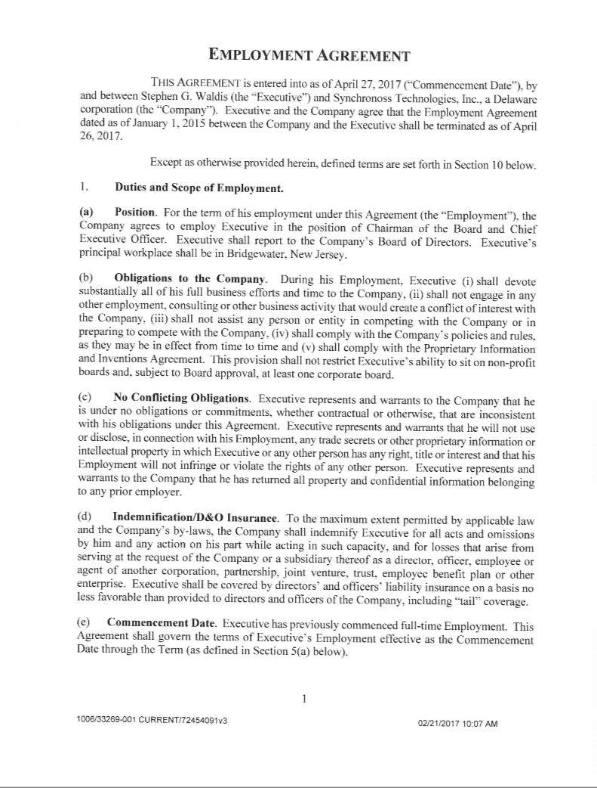

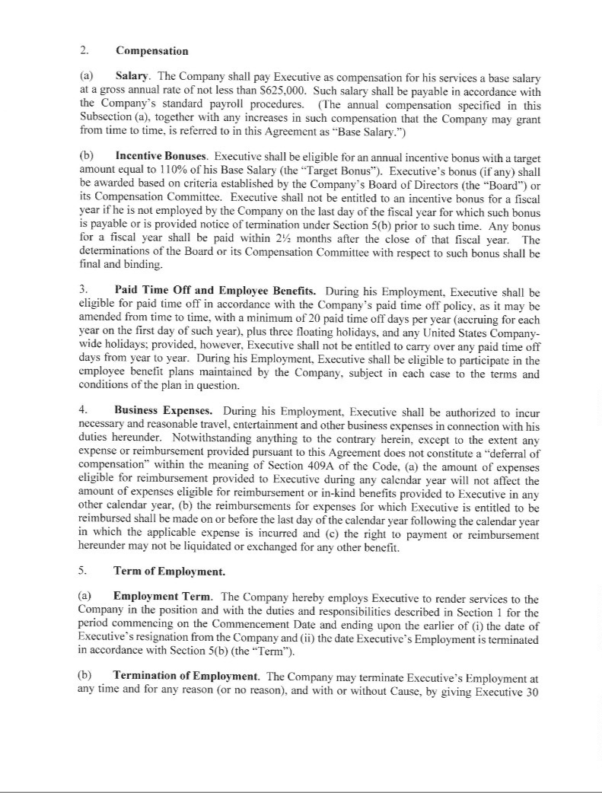

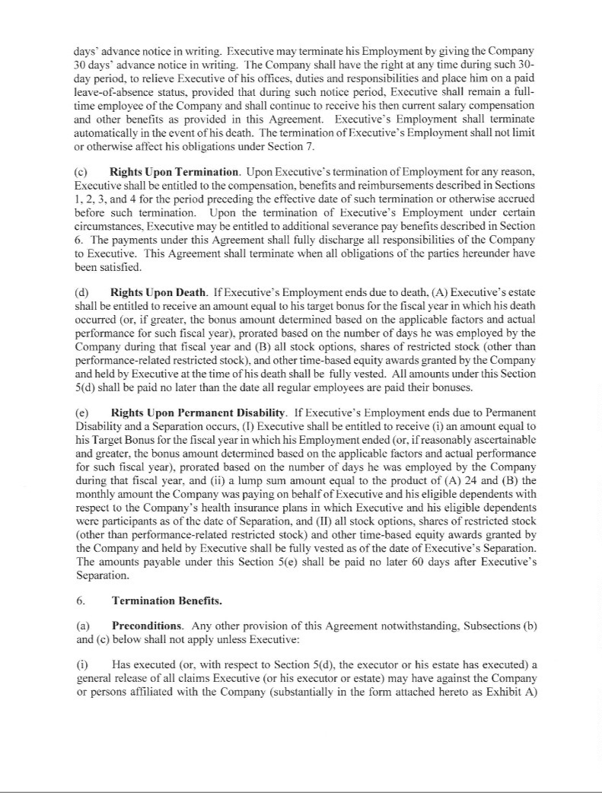

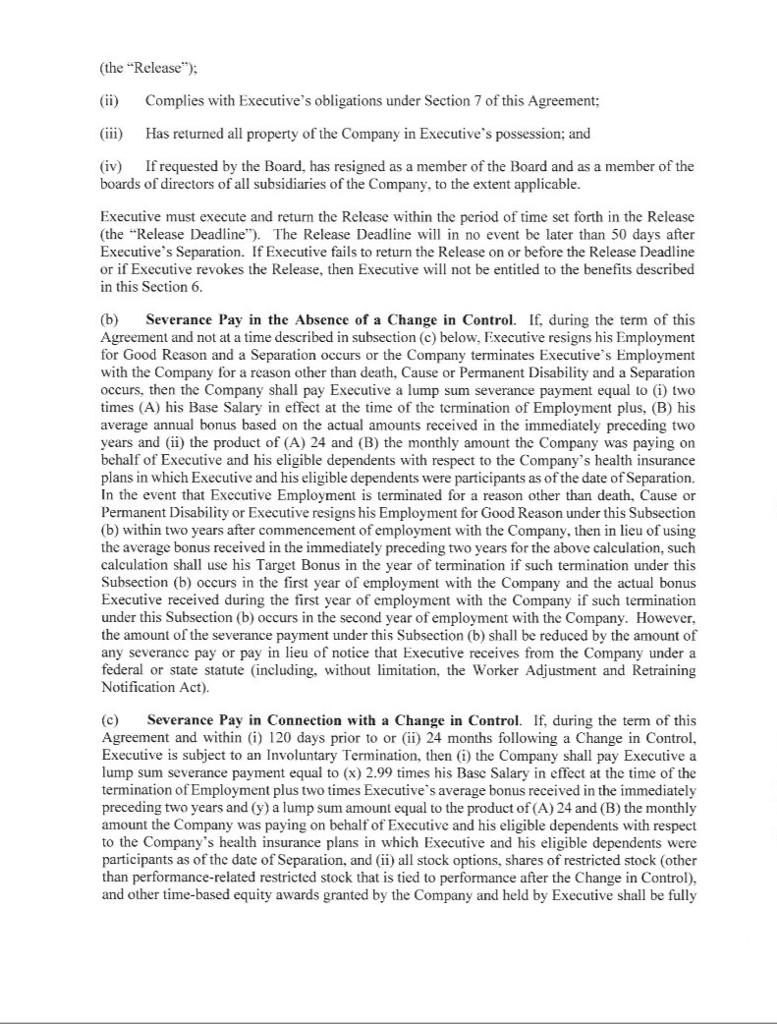

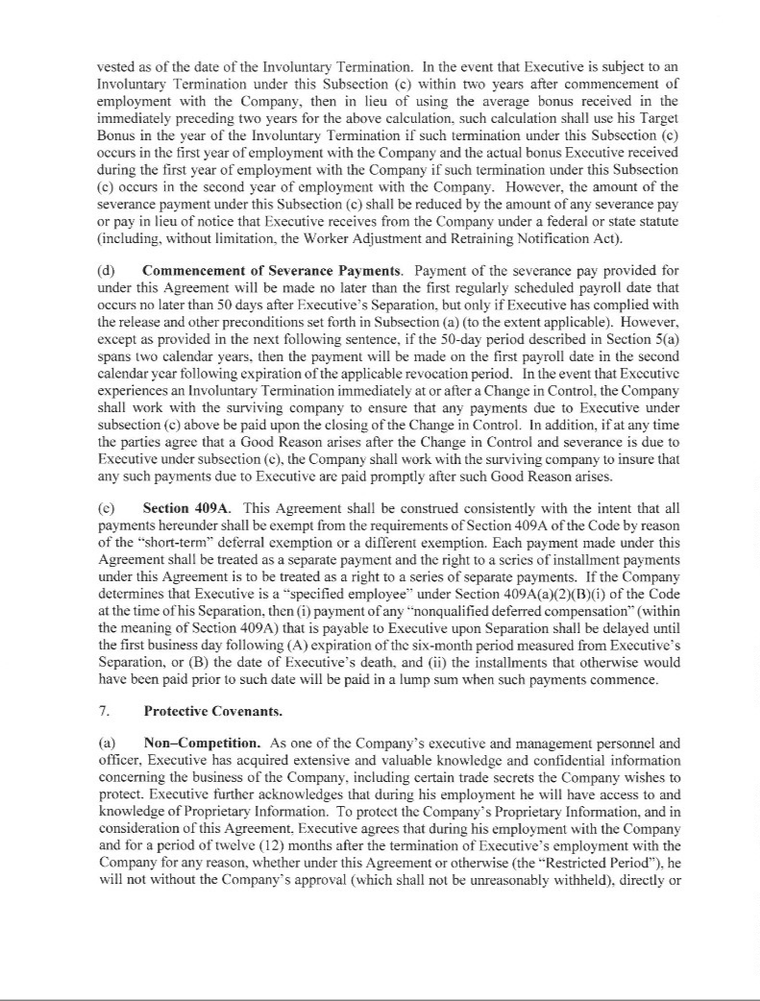

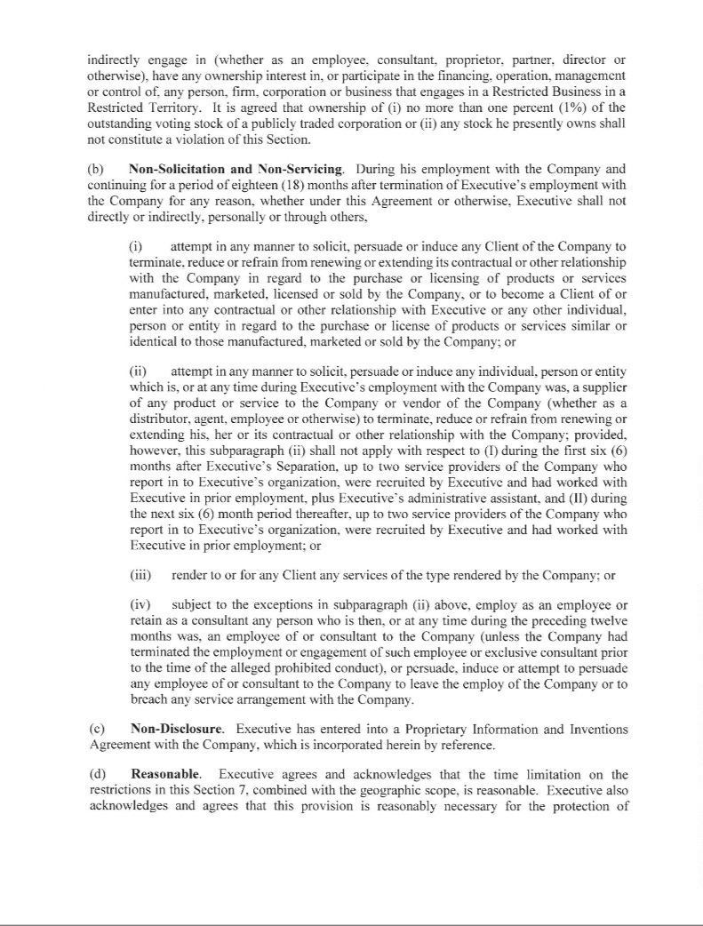

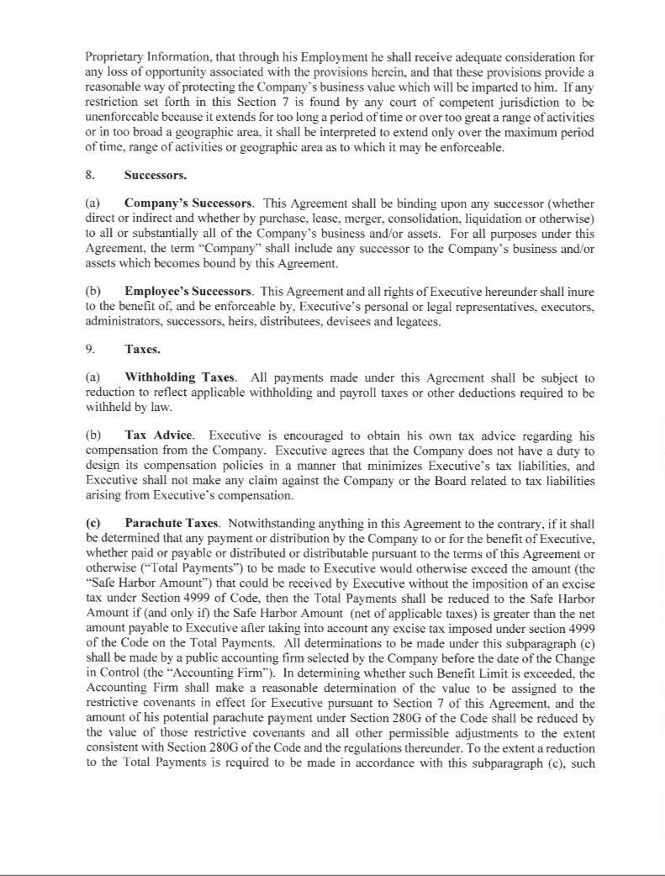

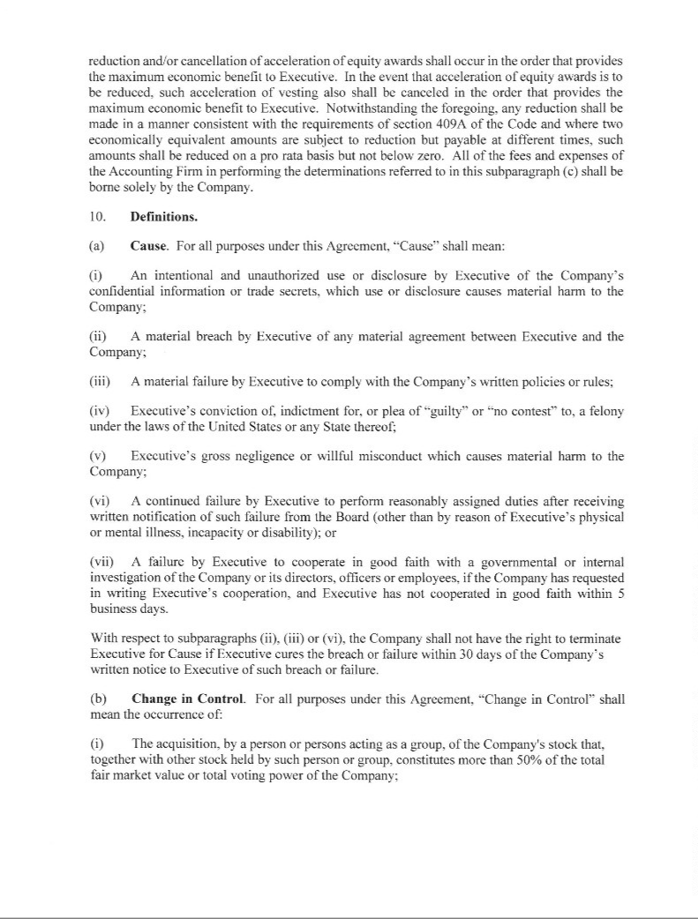

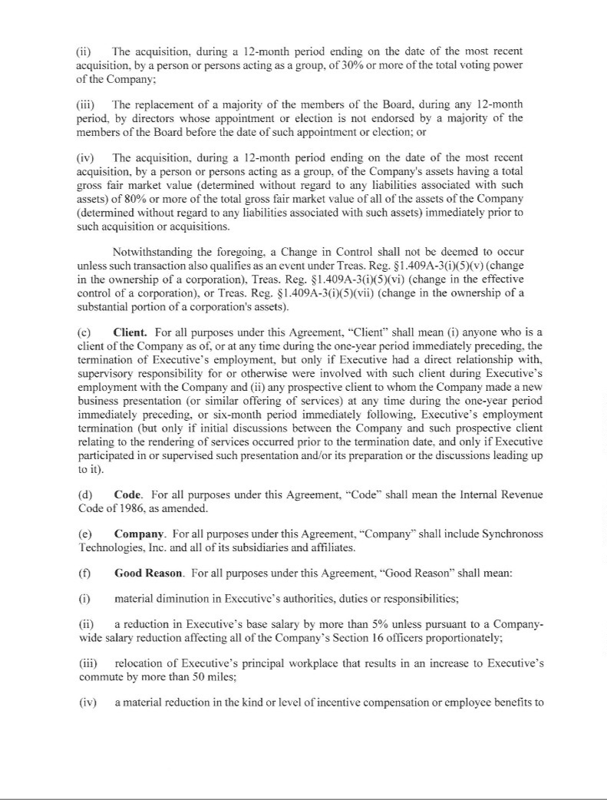

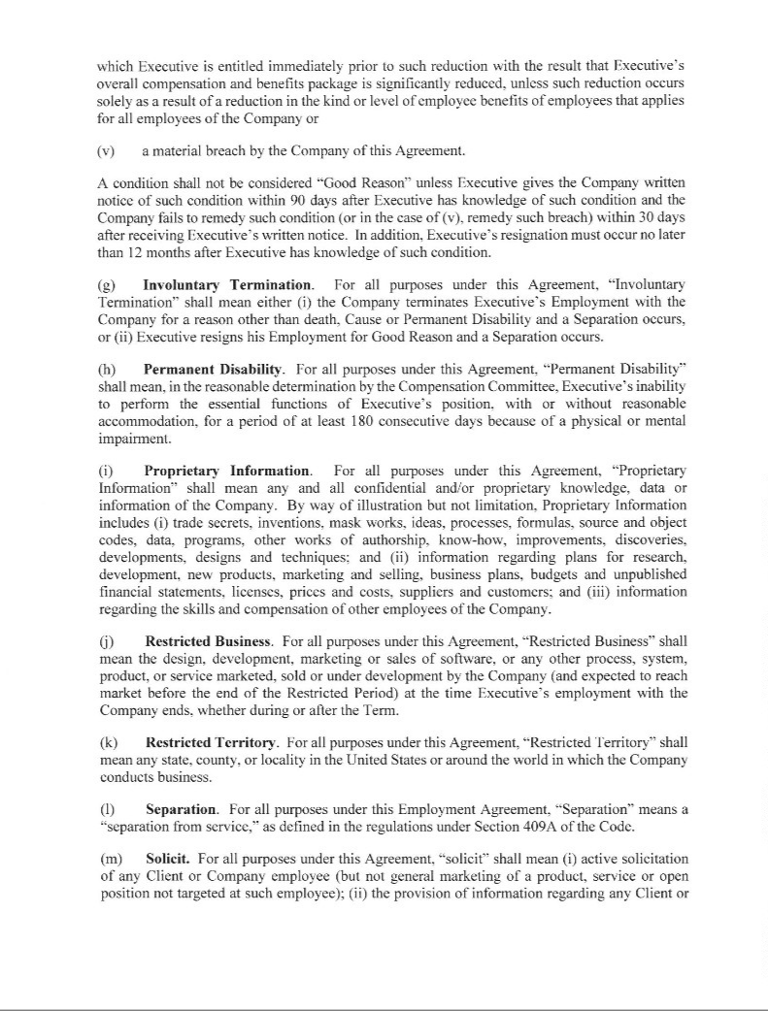

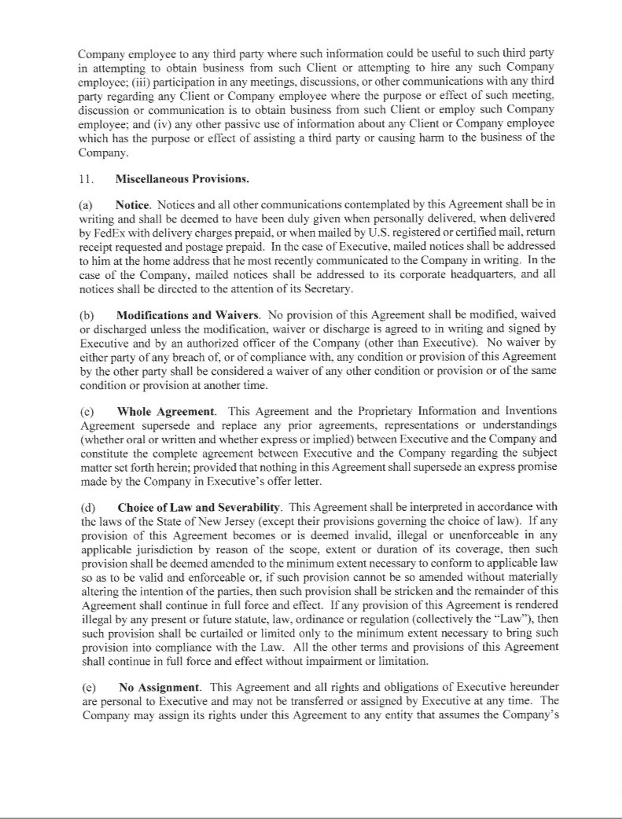

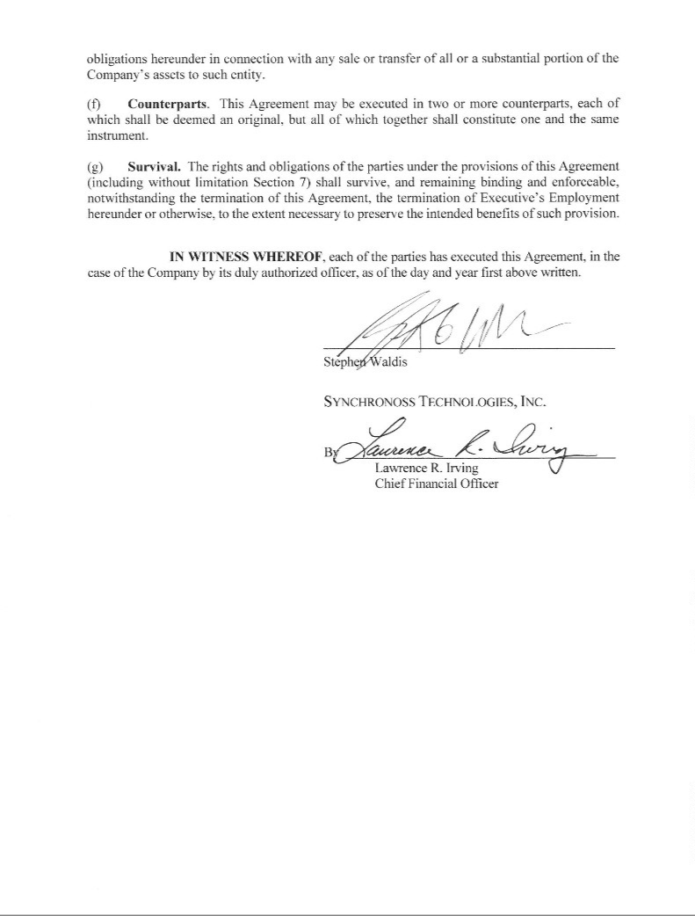

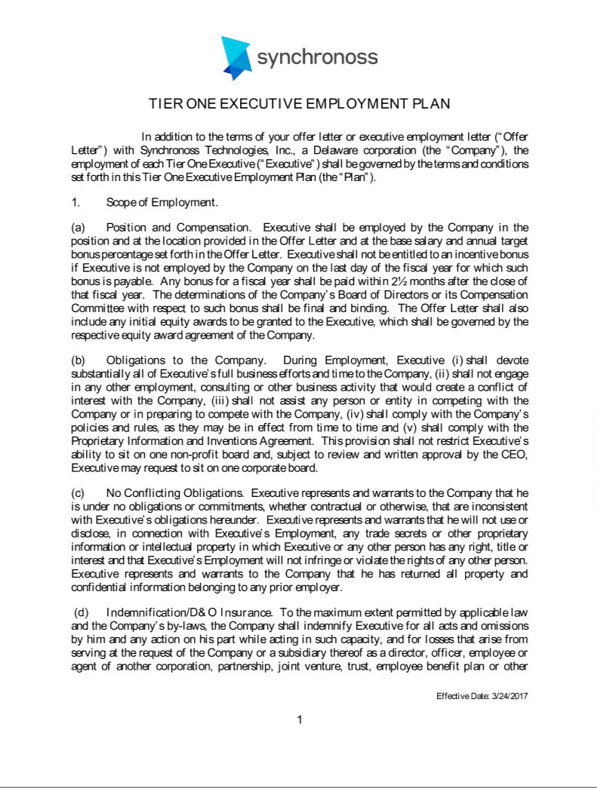

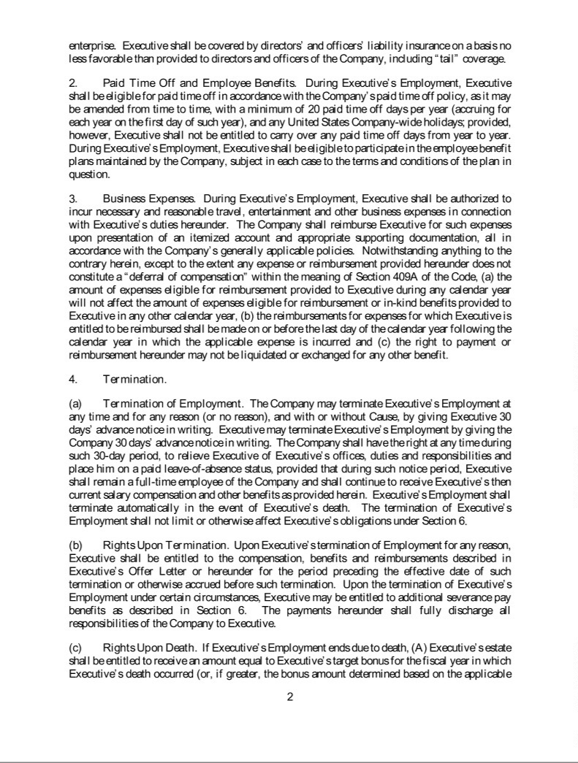

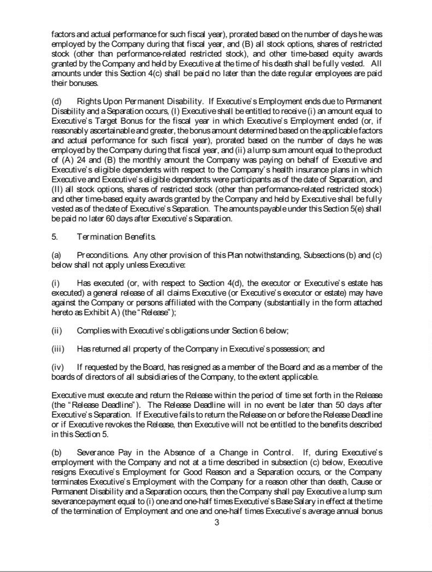

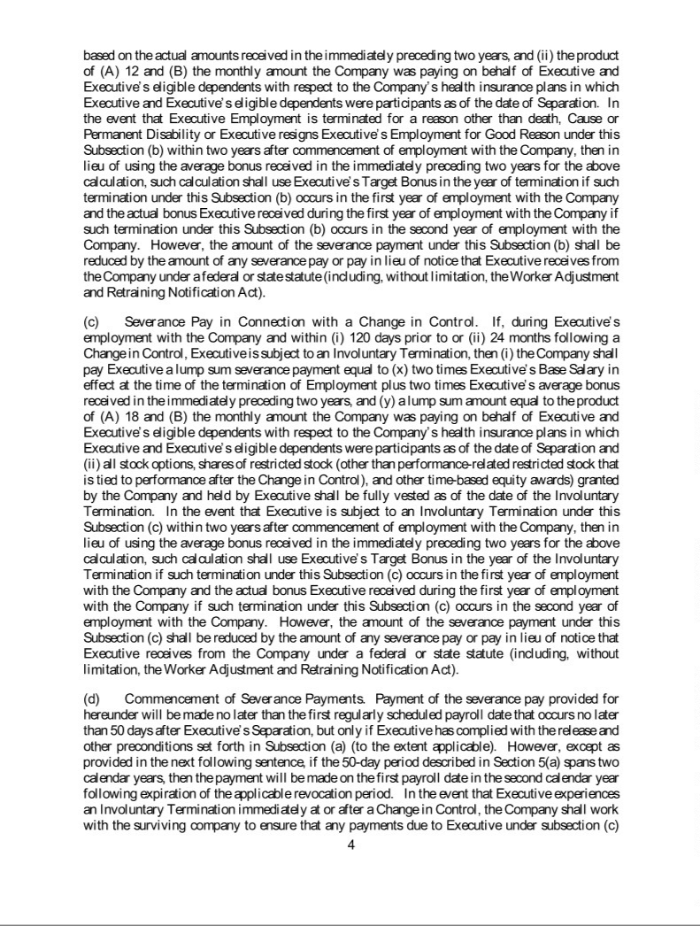

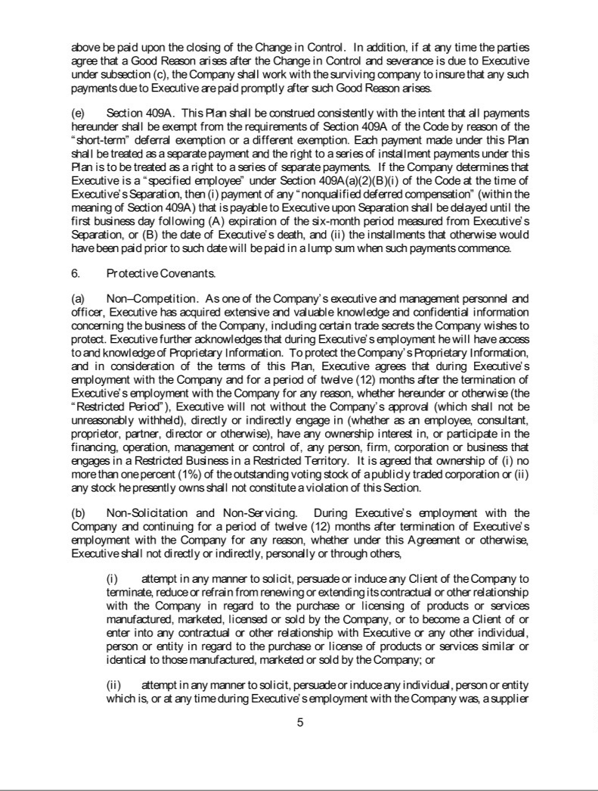

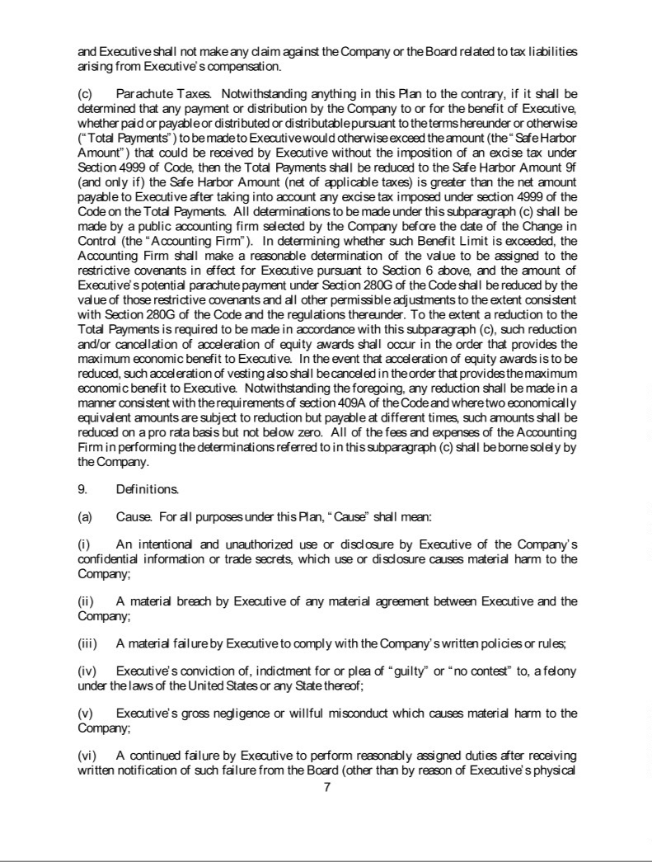

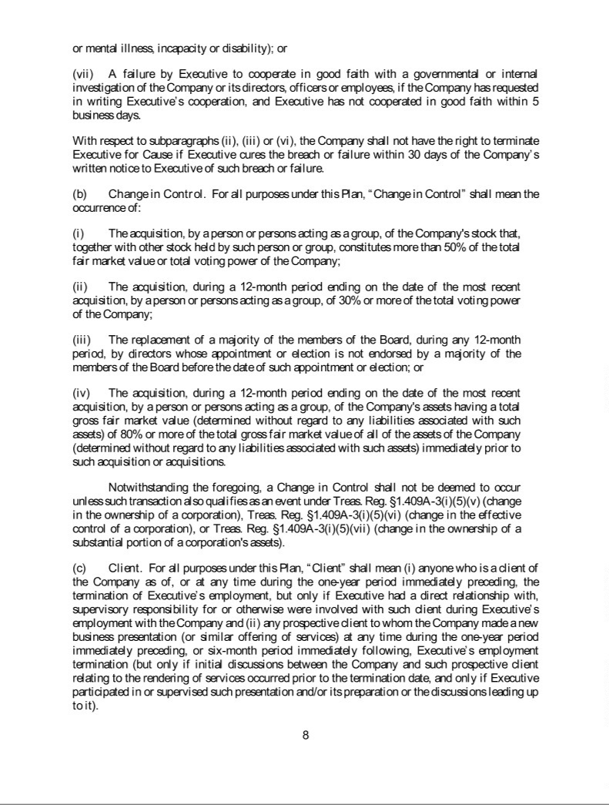

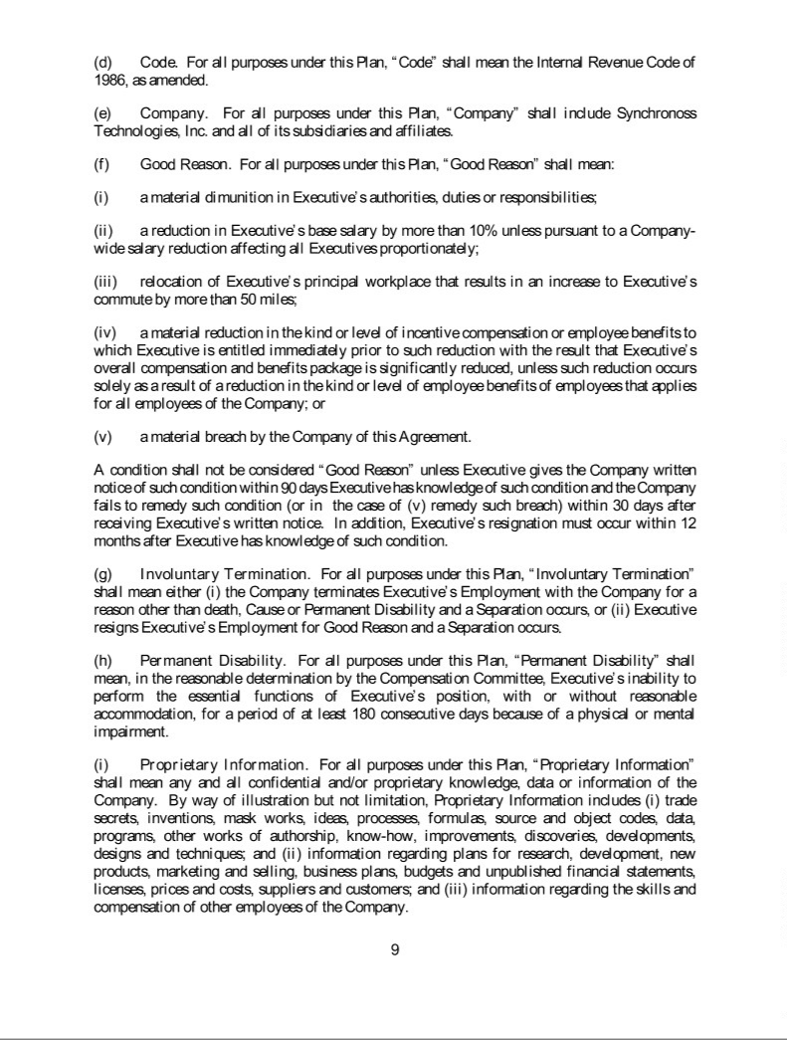

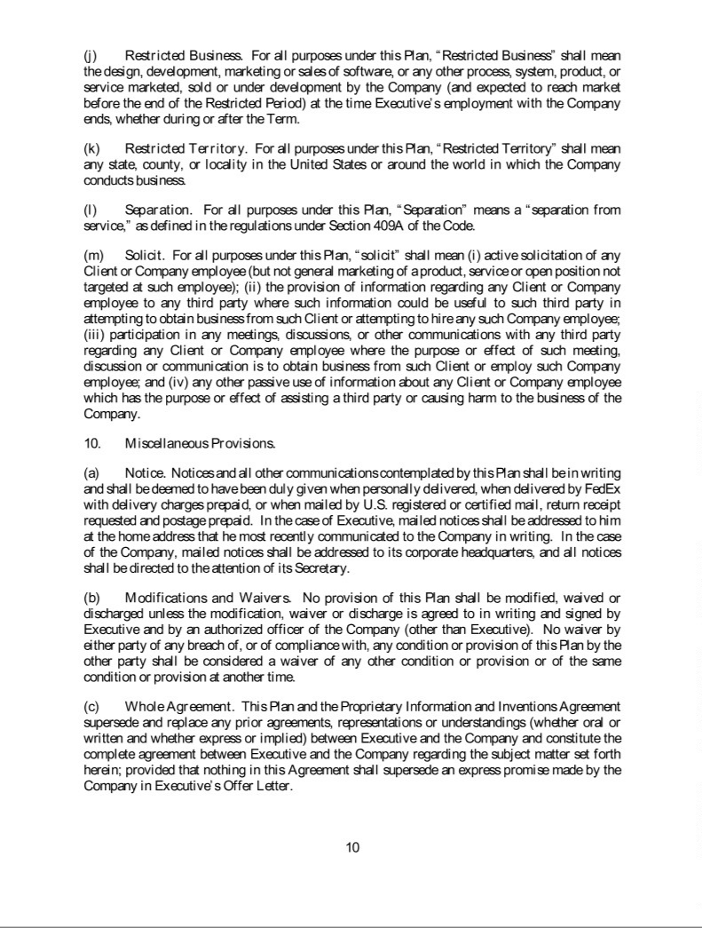

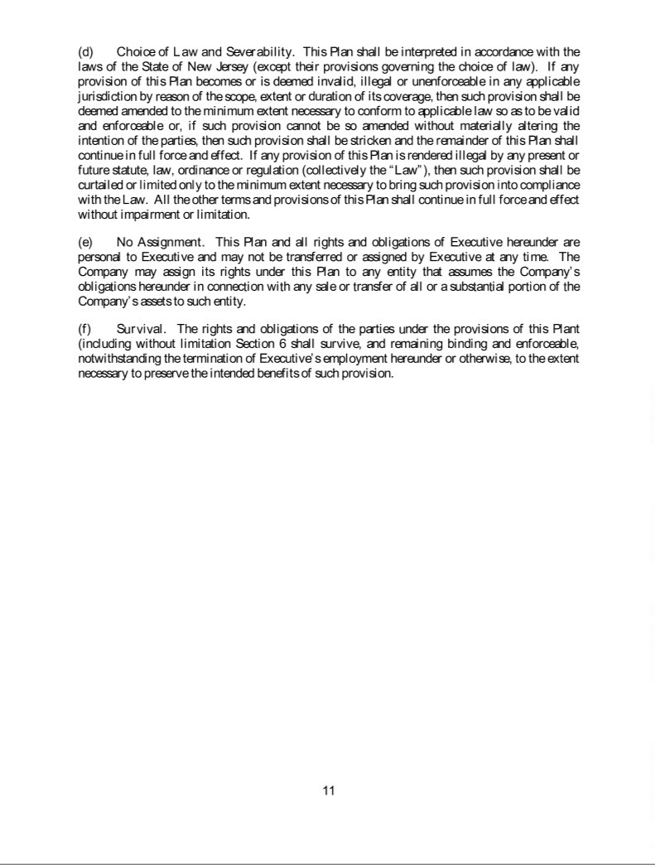

Exhibit 31.1

CERTIFICATION OF PRINCIPAL EXECUTIVE OFFICER

PURSUANT TO SECURITIES AND EXCHANGE COMMISSION RULE 13a-14(a)

I, Glenn Lurie, certify that:

- I have reviewed this Quarterly Report on Form 10-Q of Synchronoss Technologies, Inc. for the quarter ended March 31, 2017;

- Based on my knowledge, this report does not contain any untrue statement of a material fact or omit to state a material fact necessary to make the statements made, in light of the circumstances under which such statements were made, not misleading with respect to the period covered by this report;

- Based on my knowledge, the financial statements, and other financial information included in this report, fairly present in all material respects the financial condition, results of operations and cash flows of the registrant as of, and for, the periods presented in this report;

- The registrant’s other certifying officer(s) and I are responsible for establishing and maintaining disclosure controls and procedures (as defined in Exchange Act Rule 13a-15(e) and 15d-15(e)) and internal control over financial reporting (as defined in Exchange Act Rules 13a-15(f) and 15d-15(f)) for the registrant and have:

  - Designed such disclosure controls and procedures, or caused such disclosure controls and procedures to be designed under our supervision, to ensure that material information relating to the registrant, including its consolidated subsidiaries, is made known to us by others within those entities, particularly during the period in which this report is being prepared;

  - Designed such internal control over financial reporting, or caused such internal control over financial reporting to be designed under our supervision, to provide reasonable assurance regarding the reliability of financial reporting and the preparation of financial statements for external purposes in accordance with generally accepted accounting principles;

  - Evaluated the effectiveness of the registrant’s disclosure controls and procedures and presented in this report our conclusions about the effectiveness of the disclosure controls and procedures, as of the end of the period covered by this report based on such evaluation; and

  - Disclosed in this report any change in the registrant’s internal control over financial reporting that occurred during the registrant’s most recent fiscal quarter (the registrant’s fourth quarter in the case of an annual report) that has materially affected, or is reasonably likely to materially affect, the registrant’s internal control over financial reporting; and

- The registrant’s other certifying officer(s) and I have disclosed, based on our most recent evaluation of internal control over financial reporting, to the registrant’s auditors and the audit committee of the registrant’s Board of Directors (or persons performing the equivalent functions):

  - All significant deficiencies and material weaknesses in the design or operation of internal control over financial reporting which are reasonably likely to adversely affect the registrant’s ability to record, process, summarize and report financial information; and

  - Any fraud, whether or not material, that involves management or other employees who have a significant role in the registrant’s internal control over financial reporting.

Date: July 6, 2018

/s/ Glenn Lurie

Glenn Lurie

Chief Executive Officer

Exhibit 31.2

CERTIFICATION OF PRINCIPAL FINANCIAL OFFICER

PURSUANT TO SECURITIES AND EXCHANGE COMMISSION RULE 13a-14(a)

I, Lawrence R. Irving, certify that:

- I have reviewed this Quarterly Report on Form 10-Q of Synchronoss Technologies, Inc. for the quarter ended March 31, 2017;

- Based on my knowledge, this report does not contain any untrue statement of a material fact or omit to state a material fact necessary to make the statements made, in light of the circumstances under which such statements were made, not misleading with respect to the period covered by this report;

- Based on my knowledge, the financial statements, and other financial information included in this report, fairly present in all material respects the financial condition, results of operations and cash flows of the registrant as of, and for, the periods presented in this report;

- The registrant’s other certifying officer(s) and I are responsible for establishing and maintaining disclosure controls and procedures (as defined in Exchange Act Rule 13a-15(e) and 15d-15(e)) and internal control over financial reporting (as defined in Exchange Act Rules 13a-15(f) and 15d-15(f)) for the registrant and have:

  - Designed such disclosure controls and procedures, or caused such disclosure controls and procedures to be designed under our supervision, to ensure that material information relating to the registrant, including its consolidated subsidiaries, is made known to us by others within those entities, particularly during the period in which this report is being prepared;

  - Designed such internal control over financial reporting, or caused such internal control over financial reporting to be designed under our supervision, to provide reasonable assurance regarding the reliability of financial reporting and the preparation of financial statements for external purposes in accordance with generally accepted accounting principles;

  - Evaluated the effectiveness of the registrant’s disclosure controls and procedures and presented in this report our conclusions about the effectiveness of the disclosure controls and procedures, as of the end of the period covered by this report based on such evaluation; and

  - Disclosed in this report any change in the registrant’s internal control over financial reporting that occurred during the registrant’s most recent fiscal quarter (the registrant’s fourth quarter in the case of an annual report) that has materially affected, or is reasonably likely to materially affect, the registrant’s internal control over financial reporting; and

- The registrant’s other certifying officer(s) and I have disclosed, based on our most recent evaluation of internal control over financial reporting, to the registrant’s auditors and the audit committee of the registrant’s Board of Directors (or persons performing the equivalent functions):

  - All significant deficiencies and material weaknesses in the design or operation of internal control over financial reporting which are reasonably likely to adversely affect the registrant’s ability to record, process, summarize and report financial information; and

  - Any fraud, whether or not material, that involves management or other employees who have a significant role in the registrant’s internal control over financial reporting.

Date: July 6, 2018

/s/ Lawrence R. Irving

Lawrence R. Irving

Chief Financial Officer & Treasurer

Exhibit 32.1

CERTIFICATION OF PRINCIPAL EXECUTIVE OFFICER

PURSUANT TO 18 U.S.C. SECTION 1350

AS ADOPTED PURSUANT TO

SECTION 906 OF THE SARBANES-OXLEY ACT OF 2002

In connection with the Quarterly Report on Form 10-Q of Synchronoss Technologies, Inc. (the “Company”) for the quarter ended March 31, 2017, as filed with the Securities and Exchange Commission on the date hereof (the “Report”), I, Glenn Lurie, the Chief Executive Officer of the Company, hereby certify, pursuant to 18 U.S.C. 1350, as adopted pursuant to Section 906 of the Sarbanes-Oxley Act of 2002, to the best of my knowledge and belief that:

- the Report fully complies with the requirements of Section 13(a) or 15(d), as applicable, of the Securities Exchange Act of 1934, as amended, and

- the information contained in the Report fairly presents, in all material respects, the financial condition and results of operations of the Company.

This certification is being provided pursuant to 18 U.S.C. 1350 and is not to be deemed a part of the Report, nor is it to be deemed to be “filed” for any purpose whatsoever.

Date: July 6, 2018

/s/ Glenn Lurie

Glenn Lurie

Chief Executive Officer

A signed original of this written statement required by Section 906 has been provided to the Company and will be retained by the Company and furnished to the Securities and Exchange Commission or its staff upon request.

Exhibit 32.2

CERTIFICATION OF PRINCIPAL FINANCIAL OFFICER

PURSUANT TO 18 U.S.C. SECTION 1350

AS ADOPTED PURSUANT TO

SECTION 906 OF THE SARBANES-OXLEY ACT OF 2002

In connection with the Quarterly Report on Form 10-Q of Synchronoss Technologies, Inc. (the “Company”) for the quarter ended March 31, 2017, as filed with the Securities and Exchange Commission on the date hereof (the “Report”), I, Lawrence R. Irving, the Chief Financial Officer of the Company, hereby certify, pursuant to 18 U.S.C. 1350, as adopted pursuant to Section 906 of the Sarbanes-Oxley Act of 2002, to the best of my knowledge and belief that:

- the Report fully complies with the requirements of Section 13(a) or 15(d), as applicable, of the Securities Exchange Act of 1934, as amended, and

- the information contained in the Report fairly presents, in all material respects, the financial condition and results of operations of the Company.

This certification is being provided pursuant to 18 U.S.C. 1350 and is not to be deemed a part of the Report, nor is it to be deemed to be “filed” for any purpose whatsoever.

Date: July 6, 2018

/s/ Lawrence R. Irving

Lawrence R. Irving

Chief Financial Officer & Treasurer

A signed original of this written statement required by Section 906 has been provided to the Company and will be retained by the Company and furnished to the Securities and Exchange Commission or its staff upon request.

